Manuscript 05-20b
Spectral Corrected Semivariogram Models
Michael J. Pyrcz¹ and Clayton V. Deutsch²

Author Coordinates:

¹ Quantitative Stratigraphy, Earth Science R & D, Chevron Energy Technology Company, Houston, TX 77002 USA; e-mail: mjpy@chevron.com

² Department of Civil and Environmental Engineering, University of Alberta, Edmonton, AB T6G 2W2 Canada; e-mail: cdeutsch@ualberta.ca

Suggested Running Head: Spectral Semivariograms

Corresponding Author: Michael J. Pyrcz
Quantitative Stratigraphy, Earth Science R & D
Chevron Energy Technology Company
Houston, TX 77002

E-mail: mjpy@chevron.com

Phone: 1 832 854 7016

ABSTRACT
Fitting semivariograms with analytical models can be tedious and restrictive. There are many smooth functions that could be used for the semivariogram; however, arbitrary interpolation of the semivariogram will almost certainly create an invalid function. A spectral correction, that is, taking the Fourier transform of the corresponding covariance values, resetting all negative terms to zero, standardizing the spectrum to sum to the sill, and inverse transforming is a valuable method for constructing valid discrete semivariogram models. This paper addresses some important implementation details and provides a methodology to working with spectrally corrected semivariograms.

Keywords: nested structures, kriging, stochastic simulation, geostatistics, Fourier transform

INTRODUCTION
The random function paradigm of semivariogram based geostatistics depends heavily on the calculation and fitting of a reasonable semivariogram model. The inference step is largely automatic once a decision of stationarity is taken and a semivariogram model is chosen. This paper is aimed at the determination of a valid semivariogram model. A valid semivariogram model is one that is conditionally non-negative definite and that does not lead to numerical artifacts due to instability. The conventional method of modeling semivariograms by nested structures is well established (Journel and Huijbregts, 1978). While this provides a workable mechanism for modeling most semivariograms, there are some cases that are not well fit with this framework. Figure 1 shows an example structure commonly observed in experimental semivariograms that is not easy to fit with the conventional structures. The largely unexplored suite of valid models, known as geometric semivariograms, is explored in a companion paper (Pyrcz and Deutsch, in press).
The covariance is related to the semivariogram under second order stationarity, $C(h)=σ^{2}−γ(h)$, and covariances will be referred to when it is standard practice to call on the covariance and not the semivariogram.
SPECTRAL CORRECTED SEMIVARIOGRAM MODELS
Fitting an arbitrary function to experimental semivariogram points,$γ(h)$, does not guarantee a valid model for subsequent estimation and simulation. Spectral correction offers an efficient means to correct arbitrary fitted semivariogram to be conditional negative definite.
Bochner’s theorem defines the general form of a conditional negative definite function $C(h)$, continuous in $h$= 0 (without nugget effect), as:
$C(h)=\int{\text{cos}(ωh)⋅\text{dS}(ω)}$ (1)
under the constraints that $\text{dS}(ω)>0$and $\int{\text{dS}(ω)}=C(0)<∞$. $S(ω)$ is the spectral cumulative distribution function.
The link between the spectrum and covariance models is an efficient method to check for conditional negative definiteness and to correct for conditional negative definiteness in semivariogram models. A check of the spectrum representation amounts to checking if all real components are greater than 0.0 and that they sum to the variance ($C(0)$).
In practice, this is accomplished with a discrete fast Fourier transform (FFT), resulting in a discrete solution. A discrete covariance model, or covariance table, is corrected by enforcing these constraints by setting all negative real components to 0.0 and then standardizing all spectrum to sum to the variance.

Proposed Flexible Semivariogram Modeling Procedure
A new methodology for flexible semivariogram modeling is proposed. This methodology requires the following steps: (1) freely model the semivariogram in a suite of representative directions, (2) construct a consistent covariance table from the directional semivariograms and (3) correct the covariance tables for conditional negative definiteness. The corrected covariance tables may be loaded directly into kriging or simulation programs. Each of these steps are discussed in greater detail below.
These directional models may be regression fits of the experimental semivariogram points, or even hand drawn. The added flexibility allows for the integration of calculated experimental statistics and geologic information.
A covariance table will be inferred from the directional semivariograms. The covariance table must have the same dimensionality and scale as the random function model to which it will be applied. The table is set large enough that the semivariogram fully characterizes spatial continuity (i.e. extends to the range in each direciton). Also, the size of the table is set to a power of 2.
${\text{ncells}}_{x,y,z}=2^{i_{x,y,z}}$ (2)
where i_{x,y,z} is an integer. This is required by the Numerical Recipes multidimensional discrete FFT subroutine (fourn.for) (Press, W.H. and others, 1992, p. 499).
The traditional linear model of regionalization requires that the semivariogram is inferred for directions other than the principals by applying geometric anisotropy [Eq. (2)] (Isaaks and Srivastava, 1989, p. 377). This method requires the directional semivariograms to be constructed from a common set of nested structures. Each nested structure must be effective over all directions. Because we have not applied a common set of nested structures, we require a new method to infer the semivariogram in the non-principal directions.
The method proposed here is based on variable geometric anisotropy. This method is limited by two assumptions: (1) the semivariogram is provided in the principal directions and (2) the semivariogram models are monotonically increasing (no cyclicity or hole effect).
Variable geometric anisotropy is applied as follows: (1) the semivariogram model is binned by equal variance contributions, (2) the ranges in the principal directions are tabulated for each bin. These ranges parameterize nested ellipsoids that define the semivariogram in all directions with variable geometric anisotropy. These ellipsoids are demonstrated in Figure 2 and are represented by well known equation for an ellipsoid.
For all locations within the covariance table, the covariance value associated with the closest ellipsoid to the location is assigned. This is calculated quickly by solving the equation for each ellipsoid proceeding from the smallest to the largest. The application of many bins results in a smooth interpolation of the off-diagonal semivariograms.
The application of nested ellipsoids for inferring the off-diagonal semivariogram is demonstrated for a 2-D example in Figure 3. The example 2-D covariance table was calculated from semivariogram models in the principal directions defined by flexible fit models. The semivariogram model in Figure 3 would not be possible with conventional semivariogram modeling techniques. Of course, there is no guarantee that the resulting covariance table in Figure 3 is conditional negative definite. This will be dealt with in the next section.

Correct the Covariance Table
The previously outlined method of applying constraints in the spectrum representation is applied to correct for conditional negative definiteness. The practical steps include (1) translate the covariance table so that the origin is located at the table corners, (2) apply the discrete FFT to the table, (3) correct the spectrum by to be positive definite and then (4) perform the inverse FFT and (5) translate the corrected covariance table origin back to the center of the table. These steps are demonstrated for the example covariance table (Figure 3) in Figure 4.
For the example covariance table the magnitude of correction is characterized by a plot of the difference between the original and the corrected covariance table and the histogram of the difference (Figure 5). Maximum change in this case is about 5% of the sill. The original and corrected semivariogram models are shown for the principal and two off-diagonal directions along with the corrected covariance table (Figure 6).
This method has some similarities to the methodology proposed by Yao and Journel (1998). The key difference is in the construction of the covariance tables. Our method focuses on the integration of geologic information through the flexible design of semivariogram models in the principal directions and the construction of a consistent covariance table. The Yao and Journel (1998) method automatically constructs the covariance table directly from the available sample data and then applies a preliminary smoothing to remove noise due to sparse data. The resulting smoothed covariance map is then corrected in spectrum for conditional negative definite ness as outlined previously. While this method streamlines the semivariogram modeling process, it may remove the opportunity to inject geologic information with respect to the heterogeneity and anisotropy and risks the possibility of over fitting noisy experimental data.

DEMONSTRATION
The application of spectral corrected semivariogram models is demonstrated. An example 2-D data set is shown in Figure 7. An exhaustive data set was applied to remove issues related to model inference and to focus on flexible semivariogram model construction. This data set is an unconditional sequential Gaussian simulation realization with spatial structures not well modeled with nested structures. The semivariograms were modeled in the principal directions (aligned with the X and Y coordinates). The resulting semivariograms fitted by (1) traditional method of nested structures and (2) flexible semivariogram modeling method as shown in Figure 8. The flexible semivariogram modeling method resulted in a conditional negative definite semivariogram model that closely characterizes the directional experimental semivariograms.

CONCLUSION
The choice of semivariogram model has a major affect on kriging and kriging-based simulation models. Spectral corrected models offer an efficient methodology for improving semivariogram modeling. This technique allows semivariograms to be modeled with greater emphasis on geologic continuity information as opposed to limits imposed by the traditional method of nested structures. In practice the corrected semivariogram models are not so different from the uncorrected shapes. Many practitioners would like to fit directional semivariograms independently and then reconcile them in software. This provides a practical solution.
The required computer code is straightforward and mostly available in the public domain. All semivariogram models proposed here are guaranteed to be valid; therefore, there are no issues with implementation.

REFERENCES
Deutsch, C.V. and Journel A.G., 1998, GSLIB: geostatistical software library and user’s guide 2nd ed.: Oxford University Press, New York, 369 p.
Isaaks, E. H. and Srivastava R.M., 1989. An introduction to applied geostatistics: Oxford University Press, New York, 561 p.
Journel, A.G. and Huijbregts, Ch.J., 1978, Mining geostatistics: Academic Press, New York, 600 p.
Press, W.H., Flannery, B.P. and Teukolsky, S.A., 1992, Numerical recipes in FORTRAN 77 the art of scientific computing: Cambridge University Press Programs, 449 p.
Pyrcz, M.J. and Deutsch, C.V., in press, Semivariogram models based on geometric offsets: Math Geology, v. xx, no. x, p. xxx-xxx.
Yao, T. and Journel A.G., 1998, Automatic modeling of (cross) covariance tables using fast Fourier transform: Math Geology, v. 30, no. 6, p. 589-615.

Figure 1 - An example semivariogram that is not well fit by nested sets of traditional semivariogram models.

Figure 2 - Variable geometric anisotropy: the anisotropy ratios are allowed to vary with respect to semivariogram contribution. This results in the ability to consistently infer the semivariogram model in off-diagonal directions when the principal directions are not modeled by nested structures that exist in all directions. In this example the semivariogram is strongly anisotropic for the short range and then becomes more isotropic over the long range.

Figure 3 – The semivariogram models for the principal directions and the resulting covariance table. The covariance table is inferred with variable anisotropy.

Figure 4 - The steps to correct the A, covariance table. (1) translate the covariance table so that the origin is located at the table corners, B, (2) apply the discrete FFT to the table, C , (3) correct the spectrum, D, and then (4) perform the inverse FFT, E, and (5) translate the corrected covariance table origin back to the center of the table, F.

Figure 5 – The difference in the covariance table due to correction (corrected – original).

Figure 6 – A comparison of directional semivariograms from the original and corrected covariance tables.

Figure 7 – An example 2D exhaustive data set.

Figure 8 – The experimental semivariograms and the fit models based on the (1) traditional method of nested conditional negative definite models and (2) flexible semivariogram modeling method. The semivariogram is modeled to the sill since the model will be applied in sequential Gaussian simulation.

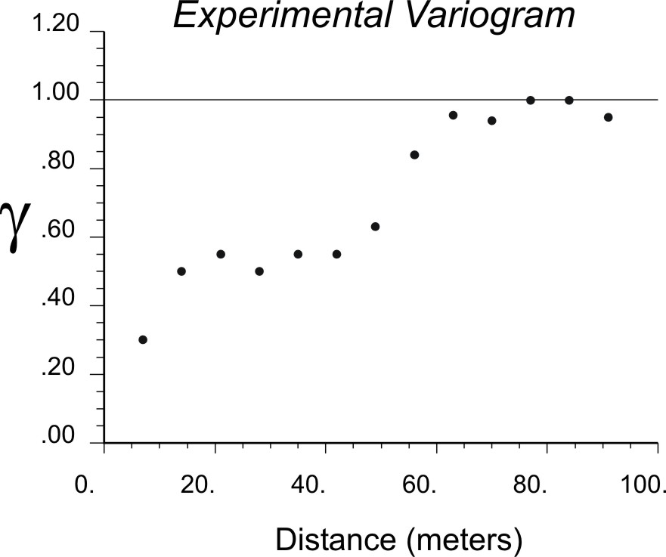
Figure 1

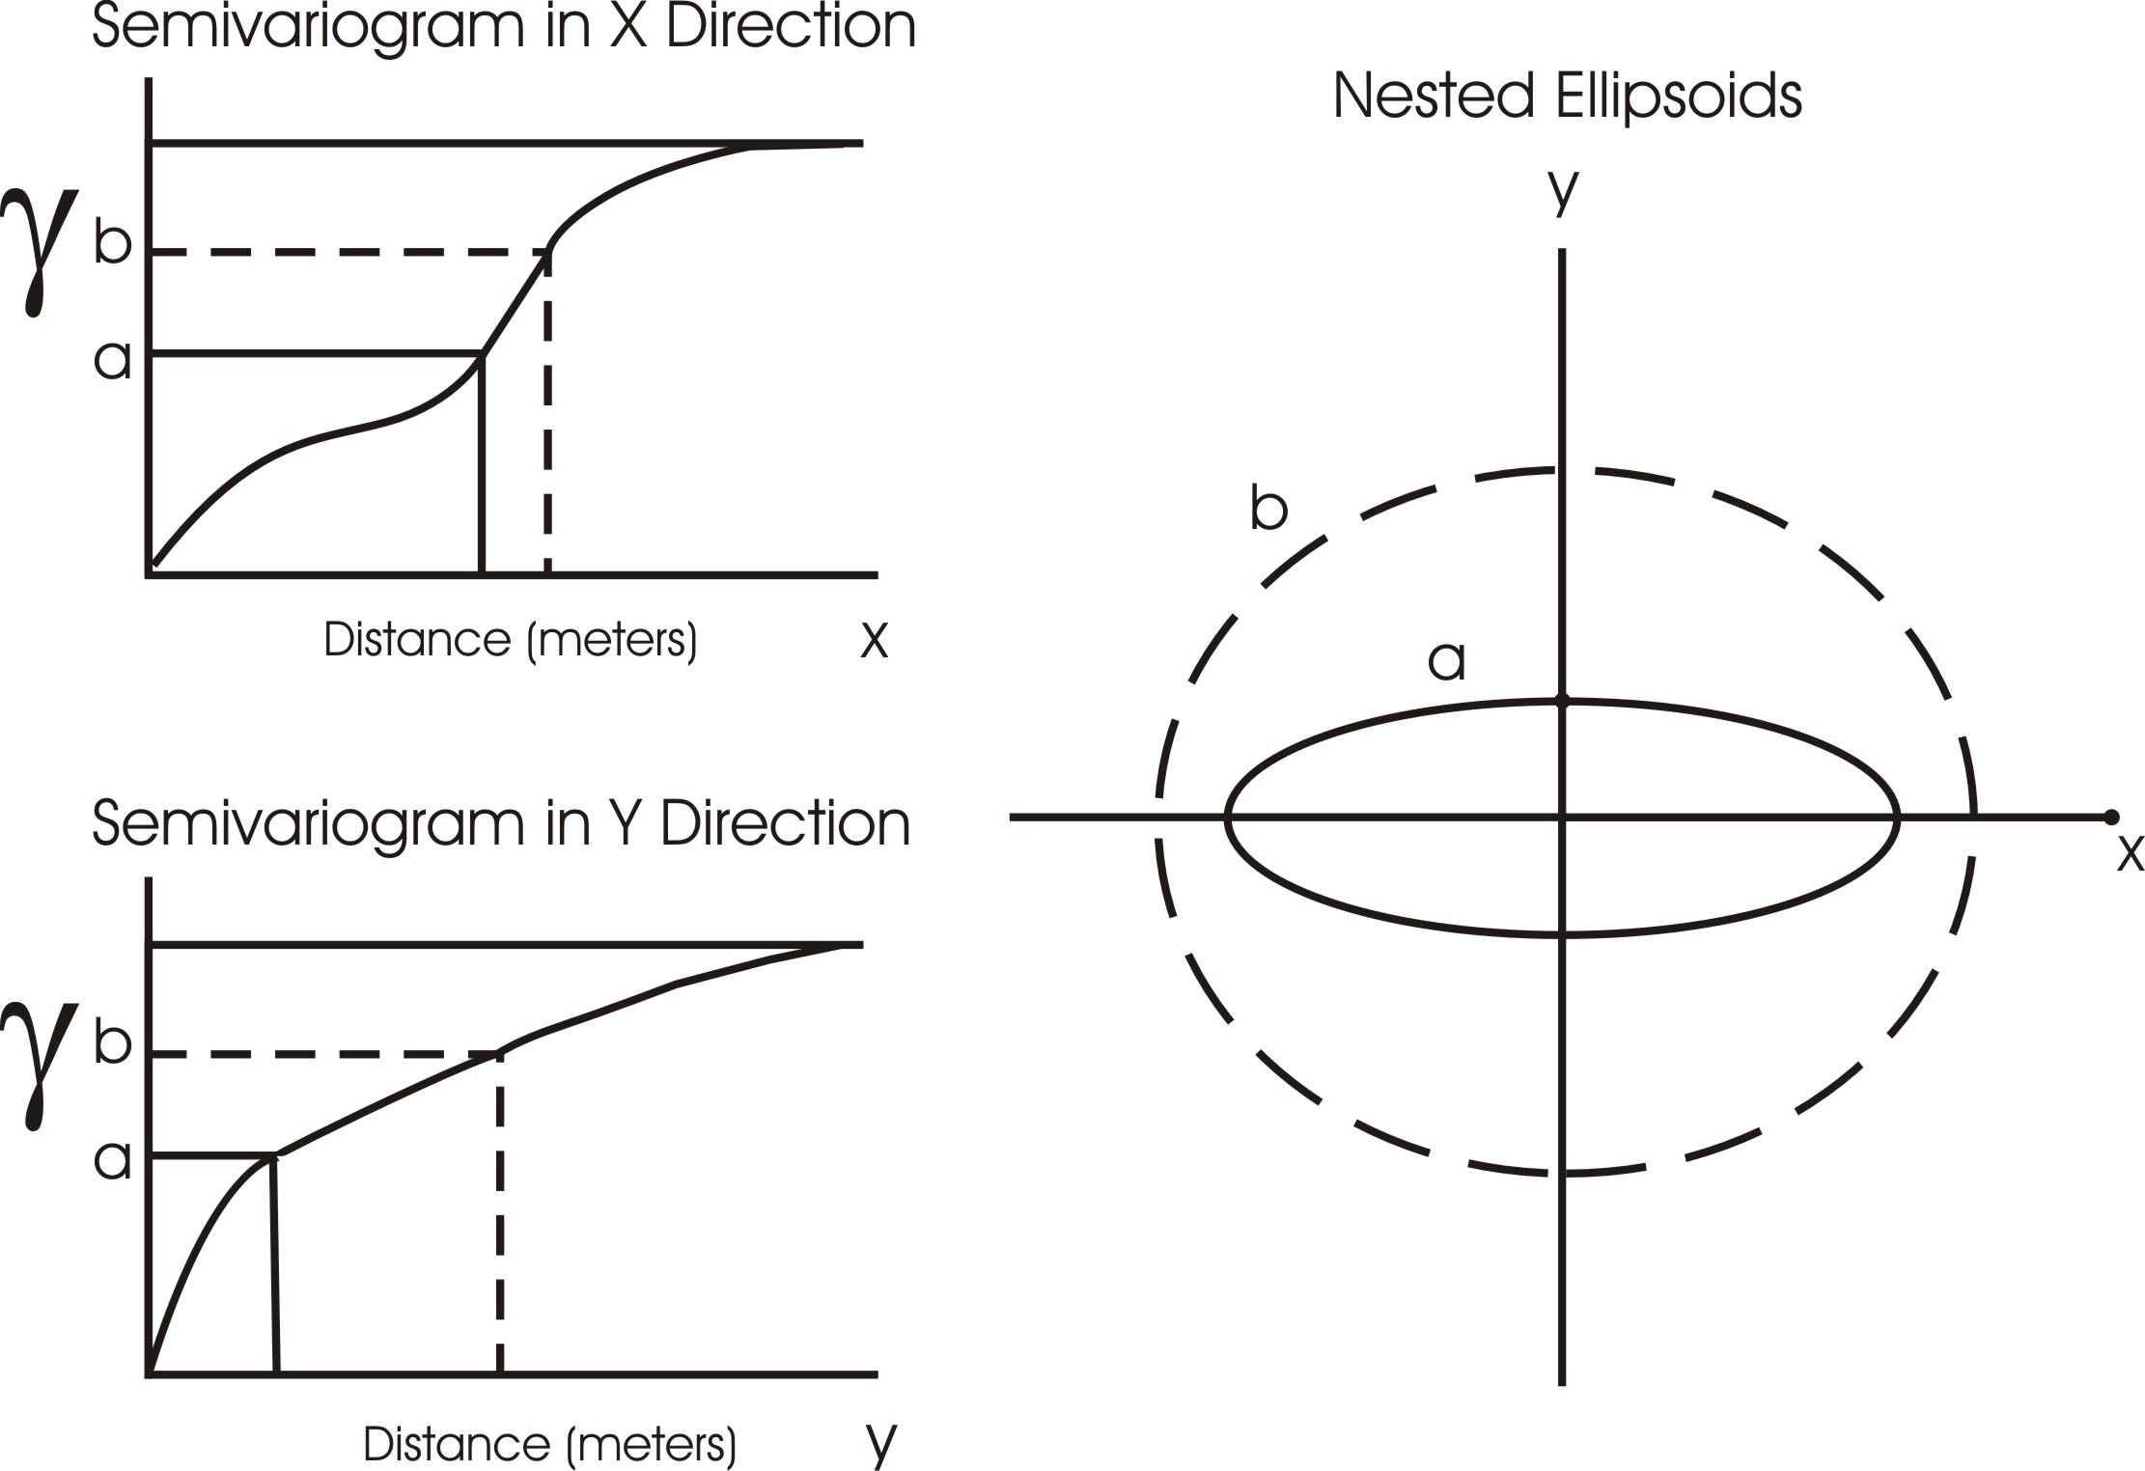
Figure 2

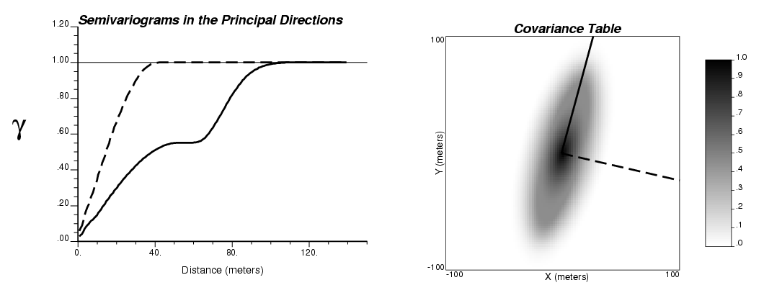
Figure 3

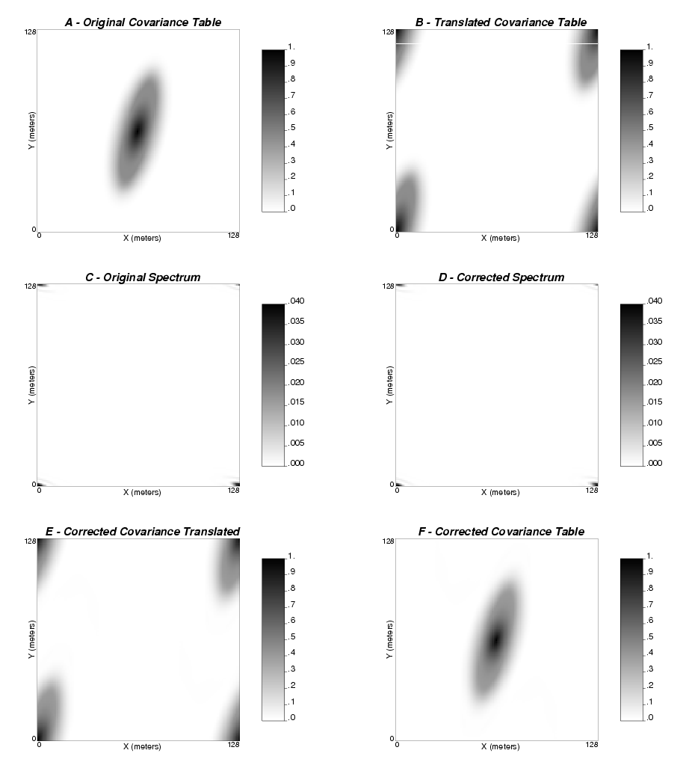
Figure 4

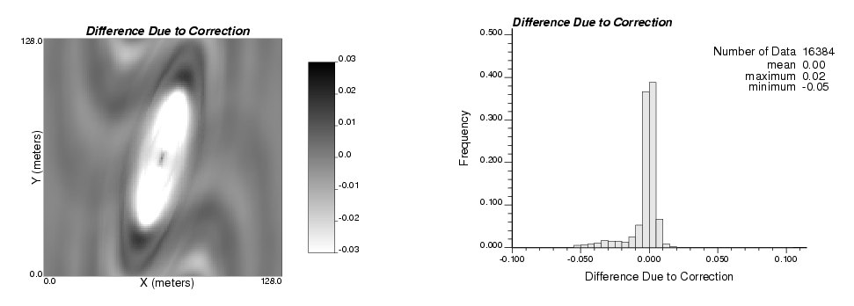
Figure 5

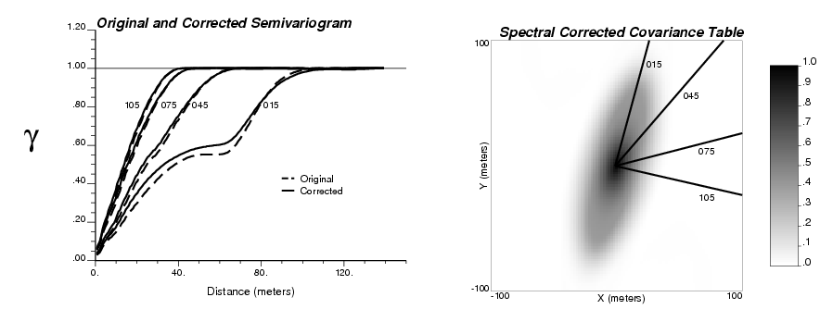
Figure 6

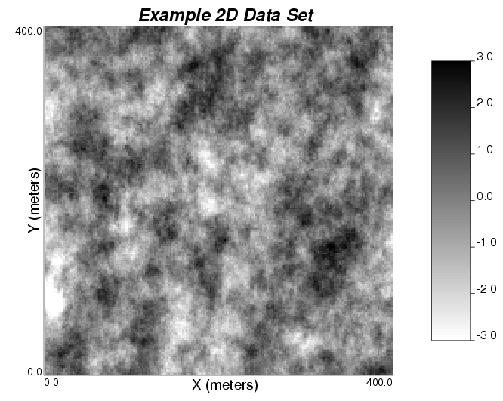
Figure 7

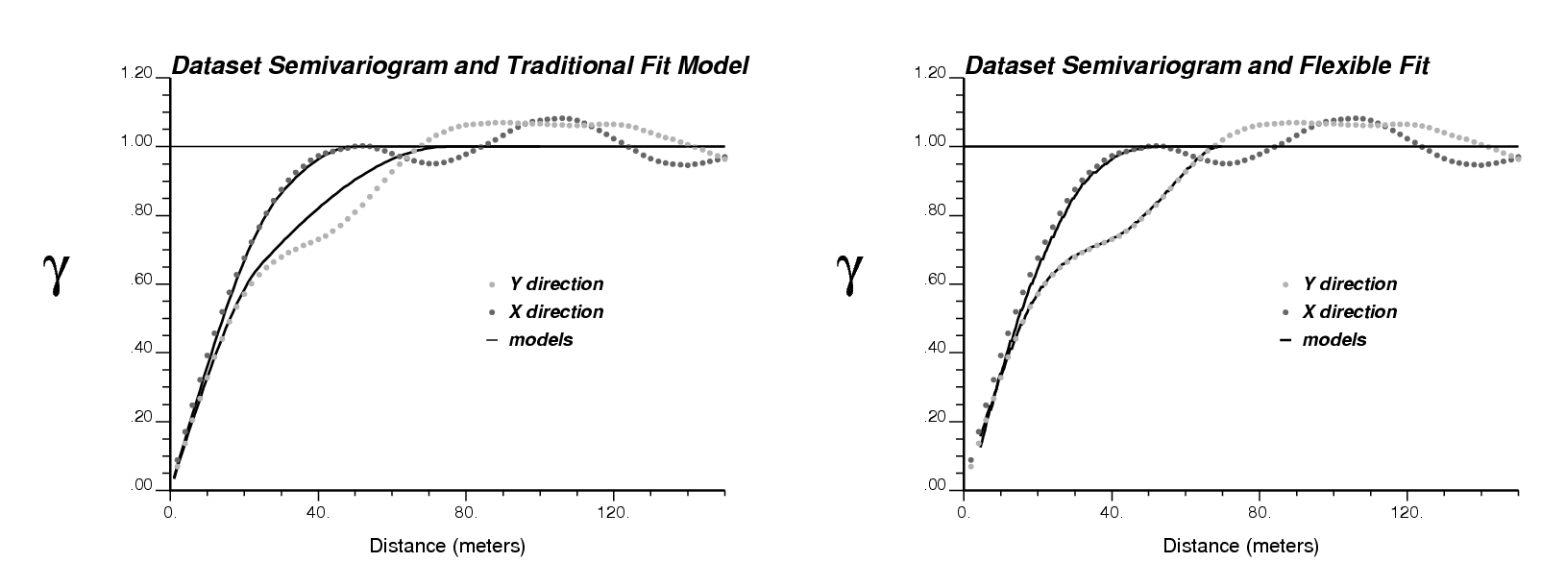
Figure 8

