Geostatistical Determination of Production Uncertainty:
Application to Pogo Gold Project

J. A. McLennan (jam12@ualberta.ca) and C. V. Deutsch (cdeutsch@ualberta.ca)
University of Alberta, Edmonton, Alberta, Canada

J. DiMarchi (jdimarchi@teckalaska.com) and P. Rolley (Peter.Rolley@teckcominco.com)
Teck Cominco Limited, Vancouver, British Columbia, Canada

Abstract
Geological uncertainty is an unavoidable characteristic of mining projects since only limited information is available from sampling. Mine planning and development decisions with significant economic consequences are made when the geological heterogeneity is inherently uncertain. The technique of kriging provides best estimates at each location; however, geostatistical simulation is preferred because it provides alternative grade realizations that can be used to assess geological uncertainty. Geological uncertainty can be transferred into production uncertainty, which can help characterize the economic risk of the project.

This paper presents a case study for the Pogo property, being prepared for development near Fairbanks, Alaska. The exact dimensions, grades and production predictions have been modified; however, the methodology is illustrative. The geostatistical methodology consists of (1) assembling the relevant drillhole data and establishing a suitable coordinate system, (2) calculating the target distribution, (3) creating a model of spatial correlation, (4) generating multiple realizations at a small scale and (5) linearly averaging all the realizations to the chosen selective mining unit (SMU) support size. The geostatistical model is then used to calculate production uncertainty.

Introduction
Mine planning is conventionally based on block estimates created from some flavor of kriging. The classical application of kriging to mine planning is discussed in Journel and Huijbregts (1978). Kriging is a form of linear regression that produces grade estimates that are smoother than the underlying true grade distribution. The smooth estimates are locally accurate, but may suffer from conditional bias; this is described in Isaaks and Davis (1999) as the kriging oxymoron. Conditional simulation is recently becoming preferred over kriging due to improved heterogeneity characterization, joint uncertainty quantification and conditional unbiasedness (McLennan and Deutsch, 2002).

Exploration drillholes are used to assist in the delineation of the geological properties of an ore deposit,however, in between drillhole samples there is some uncertainty about the geological characteristics and locations. That is, it is impossible to establish the true distribution of grades at the scale required for geological characterisation and consequently geological uncertainty is an unavoidable element in mine planning decisions.

The purpose of a geostatistical study is to quantify geological uncertainty and transfer it to production uncertainty (Deutsch, 2000). Geostatistical simulation allows alternative realizations of various attributes of the geology to be created, which jointly describe a model of geological uncertainty. Geological uncertainty is then transferable to production uncertainty that can assist mine planning and development decisions.

There are many sources of production uncertainty such as the geostatistical model parameters themselves, scale up from high resolution geological models to production scale, economic forecasting and so on. Nevertheless, for most applications, the most significant contribution to production uncertainty is the uncertainty in the resources/reserves, which can be described by the fluctuation between several possible geological realizations created from geostatistical simulation. This paper documents a study to quantify geological uncertainty using geostatistics. The main steps of the geostatistical procedure are (1) assemble the relevant drillhole data and establish a suitable coordinate system, (2) describe the target distribution, (3) create a model of spatial correlation, (4) generate multiple realizations at a small scale and (5) linearly average all the realizations to the appropriate production unit size. The geostatistical model is then used to calculate production uncertainty.

Determination of production uncertainty using geostatistics quantifies the economic risk resulting from geologic uncertainty when extracting an inherently uncertain reserve. The gross revenue forecasts for a mining project’s cash flow model are very dependant on the model of the grades. Geostatistical simulation quantifies the uncertainty in the grades and is transferable to revenue forecasts. This aids mine planning decisions and risk-qualified decisions can be made. Management can choose to collect more data to reduce uncertainty/risk or steps can be taken to mitigate risk, such as mining low uncertainty stopes first or producing a mine schedule to reduce fluctuations in cash flow uncertainty.

Key Issue
Resource estimation is often difficult because the geological variability is at a smaller scale than the relatively widely spaced exploration data. In open pit mining, therefore, there is no expectation that the blocks identified as ore in a feasibility study will all be ore when mining takes place. In fact, there is every expectation that reasonable grade control practices (blasthole sampling, short term modeling, and dig limit determination) will be put in place and that the high and low grades will be more correctly identified at the time of mining. This surface mining concept has led to the practice of kriging with relatively few samples, which leads to locally incorrect estimates but globally correct recoverable reserves. This may be acceptable in surface mining, but it can be a serious error in underground mining.

Many mechanized underground mines do not have the flexibility of surface mines to modify the mine plan, to alter the scale of the primary production unit or to alter the sequence of production. Consider two approaches to kriging: Option I: using many data within a large search radius, and Option II: using few samples within a restricted search radius. As stated above, Option II is appropriate for surface mining because global recoverable reserves are better estimated, However Option II will create unreasonably high grade estimates around isolated high grade drillholes. Designing a stope around these unreasonably high grade estimates (based on a single high grade intersection) will lead to problems; the realized grade will be less, and some high grade ore may not be captured by the stope design.

The most correct approach is to account for the variability of the grades explicitly, that is, to simulate the grades respecting the variability at different scales. The simulated realizations account for the short scale variability of the grades and avoid any problems with conditional bias or smoothing. This is the key issue addressed in this paper.

Pogo Project

The Pogo project is a potential underground gold mine operation near Fairbanks, Alaska. The project is currently in the feasibility and permitting phase with operations expected to begin in 2004. Surface and underground drilling campaigns have been completed over several years to delineate the deposit.

The Pogo gold deposit claims are underlain by high-grade gneisses of the Yukon-Tanana terrane, which have been locally intruded by granitic rocks (Rhys, 2003). Gold mineralization occurs within several shallow dipping tabular shear hosted gold-quartz veins. These quartz veins have distinct contacts with the host gneisses but the location and thickness of the quartz vein is complicated by the dynamics of the ore-forming shear system and the post-mineralization faulting that structurally dislocates the veins into several disconnected zones. The native gold mineralisation is irregularly distributed throughout the quartz vein and the mine plan is intending to stope the entire vein and not attempt to select higher grade zones within the veins.

As part of any feasibility study, the gross revenue forecasts are required. These directly affect the cash flow model and economic assessment of the project. As part of this process a mine is designed and a production schedule is constructed. In the case of Pogo an underground stope plan and schedule provides the location, dimensions, tons and timing for the cash flow forecasts. The geologists role is to estimate the gold grades for a high resolution block model and merge this model into the production schedule. This allows calculation of profiles of the gold grade, tons and revenue over time for the project.

Initially, a kriging scheme was implemented to estimate the gold grades and revenues. As stated above, kriging does not permit calculation of the uncertainty in stope grades. Consequently, a simulation study was launched to check the kriging results and incorporate the inherent gold grade uncertainty into the revenue forecasts. The emphasis of the study was to create several possible gold grade models using geostatistical simulation. Each gold grade realization is used to estimate a revenue profile. The fluctuation between revenue profiles is a representation of production uncertainty that is a result of extracting an uncertain reserve.

Methodology
GSLIB-derived programs (Deutsch and Journel, 1998) were used for geostatistical modeling. The Pogo locations, grades and revenue forecasts have been modified; however, the methodology is illustrative and can be used in virtually any mining setting.

Multiple geostatistical realizations of the gold grades are created at a small point scale and used to calculate corresponding realizations of the revenue forecasts from each stope. The main steps of the geostatistical procedure are (1) assemble the relevant drillhole data and establish a suitable coordinate system, (2) characterize the target distribution, (3) create a model of spatial correlation, (4) generate multiple realizations at a small scale and (5) linearly average all the realizations to the design stope .

Geostatistical calculations such as variography, estimation, and model scaling should be done within the deposit’s original geological structure. Alternative coordinate systems are often calculated to restore the deposit’s original geometric continuity before major structural deformations. For Pogo, a flattened horizontal coordinate system is calculated to restore the vertical mismatches that resulted from post-mineralization faulting. The geostatistical procedure is performed in this flattened space then mapped back to preserve the existing geological structure in the final model.

The geostatistical model provides the uncertainty in the gold grades and is used to calculate uncertainty in the revenue forecasts. The transfer of geological uncertainty to production uncertainty is possible by merging the gold grade realizations into the production schedule. That is, the grades in the geostatistical model are mapped to the stope location in the production schedule. This gives an estimate of the gold grade being mined at any time. According to various time scales such as days, weeks, months, quarters and years, the stopes to be extracted are flagged; within the flagged stopes, the gold grades are averaged and the tons accumulated.

Production uncertainty is presented by plotting the gold grade, tonnage and revenue versus time. The gold grade simulations could be summarized by plotting the p-90 and p-10 realization curves, that is, where the probability of the gold grade exceeding is 10% and 90%, respectively. The p-90 and p-10 revenue curves are calculated by multiplying the p-90 and p-10 gold grade curves, respectively, by the tonnage curve and an assumed gold price. The simulation results are compared with results from a conventional kriging estimation scheme.

Application
There are 1,471 gold assay [assays or composites?] data in the L1 vein with four variables for each data point: X – easting location, Y – northing location, Zrel – elevation location, and Au – gold grade. The locations and grades have been modified; however, the methodology is illustrative of the risk analysis undertaken at Pogo. The data are reformatted into an ASCII file compatible with GSLIB.
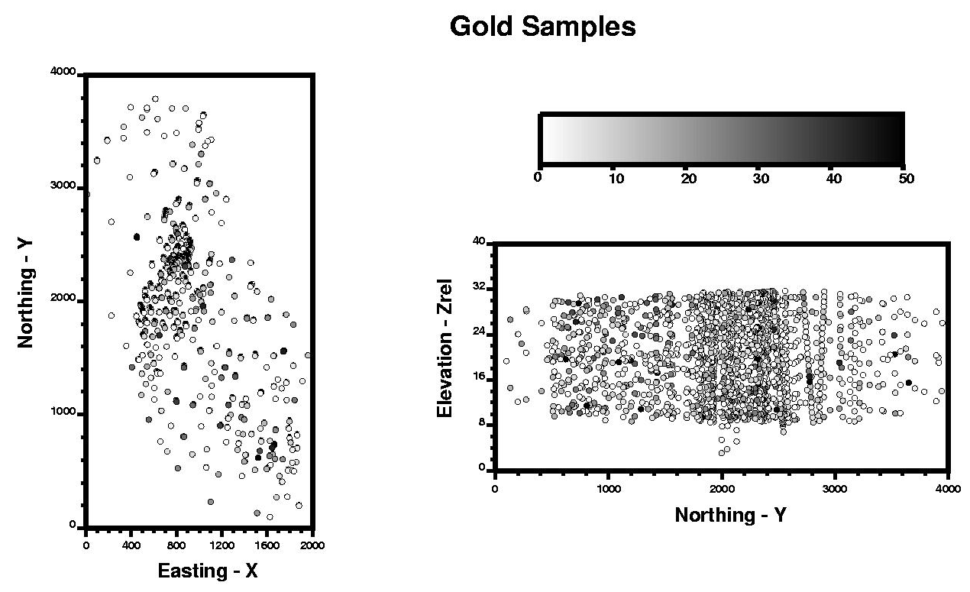
Figure 1 shows the location and grade of all the gold samples in plan and cross section (Zrel – Y) view. The study area spans 2000m in the X direction by 4000m in the Y direction by 40m in the Zrel direction. The vertical coordinate Zrel is distance from a reference plane; extents of Zrel in the geostatistical model are from 0 to 40m.

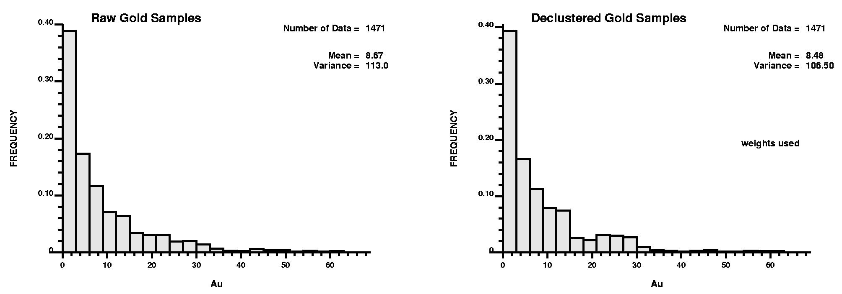
Figure 2 shows a histogram of gold grades. The distribution of raw gold grades is positively skewed, with a mean and variance of 8.67 and 113.0, respectively. [insignificant difference in mean and variance to bother commenting on declustering – suggestremove declustered histogram figure]
Figure 1: An X-Y plan view and Y-Zrel cross sectional view of the 1,471 gold assay locations in L1. The assays are also shaded according to gold grade.

Figure 2: The raw and declustered distribution of gold grades. The declustered distribution is the target distribution and has mean and variance parameters of 8.48 and 106.50, respectively.

Variography was performed using the normal score values of the raw gold grades. Experimental horizontal and vertical variograms are calculated and fitted with a final variogram model. Horizontal variography is direction-independent or omni-directional, that is, the variogram is virtually the same for all azimuth directions. Figure 3 illustrates the final 3-D variogram model fitted to the horizontal and vertical directions simultaneously.
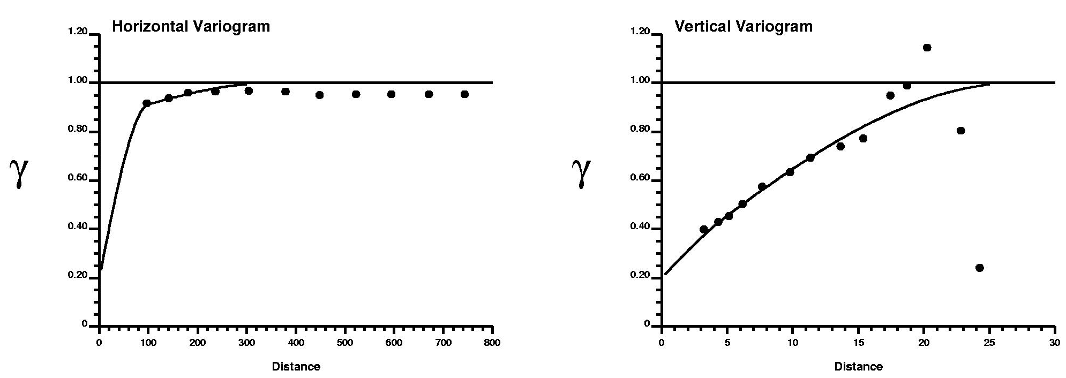

Figure 3: The horizontal and vertical gold variogram. The model variogram is shown as dark lines over top the calculated experimental points in the horizontal and vertical directions.

The gold grades are estimated using simple kriging and simulation. Both estimation algorithms use the 1,471 gold assays (Figure 1), the target distribution of gold (Figure 2), and the 3-D gold variogram model (Figure 3) [You use the norma score variogram for the kriging?] as conditioning information. For the simulation, 25 realizations were constructed at a fine scale then linearly averaged up to the stope scale. Figure 4 shows a central X-Y plan and a histogram of the gold grades for the simple kriging results and the first realization of the simulation. The histograms are plotted at the same scale as Figure 2 and the same grey scale in Figure 1 is used on the maps for easy comparison. Note, the kriged estimates are too smooth compared to the sample data. The variance of the kriged estimates is 5.43 versus the target 106.5. The simulated realizations correctly reproduce the target variability (102.41 versus 106.50, respectively).
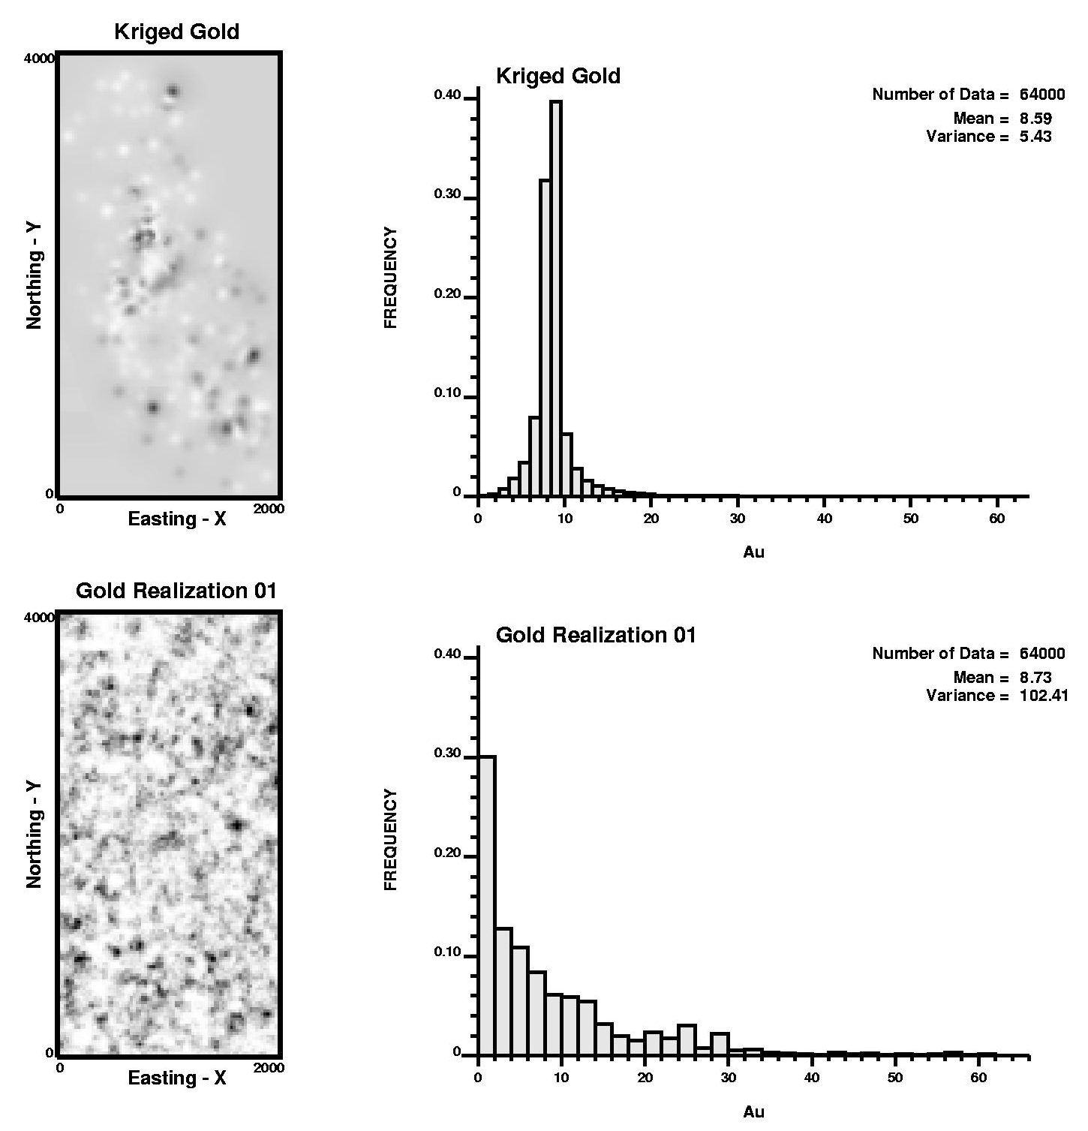
The 25 gold grade realizations and the kriged gold grade model are mapped to the stope outlines in the production schedule and the grades are averaged over each stope. For each time period the stopes scheduled to be extracted are identified and the tons and grades within these stopes are accumulated and charted. This is repeated for all 25 realizations and the kriged gold grade. A constant gold commodity price is assumed and the revenue is calculated as the product of recovered gold grade, tons and gold price. In this example the tons of ore in a stope does not vary, that is, the geometry of the designed stope is fixed.

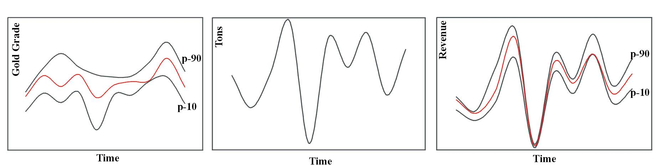
Figure 5 shows profiles of the estimated gold grade, tons and gross revenue with time. The gold grade profile curves are the geological uncertainty and the revenue profile curves are the production uncertainty. The simulation results are summarized with dark lines representing the p-90 and p-10 values where the probability of exceeding is 10% and 90%, respectively (For example, if there are 100 simulations for a single stope sorted by gold grade from highest to lowest, the gold grade for the 10th and 90th values in the sorted list). The kriging results are shown as shaded lines. Note, the kriged profile is always enclosed between the p-90 and the p-10 curves. Note that the p-90 and p-10 values are asymmetrically disposed about the kriged value, risk is not equally distributed. For example, the earlier stopes have a greater probability of having a lower grade that the kriged estimate, whilst at a later date the reverse occurs.
Figure 4: The distribution of gold grades is illustrated in an X-Y cross sectional view and histogram for the kriging and simulation scheme implementations.

The probability of exceeding or not attaining a particular revenue at a particular time is immediately attainable from the production uncertainty. For instance, the probability of exceeding the kriged grade at any time is equal to the proportion of simulated realizations that exceed the kriged revenue.
Figure 5: Geological uncertainty is the profile of possible gold grades with time (left) and production uncertainty is the profile of possible revenue forecasts (right). The transfer of geological to production uncertainty is made by multiplying grade, tons and gold price together.

Discussion and Conclusion
The revenue profiles generated in Figure 5 are important economic indicators of the project venture and can be utilized to assist mine planning development decisions. Areas of future concern such as extreme low grades at particular times are easily identifiable. Also, the timing and location of areas in the deposit with large uncertainty can be identified and investigated further. For example, specific stopes with higher uncertainty early in the mine life can be targeted and

additional drilling undertaken to allow improved mine planning decisions. The value of additional drilling is that it would reduce the uncertainty in gold grade and revenue. In terms of Figure 5, additional drilling would close the gap between the p-90 and p-10 gold grade and revenue curves. This improvement in mine planning must be balanced against the time and cost of acquiring more drillhole data. The methodology could easily be modified to quantify the reduction in geological and production uncertainty with additional drillhole data.

Whilst gold grade is a significant contributor to resource uncertainty, tons of ore in each stope are another uncertainty. The geometric uncertainty of the vein thickness and location could easily be incorporated by geostatistically modeling gold thickness and location using a similar methodology. The thickness would be multiplied by density and the stope area to calculate multiple realizations of the tonnage. Gold price is also not a constant over the project life as assumed in this study; rather; it prescribes to uncertain fluctuations that can also easily be incorporated into the revenue profile realizations. The result of incorporating such additional uncertainties will result in an inflation of the final production uncertainty.

Simulation is performed due to its ability to correctly reproduce the heterogeneity in the gold grade variable. The histogram and variogram parameters are reproduced in each simulation whereas they are not using kriging. Moreover, simulation provides access to joint uncertainty, that is, simulation provides a local distribution of possible gold grades for each stope in the model whereas kriging provides only one value. The uncertainty in the grades is represented by these local conditional distribution functions (ccdf’s) and can be used to calculate the uncertainty in production variables. For Pogo, the uncertainty in gross revenue forecasts is quantified based on the uncertainty in the gold grades.

Mine planning decisions with significant economic consequences are made based primarily on the project cash flow, and revenue forecasts are a significant component of the project cash flow. Moreover, the grade heterogeneity and uncertainty are directly linked to these revenue forecasts and their uncertainty. Geostatistical simulation can provide a process to quantify geological uncertainty in terms of cash flow that is useful for mine planning decisions.

Acknowledgements
This study was completed through cooperation between Teck – Pogo Inc. and the University of Alberta. The authors thank Teck Cominco Ltd. for publication permission.

References
Journel, A.G. and Huijbregts, Ch.J. (1978). Mining Geostatistics, Academic Press, New York.
Isaaks, E. and Davis, B. (1999). The Kriging Oxymoron: Conditionally Unbiased and Accurate Prediction, SME Annual Meeting, Denver, CO, 1999.

Rhys, D., DiMarchi, J., and Smith, M. (2003). Structural Setting, Style and Timing of Vein-Hosted Gold Mineralization at the Pogo Deposit, East Central Alaska. Mineralium Deposita 38: 863-875 (2003).
McLennan, J.A. and Deutsch, C.V. (2002). Conditional Non-Bias of Geostatistical Simulation for Estimation of Recoverable Reserves. Annual Canadian Institute of Mining and Metallurgy (CIM) Meeting, Vancouver, British Columbia, 2002.

Deutsch, C.V., and Journel, A.G. (1998). GSLIB: Geostatistical Software Library and User’s Guide, Oxford University Press, New York.

