Geostatistical Simulation of Optimum Mining Elevations for Nickel Laterite Deposits

J. A. McLennan (jam12@ualberta.ca), J. M. Ortiz (jmo1@ualberta.ca)
and C. V. Deutsch (cdeutsch@ualberta.ca)
University of Alberta, Edmonton, Alberta, CANADA

Abstract

Nickel laterite deposits are typically formed from tropically weathered mafic-ultramafic complexes. The resulting nickel concentration is found within soil horizons and is mineable with regular dozer units. At the time of mining, digging elevations are needed at selective mining units (SMUs) or representative dozer regions (RDRs). Moreover, for mine planning, the costs due to dilution and lost ore require mining elevations to be specified. A conditional simulation approach is used to calculate “optimum” RDR mining elevations. Multiple realizations of the ore base surface are simulated. For a single bottom surface realization, dilution and lost ore costs are calculated over the entire vertical extent of each RDR. The optimum mining elevation is the elevation where the lowest summed cost of “accepting dilution” and “wasting ore” occurs. The reported RDR dilution is the cost of mining the volume of waste located below the bottom surface and above the optimum mining elevation and the reported RDR lost ore is the cost of not mining the volume of ore above the bottom surface and below the optimum mining elevation. For all ore bottom surface realizations, optimum RDR mining elevations and their associated dilution and lost ore costs are calculated and compiled to represent production uncertainty.

Introduction
The purpose of a geostatistical study is to estimate and quantify uncertainty in future production parameters due to uncertainty in subsurface geological architecture and/or heterogeneity. Conditional simulation is becoming preferred over conventional estimation techniques such as kriging due to joint uncertainty quantification and improved heterogeneity characterization. Implementation and documentation of geostatistical workflows contribute to the credibility and use of conditional simulation for practical mine planning challenges. A typical nickel laterite ore bottom surface is uncertain; this architectural uncertainty can be transferred to uncertainty in production parameters such as mining elevations, dilution and lost ore.

Uncertainty is an inherent aspect in estimation and mine planning. Geological architecture and heterogeneity between drillhole samples is impossible to predict exactly. Conditional simulation allows alternative geological realizations to be created. Each realization honors the conditioning data values at their locations. The fluctuation from realization to realization is a measure of geological uncertainty, and this uncertainty can be transferred into uncertainty in mine planning parameters. This production uncertainty is then used to make various production decisions.

Nickel laterite deposits are the result of semi-tropical to tropical surface weathering of mafic to ultramafic host rock containing minor nickel mineralization, Kenyon (2002). The nickel is typically leached and found concentrated within a lower grade limonite soil horizon and at further depths within a higher grade saprolite horizon, see Figure 1. At elevations lower than the saprolite region, the nickel grades quickly decrease within a dunitic to peridotitic unweathered fresh rock mass.

Small mining equipment is available and typically used in nickel laterite settings making selectivity excellent. A typical dozer blade unit, for example, is sufficient for moving loose nickel laterite soil material containing nickel mineralization. In this context, the reference to a selective mining unit (SMU) can be changed to a representative dozer region (RDR). Mine plans for nickel laterite deposits feature RDR mining elevations and the associated dilution and lost ore costs; since selectivity is exceptionally good, dozer operators could indeed dig at prescribed RDR mining elevations with good accuracy and precision.
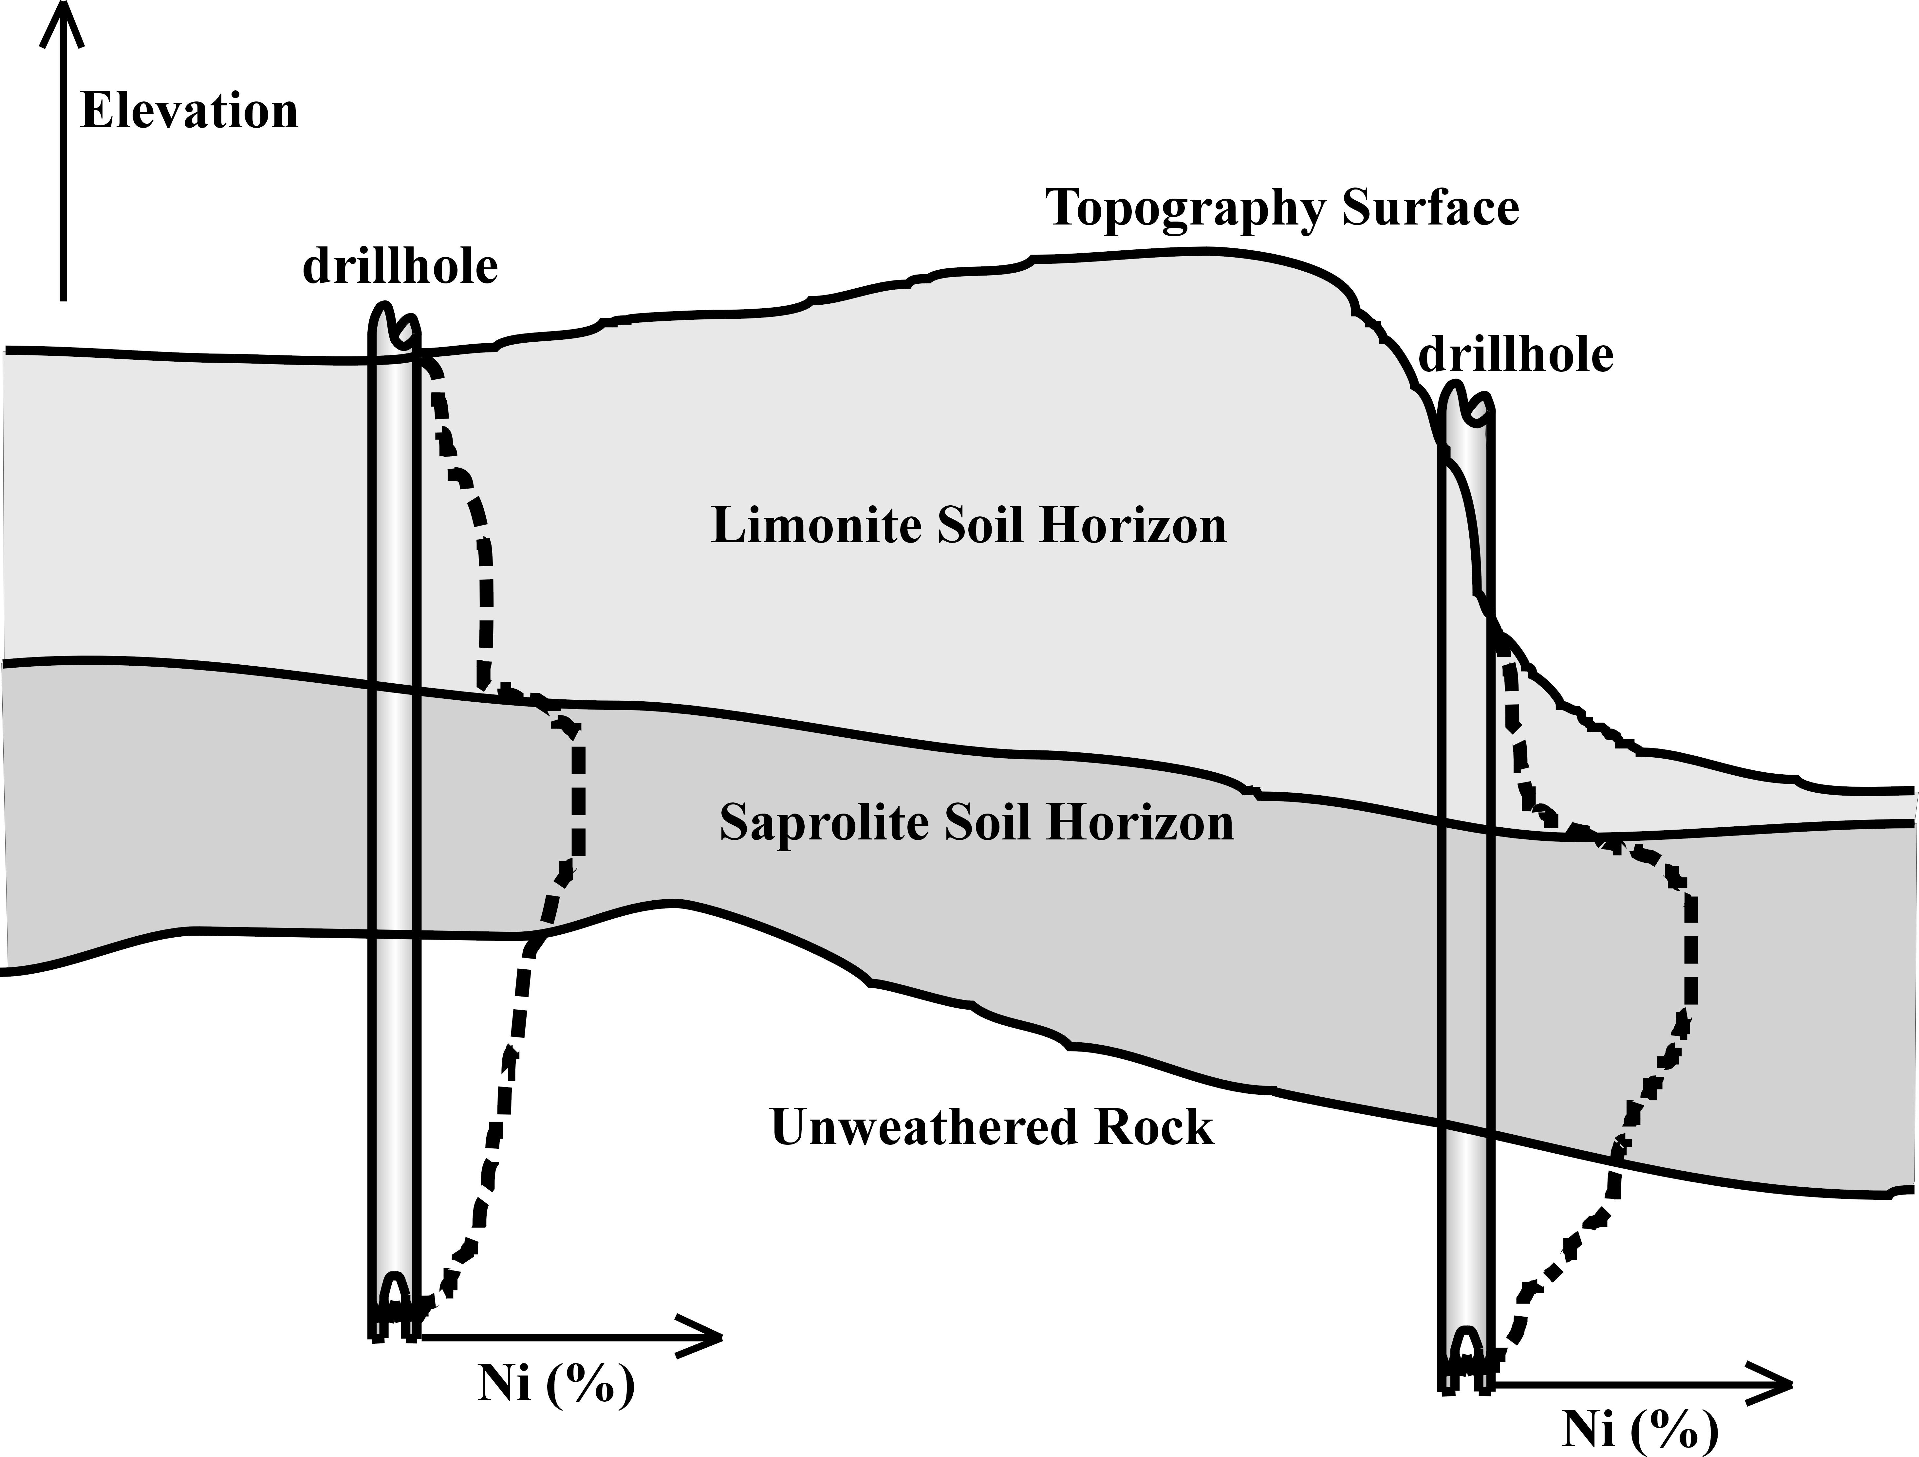
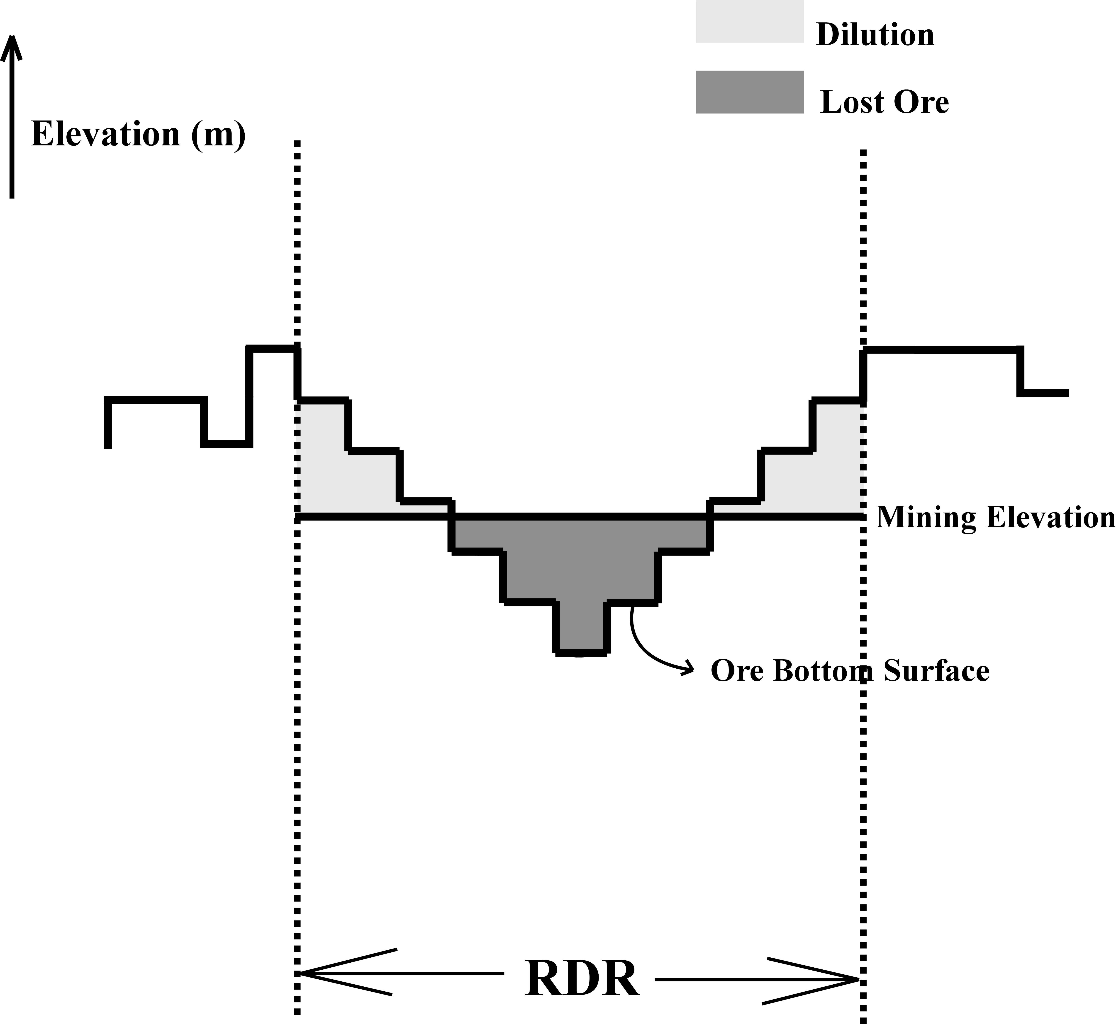
Dilution and lost ore forecasts are important mine planning parameters. Dilution is waste sent to the mill and lost ore is ore sent to the waste dump, Norrena (2000) and Deutsch. Both depend on the mining elevation, see Figure 2. For an ore bottom surface and mining elevation within a particular RDR, the dilution volume is located below the ore bottom surface and above the mining elevation and the lost ore volume is located above the ore bottom surface and below the mining elevation.
Traditional mine planning is based on maps of estimated geological attributes, which are often a smoothed and biased image of the attribute’s true distribution, Journel (2002) and Kyriakidis. Mining elevations are often hand contoured by professionals using smooth attribute maps, rock type information and cutoff grades. Hand contouring for digging elevations is sub-optimal. Quantitative geological heterogeneity is not easily accounted for, equipment limitations are hard to incorporate and additional information such as grade control blastholes cannot easily be incorporated since the process is non-repeatable. Recoverable reserves are often adjusted according to dilution and lost ore factors imposed during the feasibility stages or at the time of mining. Dilution and lost ore estimates are traditionally performed in retrospect to ensure agreement between mill feed and recoverable reserves, Sinclair (2002) and Blackwell.
Figure 2 – An example of dilution and lost ore for a mining elevation within a particular RDR.
Figure 1 – Cross section through a typical nickel laterite deposit showing soil horizons and example Ni grade profiles.

There is no reason to accept notional hand contoured digging elevations or retrospective dilution and lost ore costs. We would rather spend the increased computational effort and professional time to calculate optimum mining elevations based on simultaneously minimizing dilution and lost ore costs. This paper presents how optimum mining elevations can be derived from geostatistical simulation. The conditional simulation procedure accounts for the right geological heterogeneity and the process is repeatable with additional grade control and/or equipment limitation data.

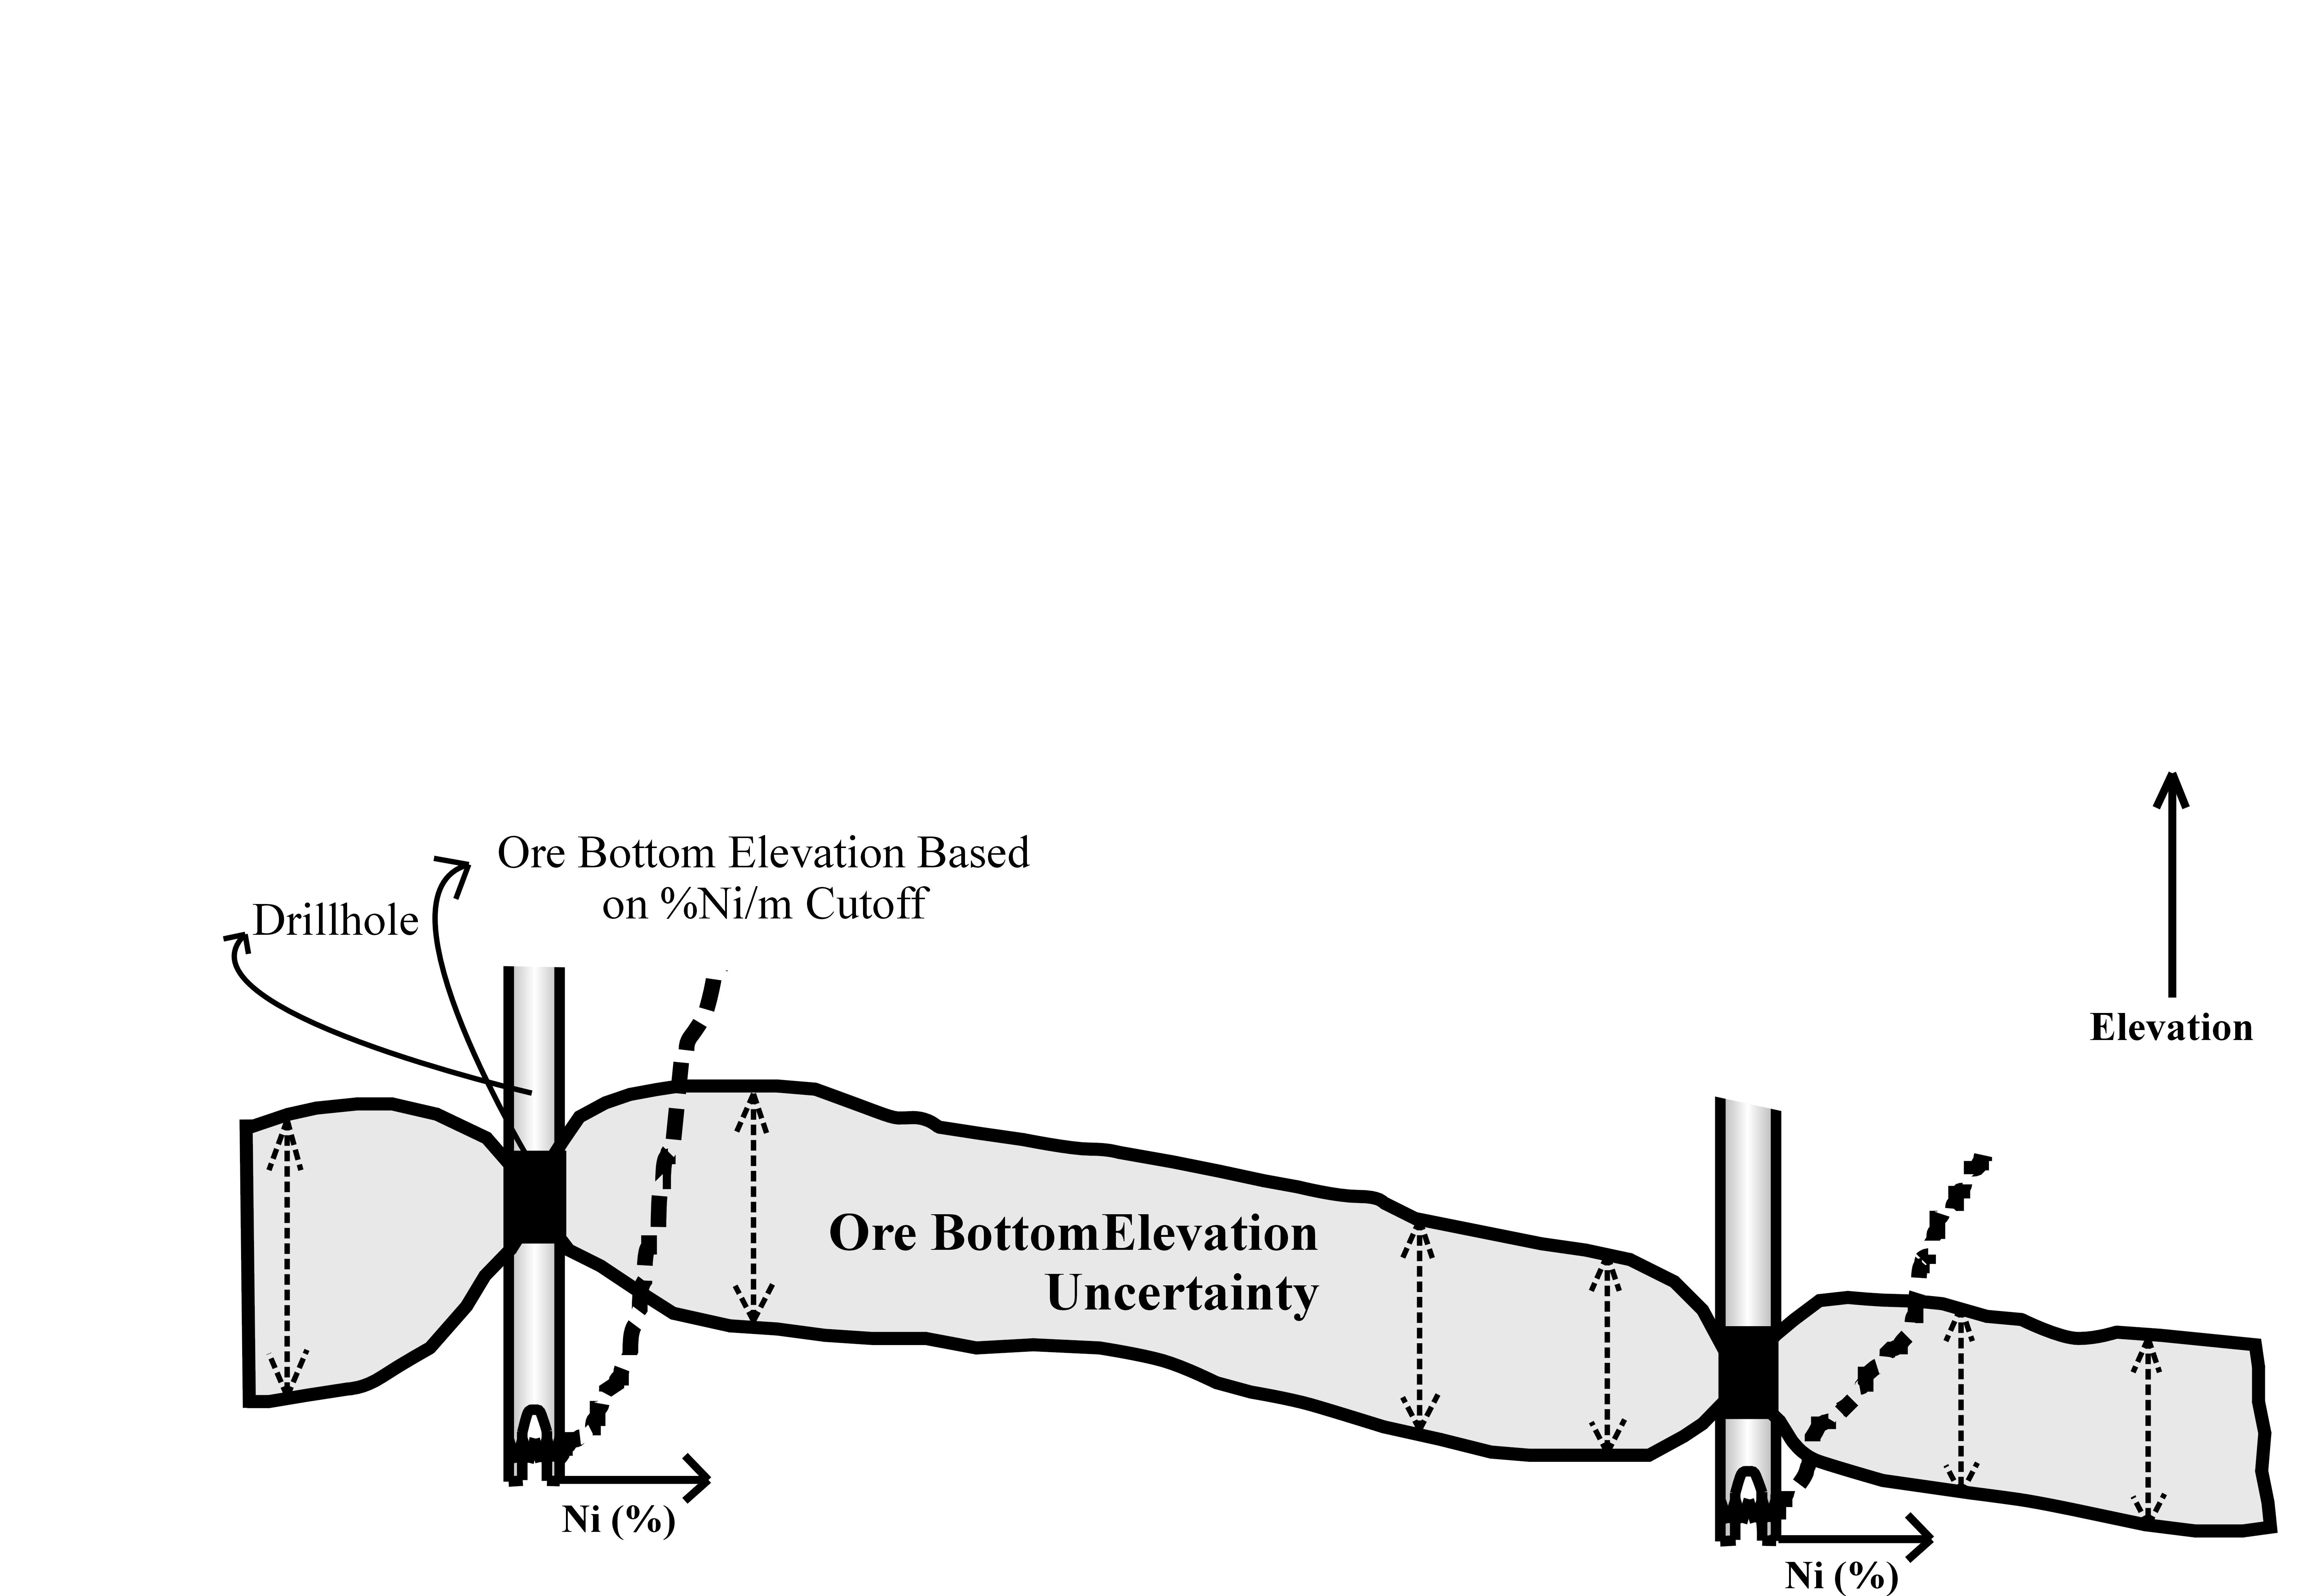
At least one ore bottom surface is needed for calculating optimum RDR mining elevations, dilution costs and lost ore costs. An ore/waste contact, usually based on a %Ni/m cutoff grade, defines the ore bottom surface at the drillhole locations, see Figure 3. Between drillholes, however, there is uncertainty in the bottom surface. Multiple geostatistical ore bottom surface realizations conditional to the drillhole ore/waste contacts are simulated and the final spread of the realizations quantifies the architectural uncertainty. An example of the upper and lower bounds of ore bottom surface realizations is also shown in Figure 3. This geological uncertainty is then transferred to production uncertainty.
Figure 3 – An example of the spread of possible ore bottom surfaces. It represents geological or architectural uncertainty.
Geological uncertainty is transferred into production uncertainty using a transfer function. The input is the geological uncertainty, which is the multiple architectural and/or geological property variable realizations, and the output is the production uncertainty, which is the multiple production parameter realizations. For mining applications, the transfer function is often a “proven-probable” scheme reserve classification (for petroleum applications, the transfer function is often flow simulation). For this paper, the transfer function is an optimization program that calculates optimum mining elevations based on minimum dilution and lost ore costs at each RDR location.

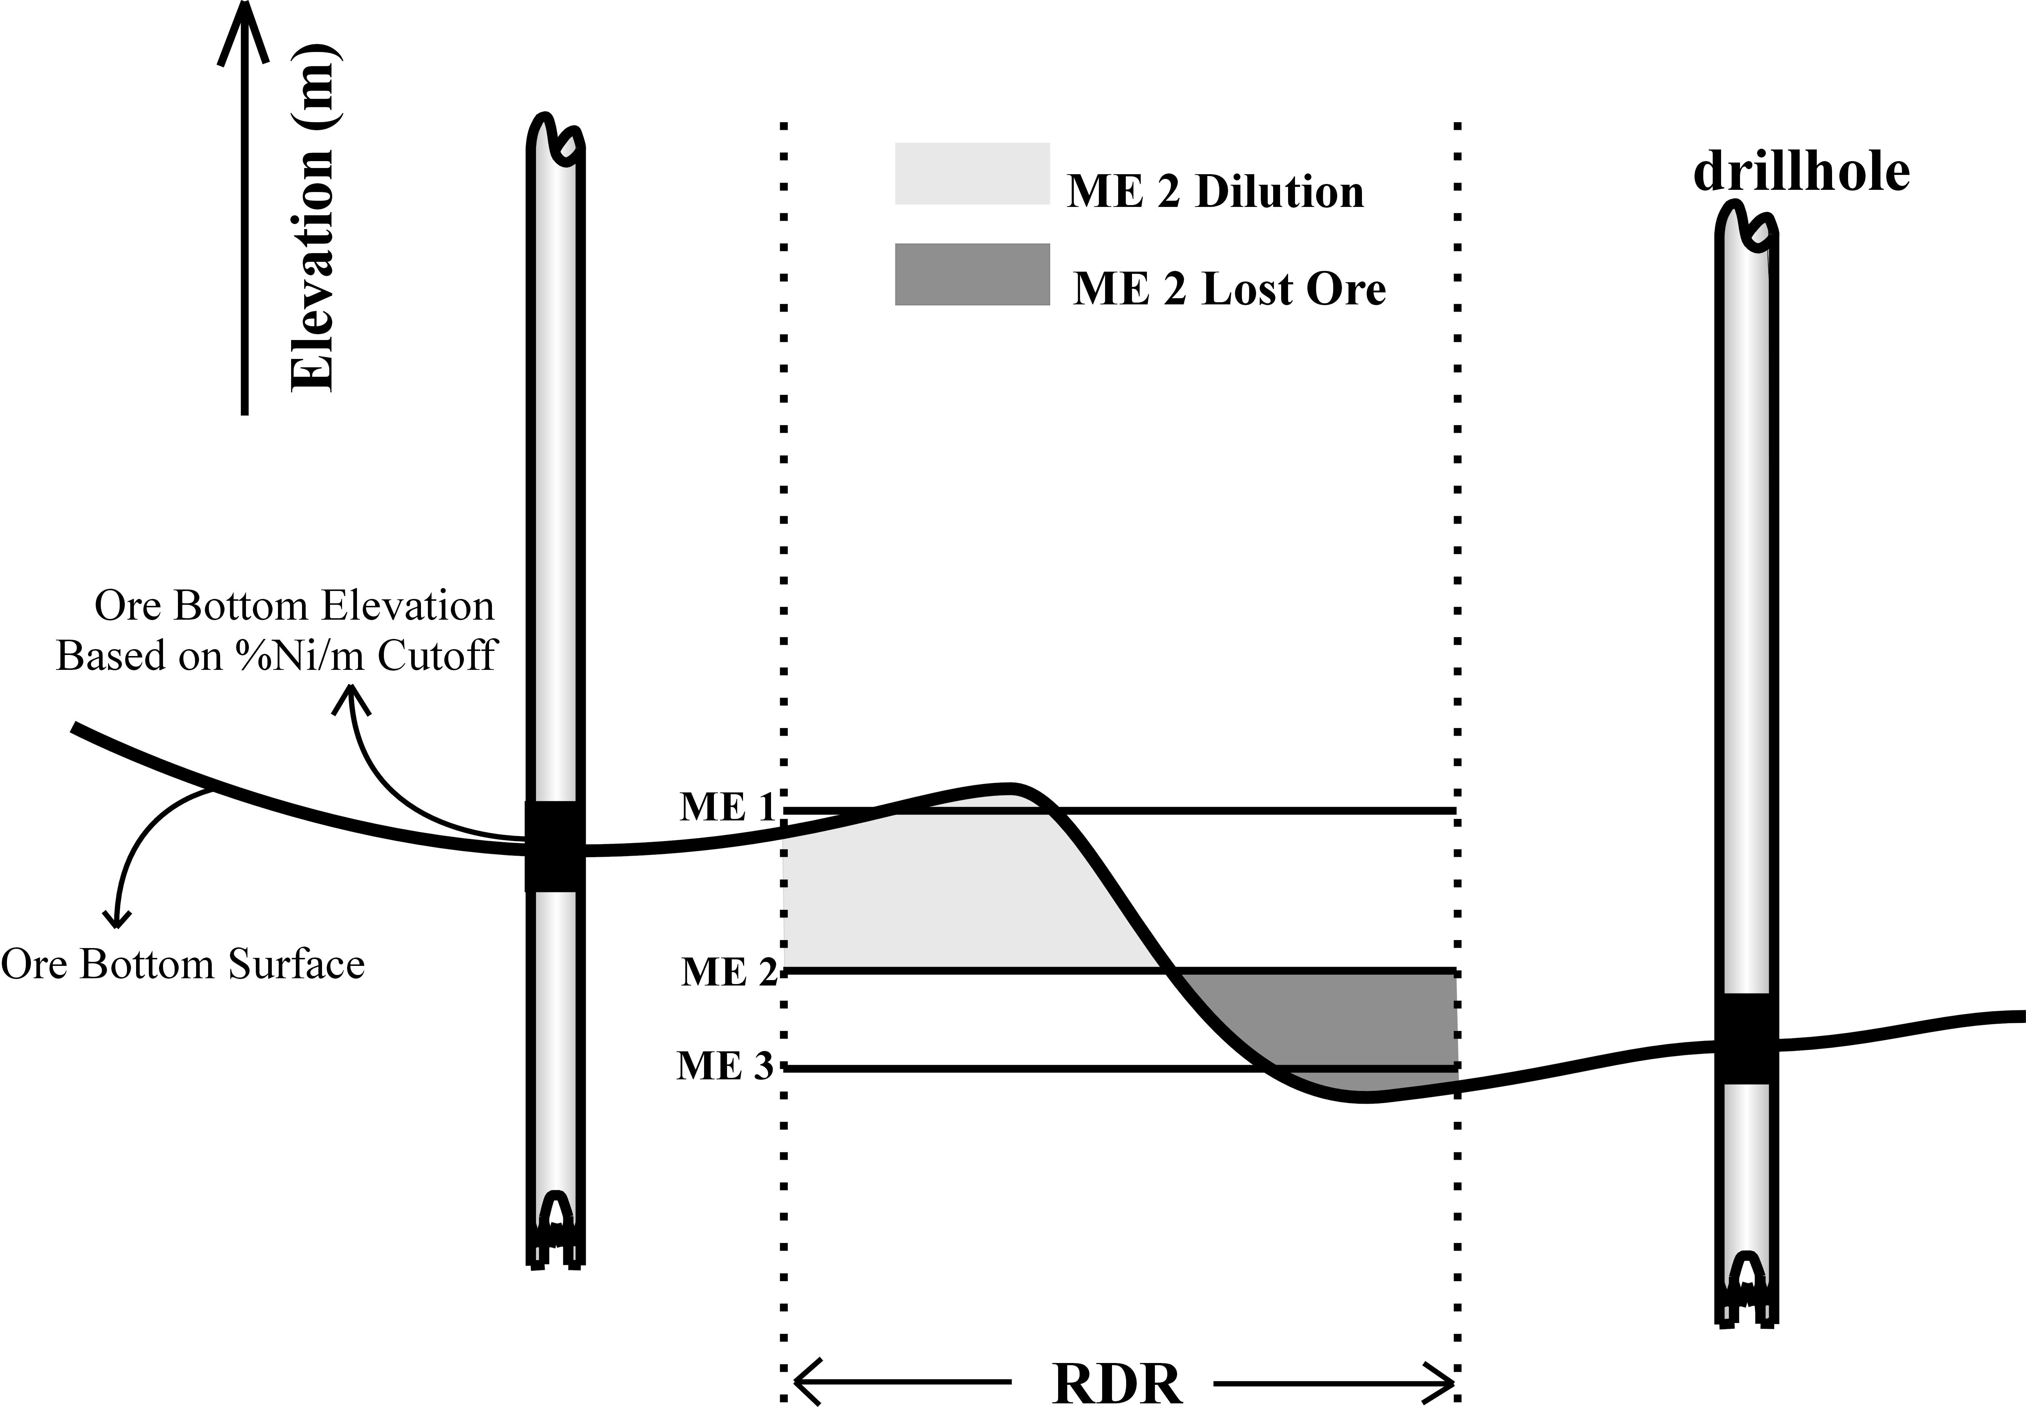
A small example has been constructed to illustrate the optimization transfer function. We will assume the cost of dilution and the cost of lost ore in $/t units is equal, that is, processing a ton of waste costs the same as the loss due to not mining a ton of ore. A single ore bottom surface realization conditional to the ore/waste contacts at the drillholes is shown in Figure 4. An RDR is outlined with broken lines within which three possible mining elevation (ME) values are considered: ME 1, ME 2 and ME 3. The dilution and lost ore volumes are calculated for each ME. Since dilution and lost ore costs are equal, the optimum mining elevation is the one with the lowest dilution and ore volume combined. Compared to ME 1, ME 2 has a lower lost ore cost and compared to ME 3, ME 2 has a lower dilution cost; therefore, ME 2 is the optimum mining elevation (OME). The dilution and lost ore volume for ME 2 are shaded in Figure 4. In practice, all possible ME values should be considered, the OME, dilution and lost ore costs should be the expected value over multiple realizations and the cost of dilution and lost ore will not be equal.
Figure 4 – An example of the optimization procedure for a single RDR and single ore bottom realization. The optimum mining elevation (OME) is ME 2.

This paper documents a conditional simulation procedure to calculate optimum RDR mining elevations. Several ore bottom surfaces are simulated to represent architectural uncertainty. These are used via the optimization transfer function, to calculate multiple realizations of the OME and associated dilution and lost ore costs at each RDR location. The OME, dilution and lost ore cost is the expected value of the realizations. The spread of the realizations represents production uncertainty and can be used for mine planning.

Methodology
The basic idea is to doze at the RDR elevations where the combined costs of dilution and lost ore are a minimum. The elevation at which this minimum criteria occurs is referred to as the optimum mining elevation (OME). The dilution and lost ore costs are then used for mine planning and production uncertainty characterization. There are two main phases to the methodology: (1) simulation of the ore bottom surface conditional to ore/waste contacts, and (2) post processing the ore bottom surface realizations via the optimization transfer function for optimum mining elevations and dilution and lost ore costs at each RDR location.

The first phase of the methodology is building multiple realizations of the ore bottom surface using geostatistical simulation. There are several preliminary topics to deal with prior to implementing the simulation. Due care should be given to stationarity, representative statistics, trends, variography, grid definition and any other case-specific preliminary investigations. A nickel cutoff grade, usually in %Ni/m, defines the ore bottom elevations at the drillholes, which are the conditioning data for simulation.

There is often a trend in the ore bottom surface, that is, the tropical weathering and leaching mechanisms mineralize a nickel laterite so that the surface topography elevations and ore bottom elevations are well correlated. A common approach to account for a variable trend is to decompose the variable into a smooth deterministic function and a more variable residual portion. In this situation, the ore bottom elevation variable is decomposed into the well known surface elevation and the more variable thickness component (ore bottom elevation = surface elevation – thickness). Thickness is stochastically modeled and subtracted from the surface elevations for the ore bottom surface elevations.

Thickness variograms for a nickel laterite deposit can exhibit a significant nugget effect. The vertical leaching process can vary significantly at a scale smaller than the grid definition, that is, a column of leached concentrated nickel can exist less than 5m away from a column of waste where leaching could not occur.

Since there is uncertainty in the ore bottom surface, there will be uncertainty in the optimum mining elevations, dilution and lost ore. The second phase of the methodology involves transferring the multiple ore bottom surfaces to multiple optimum mining elevation, dilution cost and lost ore cost realizations at each RDR location using the optimization transfer function.

A GSLIB compatible program called RDR.exe is created to calculate the optimum mining elevations and the associated dilution and lost ore costs. The main inputs are the ore bottom surface realizations and the cost of dilution C_{dil} relative to the cost of lost ore C_{lo} in $/t. For a particular RDR, the optimum mining elevation is at the elevation where the ratio between the tons of lost ore T_{lo} and the tons of dilution T_{dil}, $\frac{T_{\text{lo}}}{T_{\text{dil}}}$ is equal to the cost ratio, $\frac{C_{\text{dil}}}{C_{\text{lo}}}$, that is, where $\frac{T_{\text{lo}}}{T_{\text{dil}}}=\frac{C_{\text{dil}}}{C_{\text{lo}}}$. The program is created so that several approaches could be taken:

- Single vs. multiple ore bottom surface realizations. One or multiple ore bottom surface realizations can be input. The advantage of inputting multiple geostatistical ore bottom realizations is access to the dilution and lost ore uncertainty given the architectural uncertainty.

- Global vs. multiple RDR dilution-lost ore cost ratios. A global cost ratio $\frac{C_{\text{dil}}}{C_{\text{lo}}}$ or a 2-Dimensional variable cost ratio $\frac{C_{\text{dil}}(X,Y)}{C_{\text{lo}}(X,Y)}$, where (X, Y) defines the 2-D location, can be used. The variable cost ratio is useful when there areas that require significantly more or less than average resources to mine waste and the D_{cost} increases or decreases, respectively, or where the nickel grade is significantly higher or lower than average and LO_{cost} increases or decreases, respectively. The dilution and lost ore costs could be calculated based on a function of grade and/or processing costs. One or multiple realizations of the cost ratio can be used for the optimization.

- Multiple 3-Dimensional grade models. A final approach to the optimization problem is to consider a 3-D simulated cost ratio $\frac{C_{\text{dil}}(X,Y,Z)}{C_{\text{lo}}(X,Y,Z)}$ model. Multiple realizations can be created based on multiple 3-D grade realizations and/or processing cost realizations.

The program requires the ore bottom surface realizations. Each realization honors the ore/waste contacts, that is, the simulated ore bottom elevation is exactly the same as the sample data. It also honors the spatial continuity or variogram between contacts. For the first bottom surface realization, the program discretizes the vertical extent of the first RDR into a series of uniformly distributed elevations. For each elevation, the tonnage of dilution (material above the current elevation, but below the simulated ore bottom surface) and tonnage of lost ore (material below the current elevation, but above the simulated ore bottom surface) are calculated and a total monetary loss is computed according to the input cost ratio. The total loss at each increment is the sum of the product of the dilution tons and dilution cost and the product of the lost ore tons and lost ore cost:
$\text{Total} \text{Loss}=T_{\text{dil}}⋅C_{\text{dil}}+T_{\text{lo}}⋅C_{\text{lo}}$

The optimum mining elevation (OME) for this RDR is the elevation increment with the lowest total cost and where the dilution to lost ore cost ratio is equal to the lost ore to dilution tonnage ratio. The OME, and the dilution and lost ore costs associated with the OME are output for mine planning. The process is repeated for all RDRs in the model and then for every ore bottom surface realization in the model. The OME, dilution cost and lost ore cost are averaged over all realizations to obtain the expected OME, dilution cost and lost ore cost.

For example, if $\frac{C_{\text{dil}}}{C_{\text{lo}}}=1$, that is, mining a ton of dilution incurs the same $/t cost as not mining a ton of ore, the optimum mining elevation for a particular RDR is the elevation increment where the tons of dilution is equal to the tons of lost ore. However, it is rare the cost ratio is 1. The cost of lost ore is almost always more than dilution. Typical $\frac{C_{\text{dil}}}{C_{\text{lo}}}$ ratios range from 0.25 to 0.75. If $\frac{C_{\text{dil}}}{C_{\text{lo}}}=0\text{.}\text{25}$, the OME is deeper than if it were 1, because it is more profitable to dig lower for ore and incur the dilution costs until the dilution tonnage is equal to 4 times the lost ore tonnage or $\frac{T_{\text{lo}}}{T_{\text{dil}}}=4$.

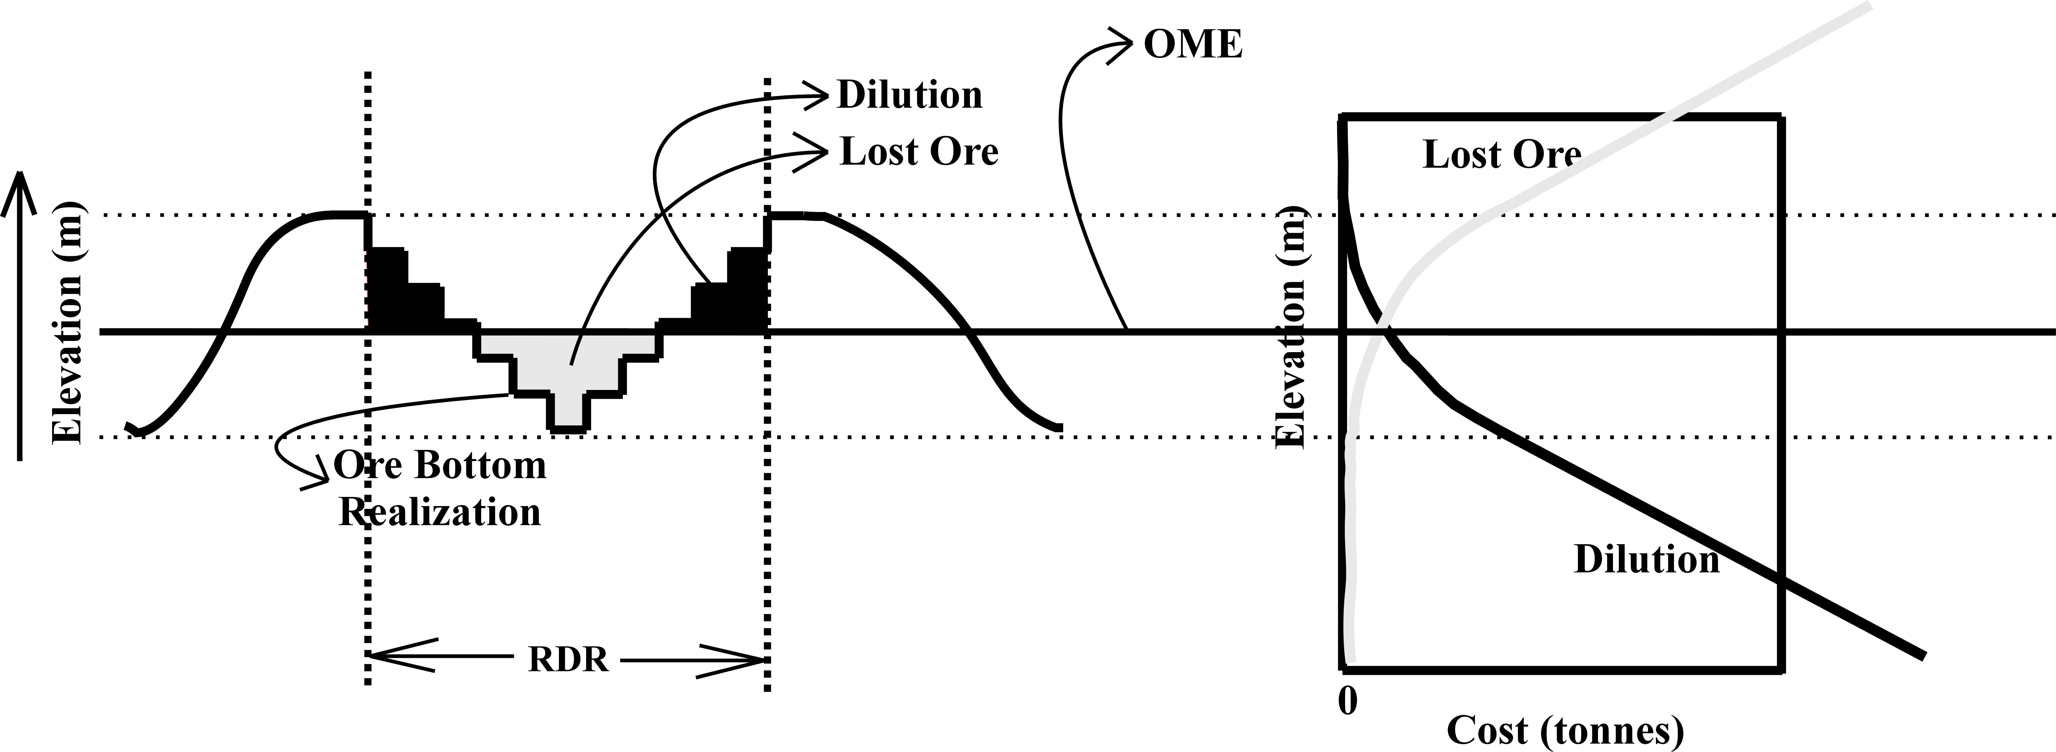
Figure 5 illustrates an example of the optimization procedure for one RDR based on a single ore bottom surface realization. The RDR is much larger than the block size used to model the ore bottom surface; therefore, a single ore bottom surface realization will fluctuate within any RDR. At each incremented elevation, the tonnage of waste material mined or dilution and the tonnage of ore material not mined or lost ore cost are both calculated. These cost curves are plotted to the right. When the mining elevation is decreasing in pure waste, the cost of dilution increases linearly and the cost of lost ore is constant at zero; when the mining elevation is decreasing in pure ore, the cost of lost ore decreases linearly and dilution is constant at zero. As the mining elevation decreases within mixed ore and waste material, dilution increases and lost ore decreases non-linearly. Figure 5 shows the OME and the associated dilution and lost ore tonnages for a cost ratio equal to 1.
Figure 5 – An example of the elevation increment vs. dilution and lost ore for a single ore bottom realization within an RDR. The OME is based on a dilution to lost ore cost ratio of 1 to 1.

When optimizing the mining elevations based on multiple ore bottom realizations, one ore bottom surface realization at a time is input into the program to get one realization of the optimum mining elevation, dilution and lost ore parameters. These parameters are then averaged to get the “expected” optimum mining elevations, dilution costs and lost ore costs at the each RDR in the model.

An Example
The conditioning drillhole data and spatial structure in this example are synthetic; however, the proposed approach is the same with real data. All work is done in the GSLIB environment, which uses ASCII format input/output files. All units are in meters (m). Thickness is the geostatistical variable modeled.

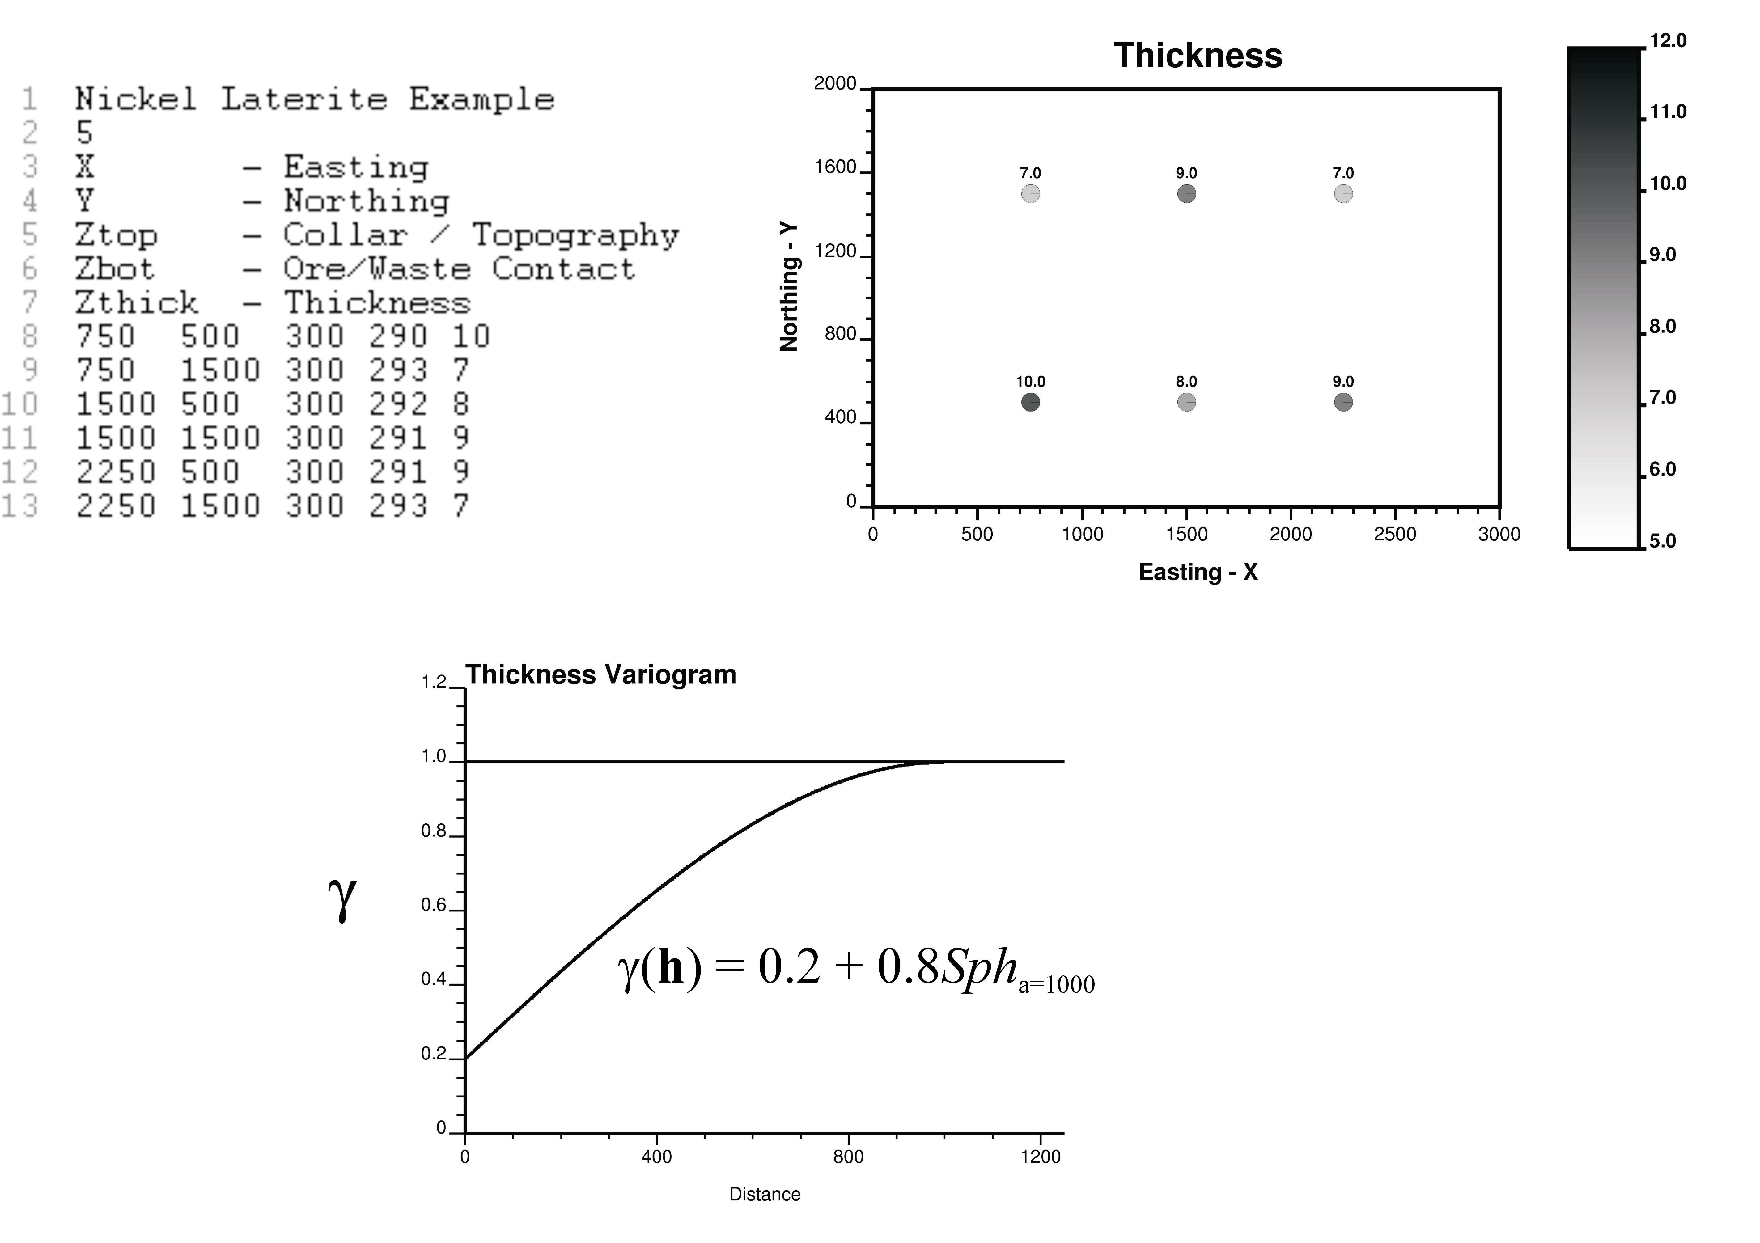
The study area is 3000m in the Easting direction and 2000m in the Northing direction. There are 6 conditioning drillholes available, each with an Easting (X), Northing (Y), collar/topography elevation (Ztop), ore/waste contact elevation (Zbot) and thickness (Zthick = Ztop – Zbot) value. Figure 6 shows the ASCII drillhole file, a location map and a variogram of the thickness values. The variogram used is a single spherical structure with an isotropic range of 1000m and a relative nugget effect of 20%. The topography is assumed constant at 300m.

Using the 6 conditioning thickness values and the thickness variogram, sequential Gaussian simulation is used to simulate 100 realizations of thickness on square grid cells measuring 10m a side. Each grid value from each thickness realization is then subtracted from the topography (300m) to get a set of 100 corresponding ore bottom elevation realizations, see Figure 7. The average thickness and average ore bottom elevations are also shown in Figure 2. The 50th realization is shown on top.
Figure 6 – The ASCII data file, location map and variogram of thickness values used for the example.

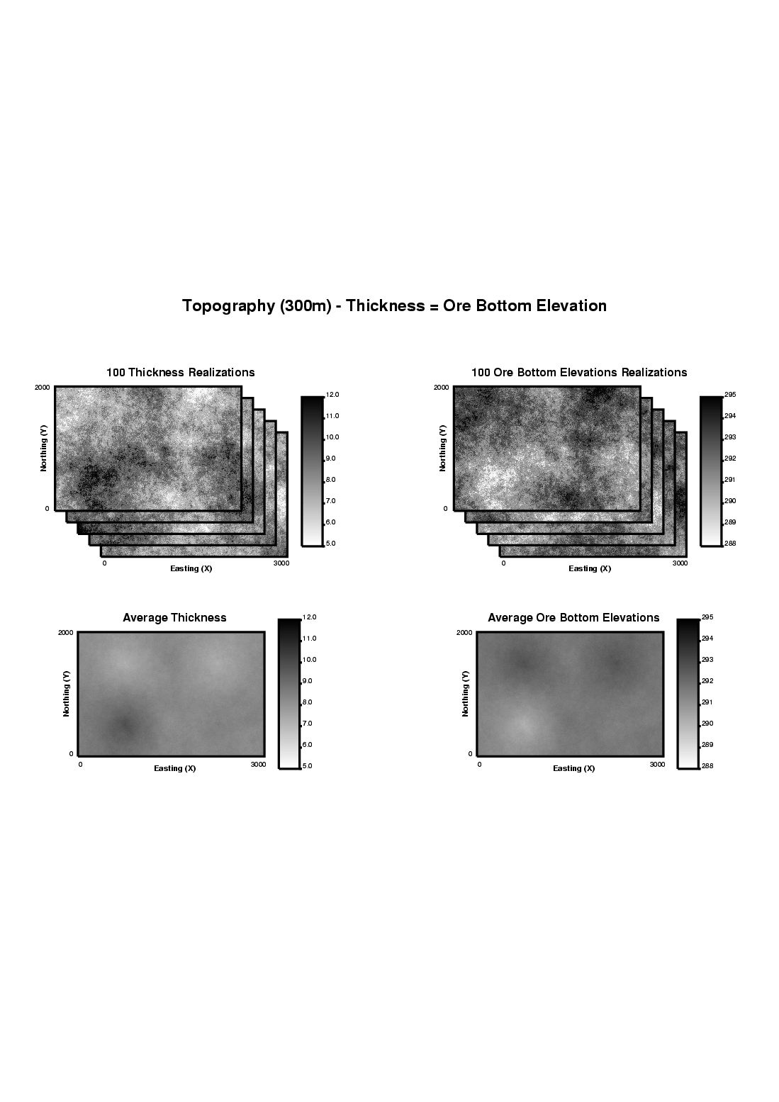
Application to real data should include an exploratory data analysis, declustering and debiasing analysis and full variography study prior to conditional simulation implementation.

The 100 possible ore bottom surfaces are now input into the GSLIB environment program “RDR.exe” to calculate the optimum mining elevations and the associated dilution and lost ore costs. Leaving ore is assumed to be three times more expensive than mining waste. A specific gravity of 1.3 is used. The elevations checked range from 285m to 300m at increments of 0.05m. A representative dozer region spanning 100m (10 simulation blocks) in the X direction and 50m (5 simulation blocks) in the Y direction is used.
Figure 7 – The 100 thickness realizations and corresponding ore bottom surface realizations (topography – thickness) as well as the average thickness and ore bottom surface maps.

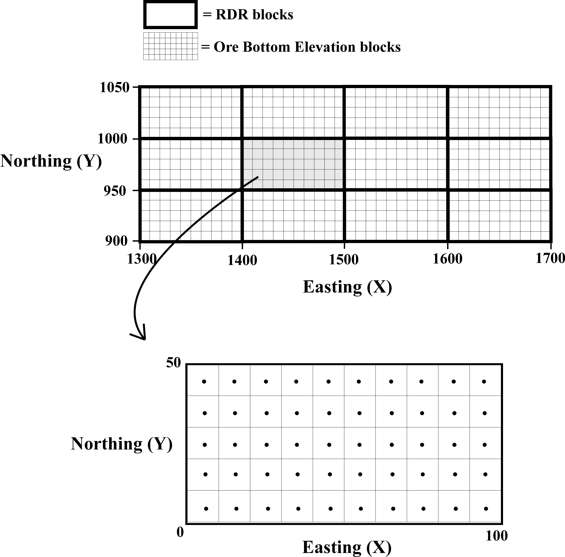
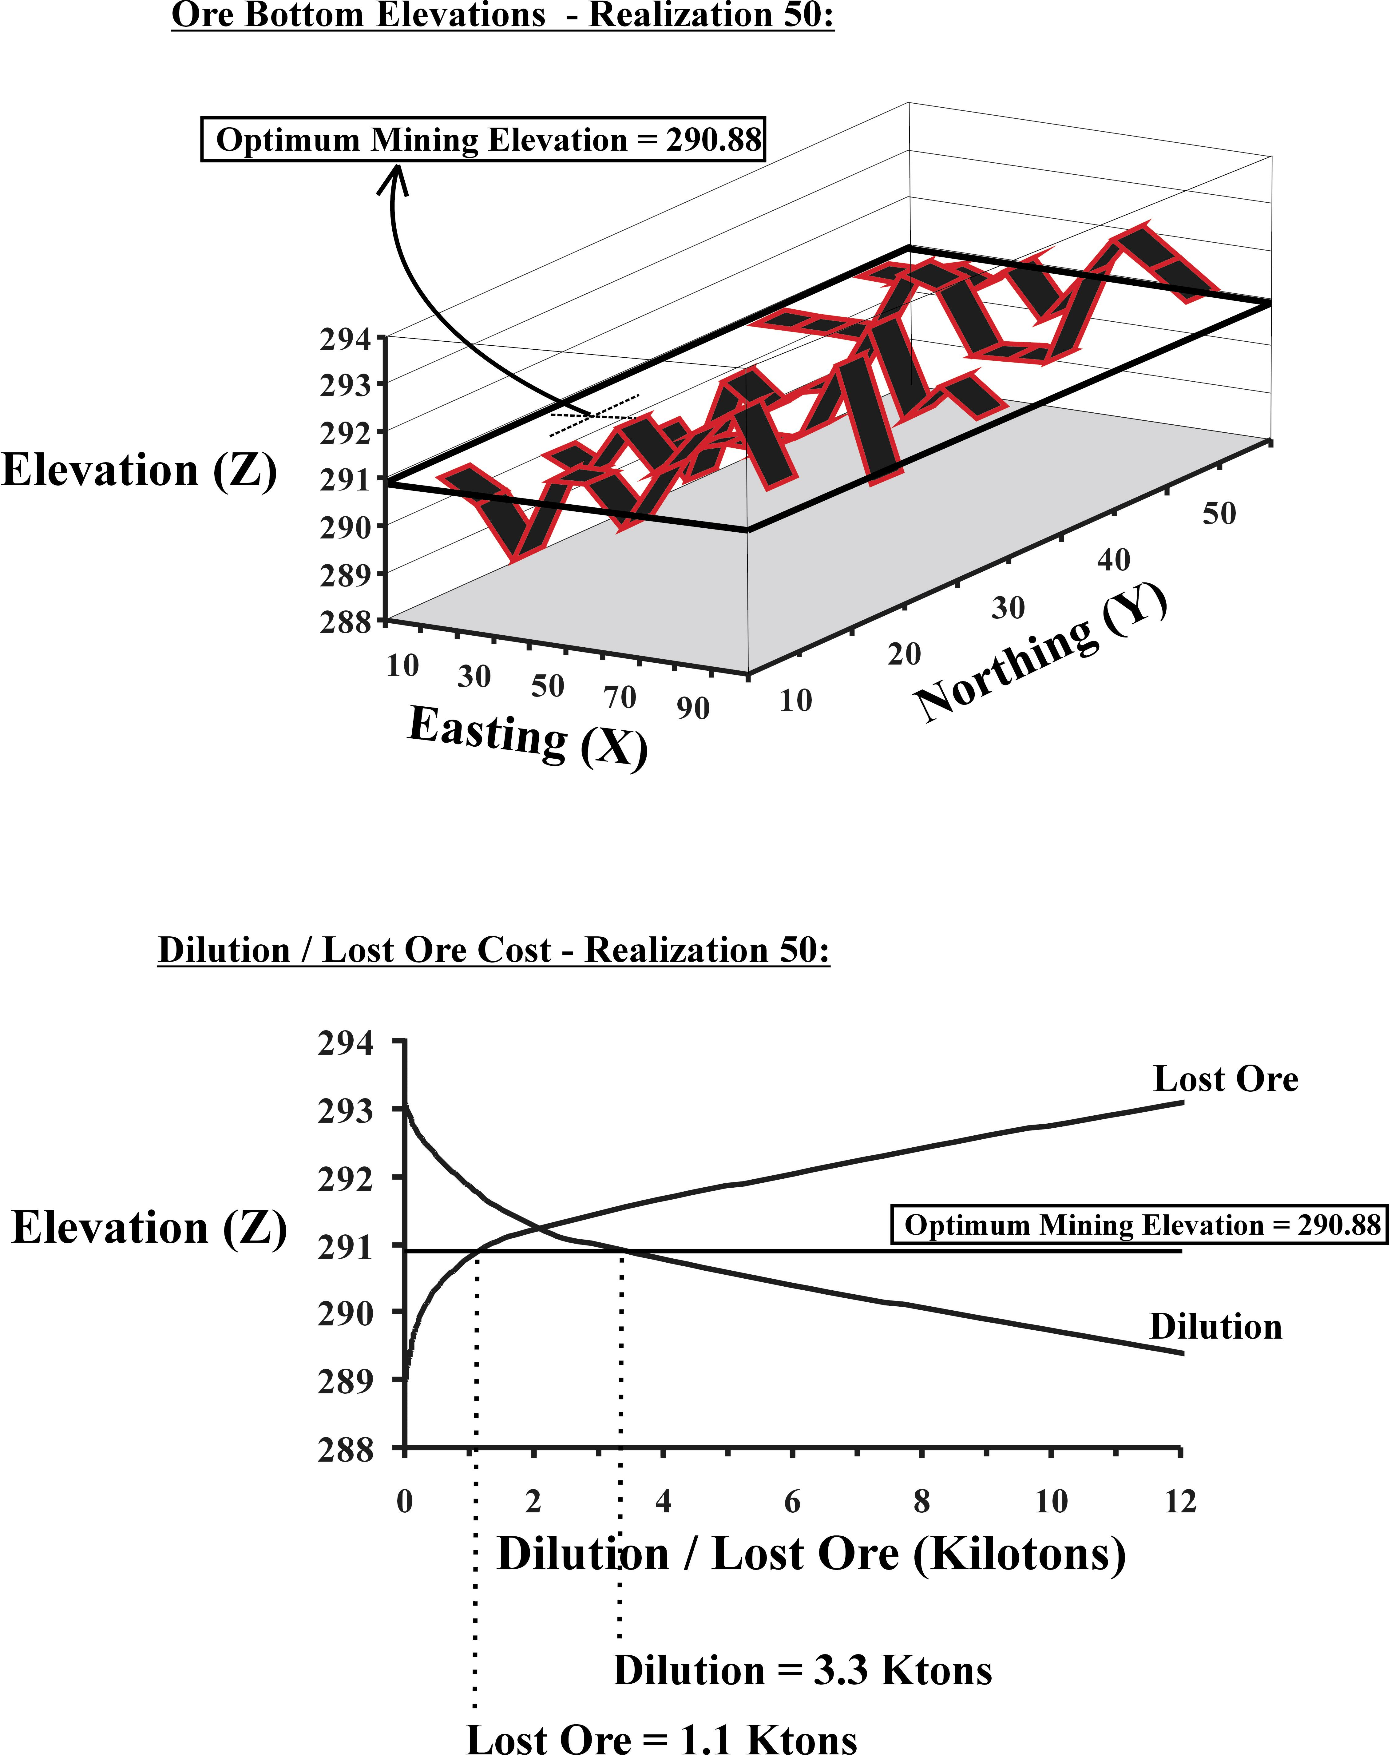
One particular RDR region is chosen for detailed investigation, see Figure 8. The ore bottom elevation realizations and dilution and lost ore costs are extracted for this RDR. The RDR chosen is the 15th RDR in the X direction and the 20th RDR in the Y direction and spans 1400 to 1500 in the X direction and 950 to 1000 in the Y direction. For the 50th realization, Figure 9 shows a 3-D view of the ore bottom elevations within the extracted RDR location. Below this, the dilution and lost ore volumes (converted to kilotons) are shown for all elevation increments. The optimum mining elevation, where the tons of dilution are three times the tons of lost ore is at 290.88m. The associated dilution and lost ore costs are 3.3 and 1.1 Ktons, respectively. Figure 10 shows the expected results over all the realizations. The optimum mining elevation and associated dilution and lost ore given all realizations are 291.23m, 4.8 and 1.6 Ktons, respectively. The same results are available at every other RDR.
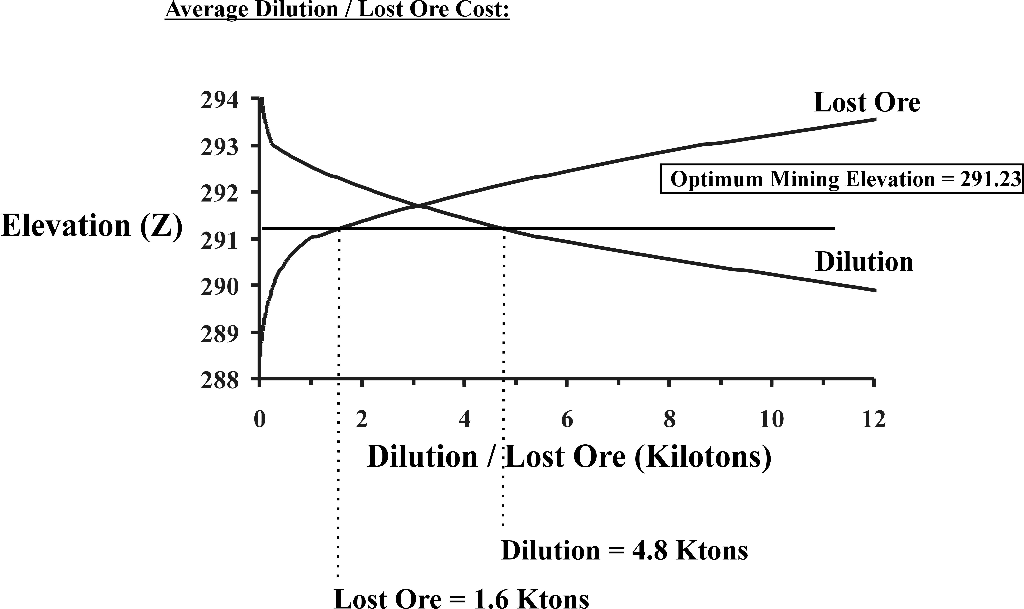
Figure 11 shows the expected optimum mining elevation, dilution and lost ore results. Maps are shown to the left and histograms of the values in the maps are shown to the right. To represent uncertainty in dilution and lost ore, the probability to be within 10% of the average is calculated and shown in Figure 12.
Figure 8 – The extracted RDR for detailed investigation in the example.
Figure 9 – The ore bottom elevations and dilution and lost ore costs associated with the optimum mining elevation are shown for the 50th realization of the extracted RDR.

Discussion
During mining, additional information beyond the information available at the time of the simulation study will be available. Grade control should be used to update the optimum mining elevations and expected dilution and lost ore costs. During the feasibility stages, to mimic the information available at the time of mining, one ore bottom surface realization at a time is used to find optimum mining elevations. This is because there is really only one realization of the ore bottom surface, which are the elevations that were already mined at. As additional information becomes available at the time of mining, estimation of the ore bottom surface realizations and of the optimum mining elevations will improve and the expected dilution and lost ore costs will decrease.
Figure 10 – The dilution and lost ore costs associated with the optimum mining elevation given all 100 realizations of the extracted RDR.
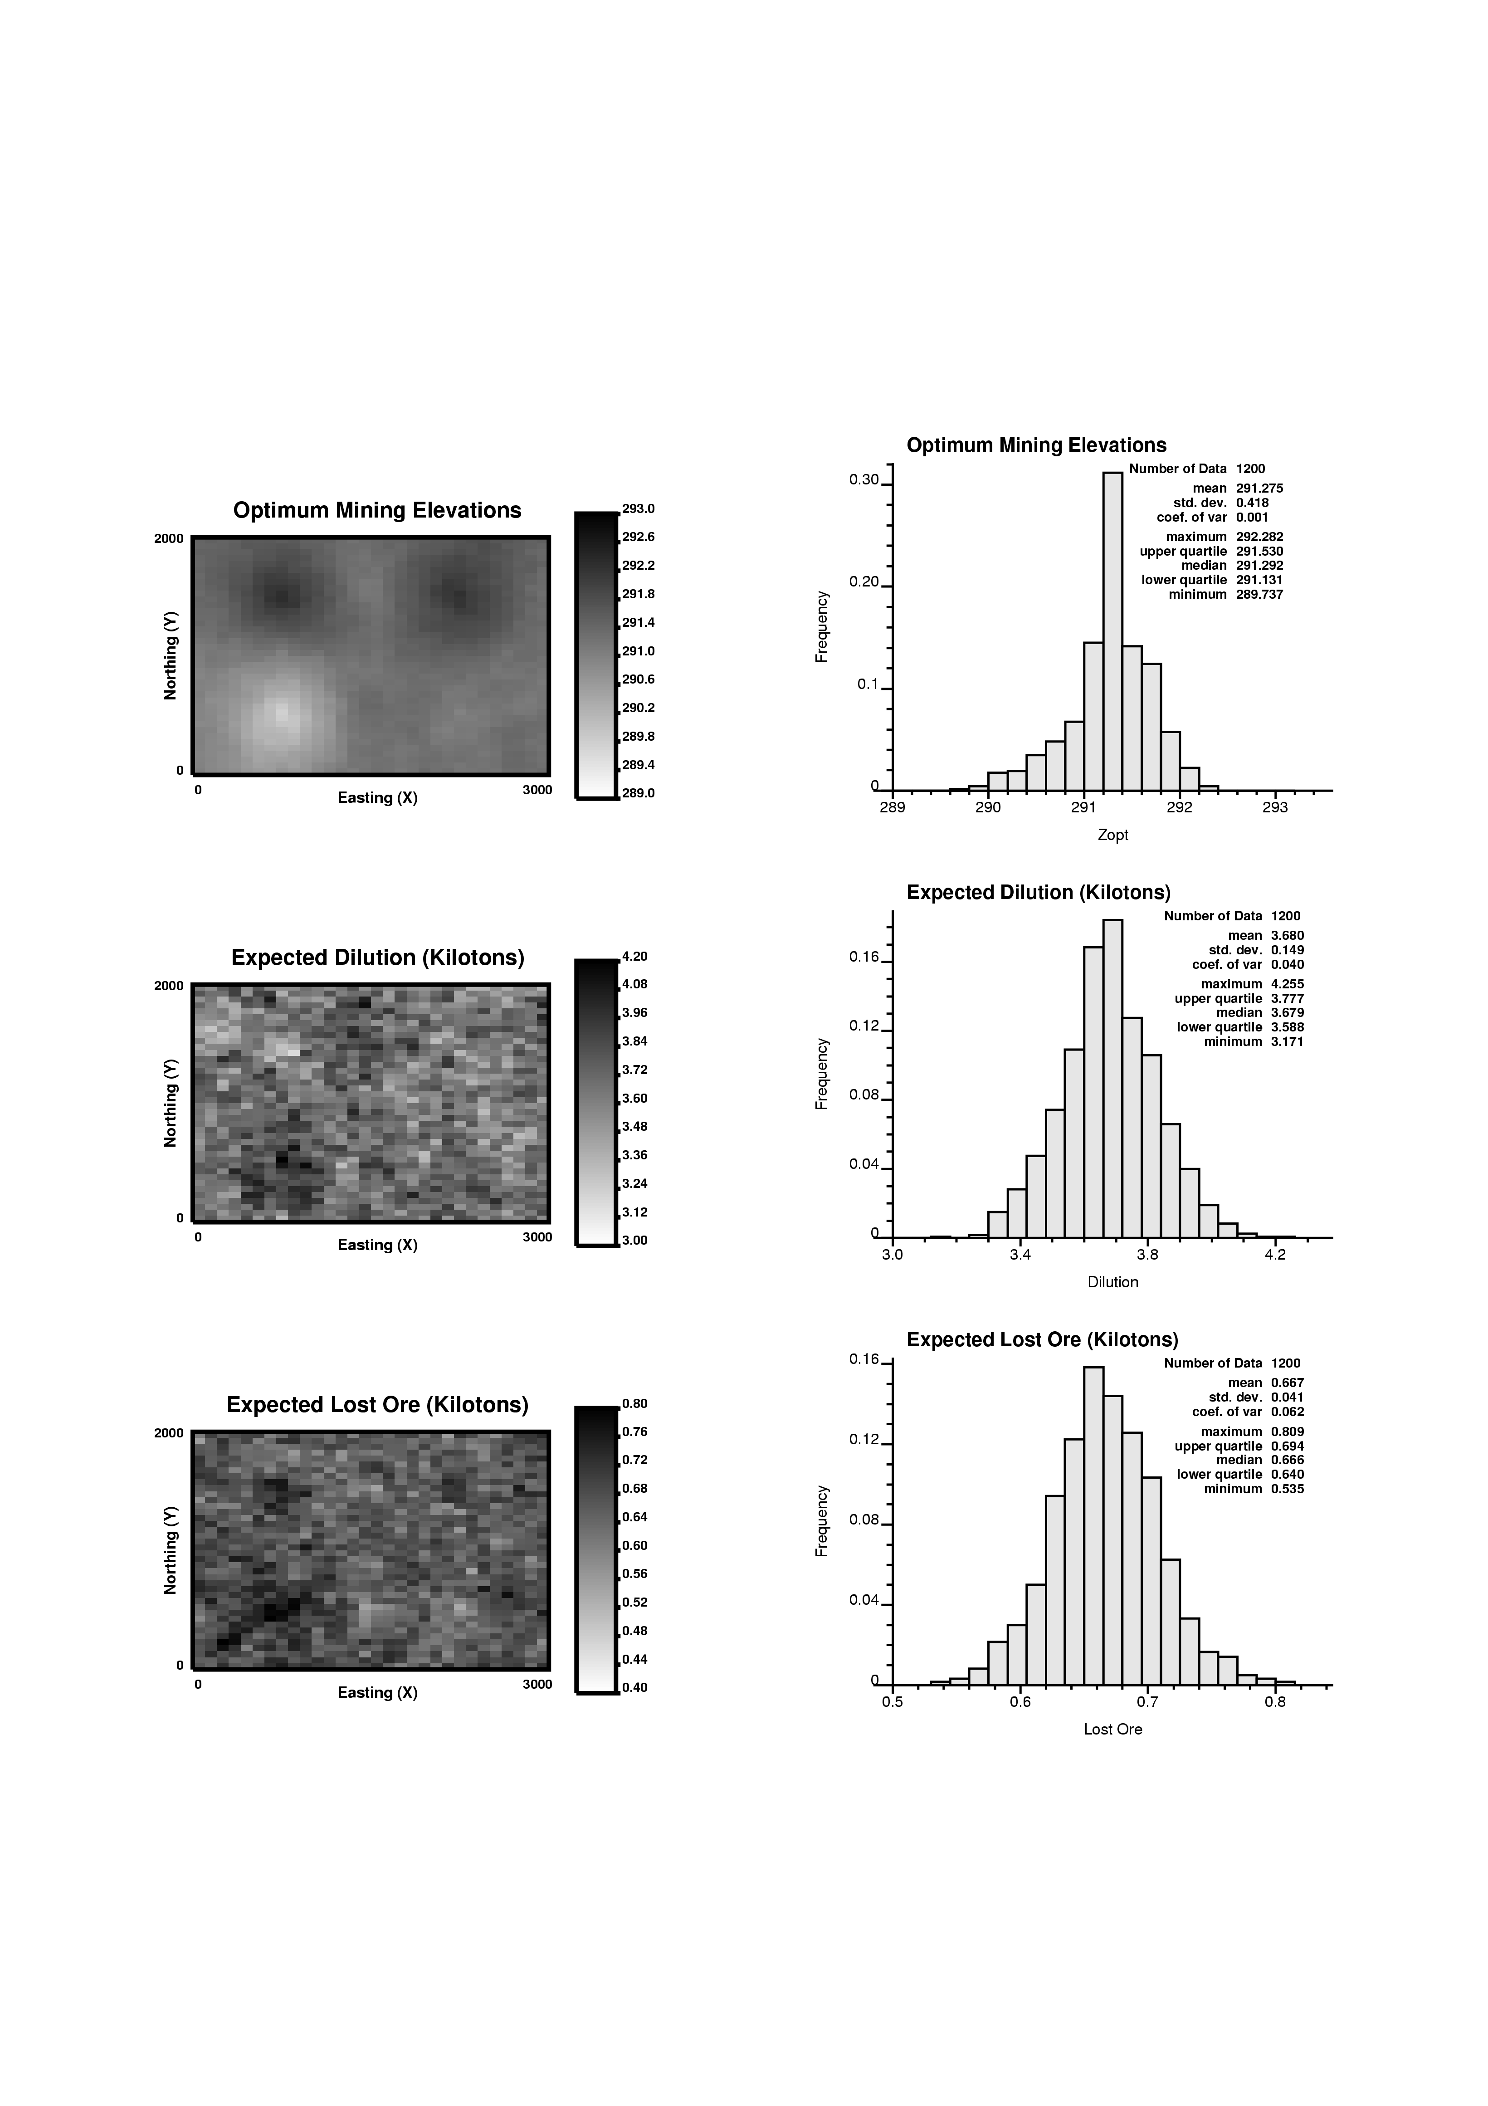
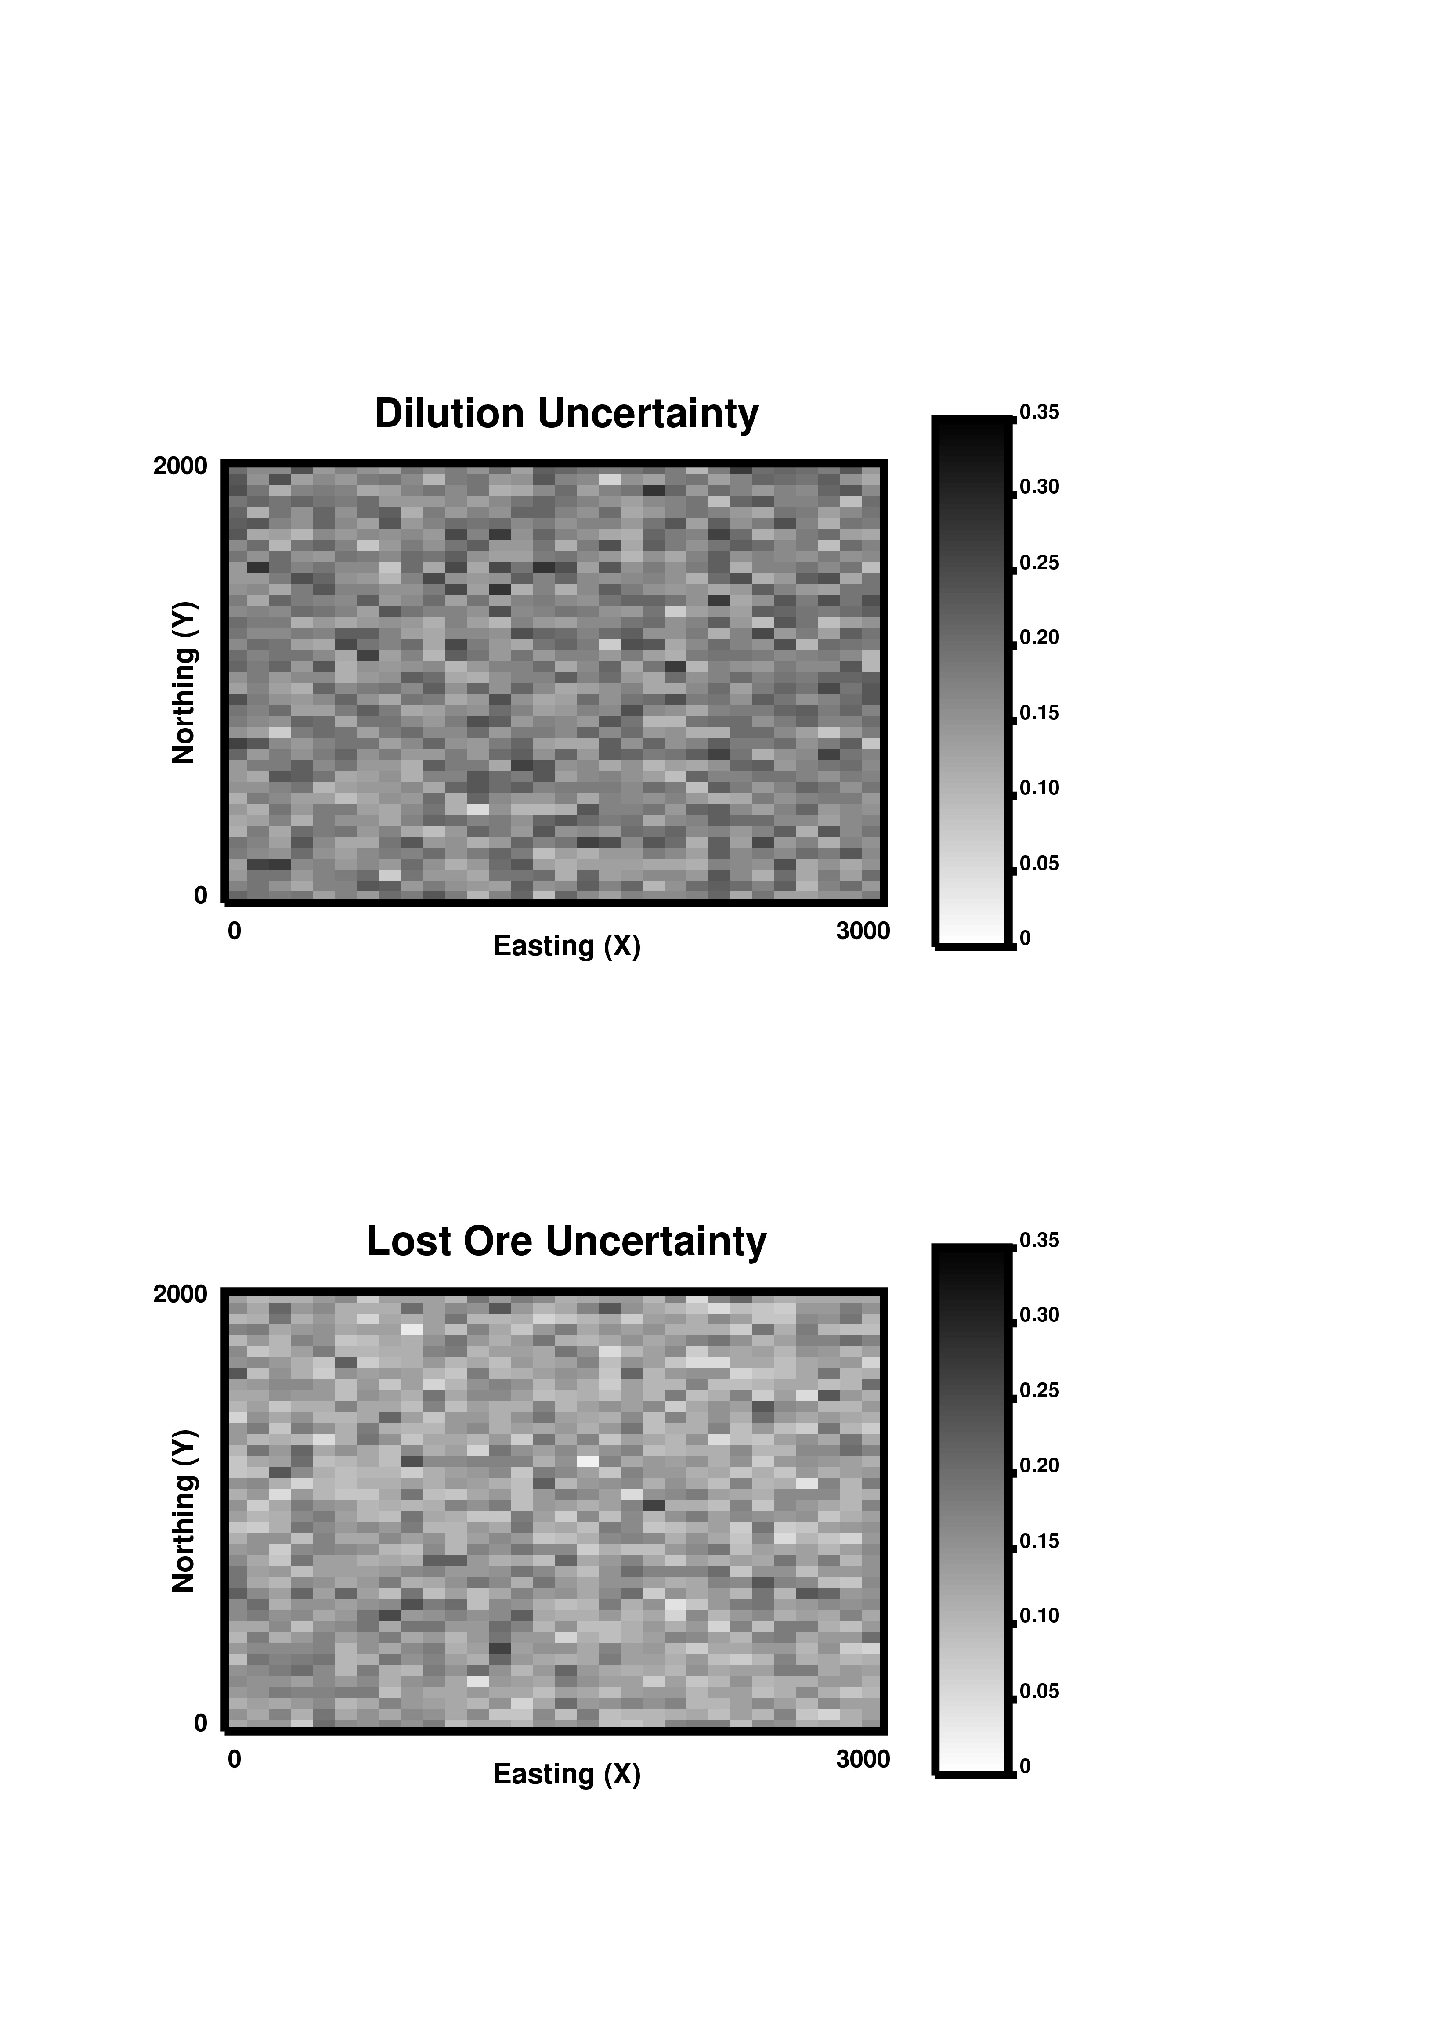
8Both the support effect and information effect are taken into consideration by this methodology. The support effect is considered by calculating the dilution and lost ore due to the selectivity requirement. Unfortunately, in practice, we cannot mine precisely up to the contact. Since relatively large equipment is used, perfect selection is not possible. The information effect is considered by evaluating the expected dilution and lost ore using one realization of the ore bottom surface at a time. The dilution and lost ore calculated on this basis represent the inability of the mining equipment to separate the ore from the waste, when the elevation of the surface fluctuates over the representative dozer region. These values are obtained by averaging the result over multiple realizations, with a new optimum surface every time, which is different than fixing the elevation and calculating the dilution and lost ore over all realizations.
Figure 11 – The expected optimum mining elevations, dilution and lost ore costs shown in a map and a histogram.
Figure 12 – The probability to be within 10% of the expected dilution and lost ore costs shown in Figure 11.

Conclusions
Conditional simulation can be used to calculate optimum mining elevations based on minimizing the combined costs of dilution and lost ore. The mining elevations, dilution and lost ore costs can then be used for mine planning. The uncertainty in dilution and lost ore can be used to assist in production decision making.

References
- Canico Resources Corporation, June 12, 2003, Onca-Puma Information, http://www.canico.com/s/Projects.asp.

- Kenyon, M., August 29, 2002, Nickel Laterites - Are There Any Good Ones Left?, http://www.bc-mining-house.com/toolkit/meg/megabst7.HTM#nickel.

- Norrena, K. P. and Deutsch, C. V., 2000. Automatic Determination of Dig Limits Subject to Geostatistical, Economical and Equipment Constraints. Center for Computational Geostatistics (CCG), University of Alberta, Edmonton, Alberta, Canada.

- Leuangthong, O. and Deutsch, C. V., 2003. Transformation of residuals to avoid artifacts in Geostatistical Modeling with a Trend. Center for Computational Geostatistics (CCG), University of Alberta, Edmonton, Alberta, Canada.

- Journel, A. G. and Kyriakidis, P. C., 2002. Evaluation of Mineral Reserves: A Simulation Approach to Mining Dilution., Department of Geological and Environmental Sciences, Stanford University, California, United States.

- Sinclair, A. J. and Blackwell, G. H., 2002. Applied Mineral Inventory Estimation, Cambridge University Press, New York, New York, United States.

