Geostatistical Determination of Production Uncertainty:
Application to Pogo Gold Project

J. A. McLennan (jam12@ualberta.ca) and C. V. Deutsch (cdeutsch@ualberta.ca)
University of Alberta, Edmonton, Alberta, Canada

J. DiMarchi (jdimarchi@teckalaska.com) and P. Rolley (Peter.Rolley@teckcominco.com)
Teck Cominco Limited, Vancouver, British Columbia, Canada

Abstract
Geological uncertainty is an unavoidable characteristic of mining projects since only limited information is available from sampling. Mine planning and development decisions with significant economic consequences are made when the geological heterogeneity is inherently uncertain. The technique of kriging provides best estimates at each location; however, geostatistical simulation is preferred because it provides alternative grade realizations that can be used to assess geological uncertainty. Geological uncertainty can be transferred into production uncertainty, which can help characterize the economic risk of the project.

This paper presents a case study for the Pogo property, being prepared for development near Fairbanks, Alaska. The exact dimensions, grades and production predictions have been modified; however, the methodology is illustrative. The geostatistical methodology consists of (1) assembling the relevant drillhole data and establishing a suitable coordinate system, (2) calculating the target distribution, (3) creating a model of spatial correlation, (4) generating multiple realizations at a small scale and (5) linearly averaging all the realizations to the chosen selective mining unit (SMU) support size. The geostatistical model is then used to calculate production uncertainty.

Introduction
Mine planning is conventionally based on block estimates created from some flavor of kriging. The classical application of kriging to mine planning is discussed in Journel and Huijbregts (1978). Kriging is a form of linear regression that calculates estimates that are smoother than the underlying true grade distribution. The smooth estimates are locally accurate, but may suffer from conditional bias; this is described in Isaaks and Davis (1999) as the kriging oxymoron. Conditional simulation is recently becoming preferred over kriging due to improved heterogeneity characterization, joint uncertainty quantification and conditional unbiasedness, McLennan and Deutsch (2002).

Exploration drillholes help delineate the geological properties of an ore deposit; however; in between drillhole samples, the geology is impossible to exactly predict. That is, it is impossible to establish the true distribution of grades until the deposit is recovered at the end of the mine life. Geological uncertainty is, therefore, an unavoidable element of making mine planning decisions.

The purpose of a geostatistical study is to quantify geological uncertainty and transfer it to production uncertainty (Deutsch, 2000). Geostatistical simulation allows alternative realizations of the geology to be created, which jointly define a model of geological uncertainty. The geological uncertainty is then transferable to production uncertainty that can assist mine planning and development decisions.

There are many sources of production uncertainty such as the geostatistical model parameters themselves, scale up from high resolution geological models to production scale, economic forecasting and so on. Nevertheless, for most applications, the most significant contribution to production uncertainty is the uncertainty in the resources/reserves, which is characterized by the fluctuation between several possible geological realizations created from geostatistical simulation. This paper documents a study to quantify geological uncertainty using geostatistics. The main steps of the geostatistical procedure are (1) assemble the relevant drillhole data and establish a suitable coordinate system, (2) define the target distribution, (3) create a model of spatial correlation, (4) generate multiple realizations at a small scale and (5) linearly average all the realizations to the SMU support size. The geostatistical model is then used to calculate production uncertainty.

Determination of production uncertainty using geostatistics quantifies the economic risk resulting from geological uncertainty when extracting an inherently uncertain reserve. The gross revenue forecasts for a mining project’s cash flow model depend on the model of the grades. Geostatistical simulation quantifies the uncertainty in the grades and is transferable to revenue forecasts. This aids mine planning so that risk-qualified decisions can be made. Management can choose to collect more data to reduce uncertainty/risk or steps can be taken to mitigate risk, such as mining low uncertainty stopes first or mining in different areas to reduce uncertainty.

Key Issue
Resource and reserve estimation is often difficult because of relatively widely spaced data and geological variability at smaller scales than the drillhole spacing. There is a fundamental difference between underground and surface mining. Grade control in surface mining is more flexible; there is no expectation that the blocks identified as ore in a feasibility study will all be ore when mining takes place. In fact, there is every expectation that reasonable grade control practices (blasthole sampling, short term modeling, and dig limit determination) will be put in place and that the high and low grades will be more correctly identified at the time of mining. This surface mining concept has led to the practice of kriging with relatively few samples, which leads to locally incorrect estimates but globally correct recoverable reserves. This may be acceptable in surface mining, but it can be a serious error in underground mining.

Many mechanized underground mines do not have the flexibility of surface mines to modify the mine plan to alter the sequence of production. The stope plan is changed only slowly as the operation learns more about the nature of mineralization and collects more blasthole information. Consider two approaches to kriging: Option I: using many data within a large search radius, and Option II: using few samples within a restricted search radius. As stated above, Option II is appropriate for surface mining because global recoverable reserves are better estimated; however, Option I is much better in an underground context. Option II would create unreasonably high grade estimates around isolated high grade drillholes. Designing a stope around unreasonably high grade estimates (based on a single high grade intersection) will lead to problems; the realized grade will be less. Kriging with Option I would smooth the high grades out with other samples within a large search radius. Although the map is smooth, it is better to smooth out the grades than to predict high grades incorrectly hear isolated high grade samples.

The most correct approach is to account for the variability of the grades explicitly, that is, to simulate the grades respecting the variability at different scales. The simulated realizations account for the short scale variability of the grades and avoid any problems with conditional bias or smoothing. This is the key issue addressed in this paper.

Pogo Project
The Pogo project is a potential underground gold mine operation near Fairbanks, Alaska. The project is currently in the feasibility and permitting phase with operations expected to begin in late 2004. Surface and underground drilling campaigns have been completed over several years to delineate the deposit. There are 281 drillholes and 1,471 assays available to help determine the spatial distribution of gold grades.

Gold mineralization at Pogo occurs within several shallow dipping tabular auriferous shear hosted gold-quartz veins (Rhys, 2003). The most economically significant vein is known as L1. Post-mineral faulting has dismembered L1 into several segments with significant vertical and lateral offsets resulting in spatially disjointed gold populations.
As part of the Pogo feasibility study, the gross revenue forecasts are required. These directly affect the cash flow model and economic assessment of the project. An underground stope plan and schedule provides the location, dimensions, tons and timing for the cash flow forecasts. The geologist’s role is to estimate the gold grades for a high resolution block model and merge this model into the production schedule. This allows calculation of profiles of the gold grade, tons and revenue over time for the project.

Initially, a kriging scheme was implemented to estimate the gold grades and revenues. As stated above, kriging does not permit calculation of the uncertainty in stope grades. Consequently, a simulation study was launched to check the kriging results and incorporate the inherent gold grade uncertainty into the revenue forecasts. The emphasis of the study was to create several possible gold grade models using geostatistical simulation. Each gold grade realization is used to calculate a corresponding revenue profile. The fluctuation between revenue profiles is a representation of production uncertainty that is a result of extracting an uncertain reserve.

Methodology
GSLIB-derived programs (Deutsch and Journel, 1998) were used for geostatistical modeling. The locations, grades and revenue forecasts have been modified; however, the methodology is illustrative and can be used in virtually any mining setting.

Multiple geostatistical realizations of the gold grades are created at a small scale and used to calculate corresponding realizations of the revenue forecasts at each planned stope. The main steps of the geostatistical procedure are (1) assemble the relevant drillhole data and establish a suitable coordinate system, (2) define the target distribution, (3) create a model of spatial correlation, (4) generate multiple realizations at a small scale and (5) linearly average all the realizations to the design stope size.

Geostatistical calculations such as variography, estimation, and model scaling should be done within the deposit’s original geological structure. Alternative coordinate systems are often calculated to restore the deposit’s existing structure to its original structure before major structural deformations. For Pogo, a flattened vertical coordinate system is calculated to restore the vertical mismatches that resulted from post-mineralization faulting. The geostatistical procedure is performed in this flattened space then mapped back to preserve the existing geological structure in the final model.

The geostatistical model provides the uncertainty in the gold grades and is used to calculate uncertainty in the revenue forecasts. The transfer of geological uncertainty to production uncertainty is possible by merging the gold grade realizations into the production schedule. That is, the grades in the geostatistical model are mapped to the stope location in the production schedule. This gives an estimate of the gold grade being mined at any time. According to various time scales such as days, weeks, months, quarters and years, the stopes to be extracted are flagged; then within the flagged stopes, the gold grades are averaged and the tons are accumulated.

Production uncertainty is presented by plotting the gold grade, tonnage and revenue versus time. The gold grade simulations could be summarized by plotting the p-90 and p-10 realization curves, that is, where the probability of the gold grade exceeding is 10% and 90%, respectively. The p-90 and p-10 revenue curves are calculated by multiplying the p-90 and p-10 gold grade curves, respectively, by the tonnage curve and an assumed gold price. The simulation results are compared with results from a conventional kriging estimation scheme.

Application
The 1,471 L1 gold assay drillhole data are used for the example. The locations and grades have been modified; however, the methodology is illustrative. There are four variables for each data point: X – easting location, Y – northing location, Zrel – elevation location, and Au – gold grade. The data are reformatted into an ASCII file compatible with GSLIB.

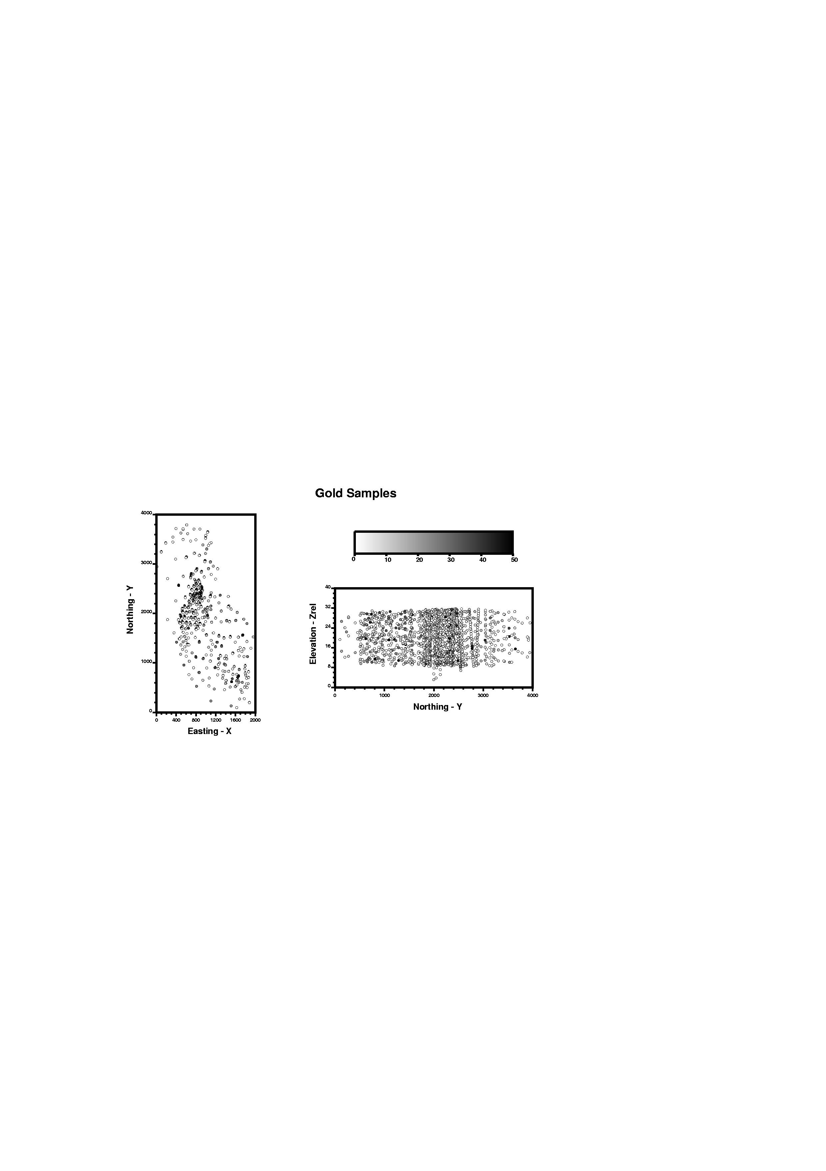
Figure 1 shows the location and grade of all the gold samples in plan and cross section (Zrel – Y) view. The study area spans 2000m in the X direction by 4000m in the Y direction by 40m in the Zrel direction. The vertical coordinate Zrel is distance from an imposed centerline assumed to be at a constant elevation of 20m; the extents of Zrel in the geostatistical model are from 0 to 40m.

Figure 2 shows a histogram of gold grades. The distribution of raw gold grades is positively skewed with a mean and variance of 8.67 and 113.0, respectively. Preferential sampling in the high grade areas requires use of declustering to obtain the target distribution. This target distribution is shown in Figure 2 with a reduced mean and variance of 8.48 and 106.50, respectively.
Figure 1: An X-Y plan view and Y-Zrel cross sectional view of the 1,471 gold assay locations in L1. The assays are also shaded according to gold grade.

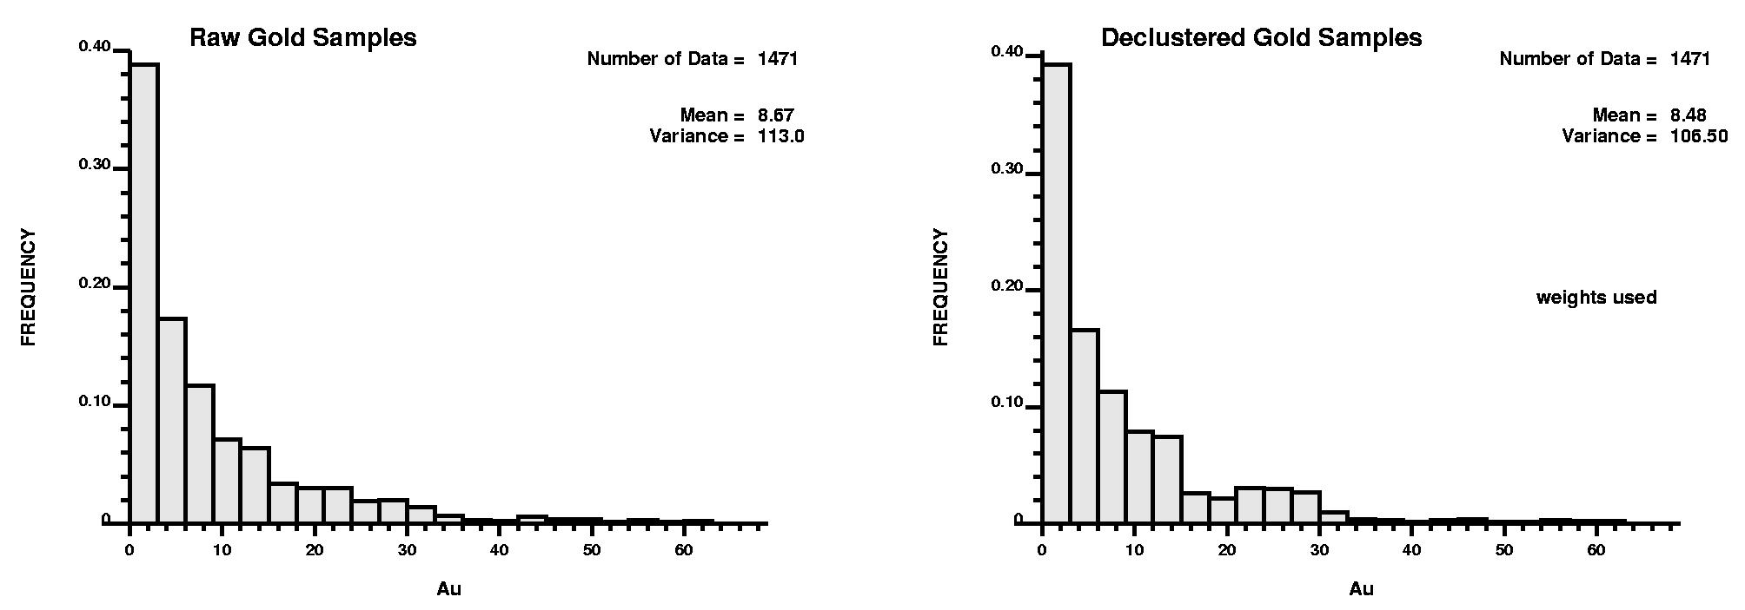
Variography was performed using the normal score values of the raw gold grades. Experimental horizontal and vertical variograms are calculated and fitted with a final variogram model. Aerial variography is direction-independent or omni-directional, that is, the variogram is virtually the same for all azimuth directions. Figure 3 illustrates the final 3-D variogram model fitted to the horizontal and vertical directions simultaneously.
Figure 2: The raw and declustered distribution of gold grades. The declustered distribution is the target distribution and has mean and variance parameters of 8.48 and 106.50, respectively.

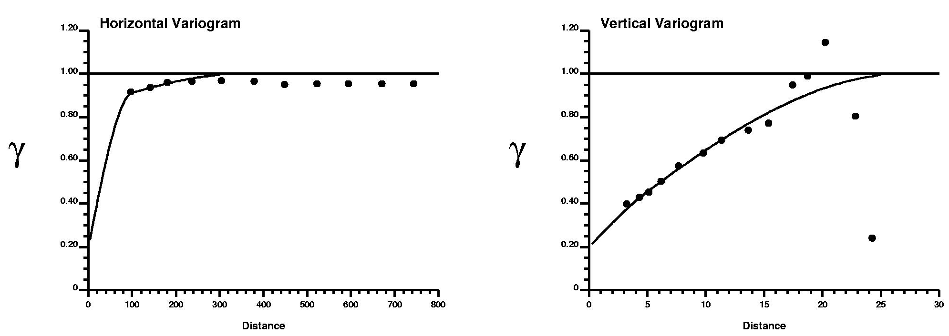

Figure 3: The horizontal and vertical gold variogram. The model variogram is shown as dark lines over top the calculated experimental points in the horizontal and vertical directions.

The gold grades are estimated using simple kriging and simulation. Both estimation algorithms use the 1,471 gold assays (Figure 1), the target distribution of gold (Figure 2), and the normal score 3-D gold variogram model (Figure 3) as conditioning information. The SMU measures 25m x 25m x 8m in the X, Y, and Z directions, respectively. For the simulation, 25 realizations were constructed at a fine scale then linearly averaged up to the stope scale. Figure 4 shows a central X-Y section and a histogram of the gold grades for the simple kriging results and the first realization of the simulation. The histograms are plotted at the same scale as Figure 2 and the same grey scale in Figure 1 is used on the maps for easy comparison. Note, the kriged estimates are too smooth compared to the sample data. The variance of the kriged estimates is 5.43 versus the target 106.5. The simulated realizations correctly reproduce the target variability (102.41 versus 106.50, respectively).
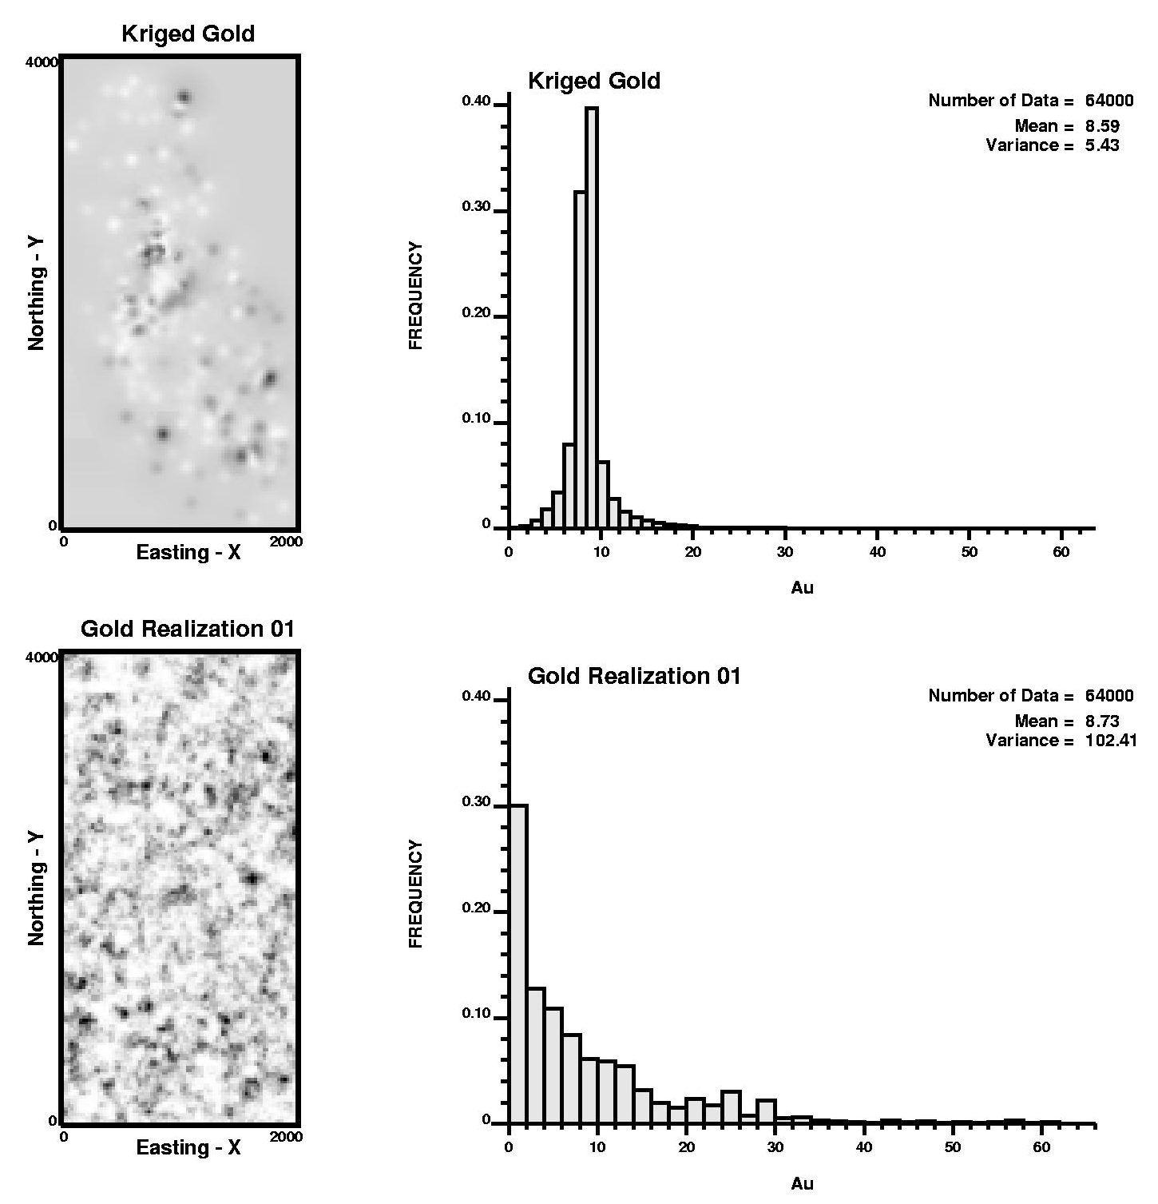
The 25 gold grade realizations and the kriged gold grade model are mapped to the stope outlines in the production schedule. The grades are averaged within each stope. Average gold grades are calculated and tons are accumulated from the stopes inside one year time periods. This is repeated for all 25 realizations and the kriged gold grade. A constant gold commodity price is assumed and the revenue is calculated as the product of gold grade, tons and price.

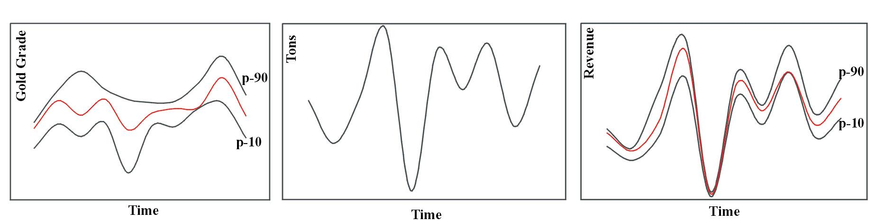
Figure 5 shows profiles of the estimated gold grade, tons and gross revenue with time. The gold grade profile curves are the geological uncertainty and the revenue profile curves are the production uncertainty. The simulation results are summarized with dark lines representing the p-90 and p-10 values where the probability of exceeding is 10% and 90%, respectively. The kriging results are shown as shaded lines. Note, the kriged profile is always enclosed between the p-90 and p-10 curves. Also, the p-90 and p-10 values are asymmetrically disposed about the kriged value, which means revenue risk is not equally distributed. The probability of exceeding a particular revenue at a particular time is immediately attainable from the production uncertainty. For example, the earlier times have a greater probability of having lower grade than the kriged estimates, while at later times, the reverse occurs.
Figure 4: The distribution of gold grades is illustrated in an X-Y cross sectional view and histogram for the kriging and simulation scheme implementations.

Figure 5: Geological uncertainty is the profile of possible gold grades with time (left) and production uncertainty is the profile of possible revenue forecasts (right). The transfer of geological to production uncertainty is made by multiplying grade, tons and gold price together.

Discussion and Conclusion
The revenue profiles generated in Figure 5 are important economic indicators of the project venture and can be utilized to assist mine planning development decisions. Areas of future concern such as extreme low grades at particular times are easily identifiable. Also, the scheduling and location of areas in the deposit with large uncertainty can be identified and investigated further. For example, specific stopes with higher uncertainty early in the mine life can be targeted and additional drilling undertaken to allow improved mine planning decisions. d to iterate the production sequence so that a specific amount of gold is recovered over a specific time increment within the mine life. The value of additional drilling is that it would reduce the uncertainty in gold grade and revenue. In terms of Figure 5, additional drilling would close the gap between the p-90 and p-10 gold grade and revenue curves. This improvement in mine planning must be balanced against the time and cost of acquiring more drillhole data. The methodology could easily be modified to quantify the reduction in geological and production uncertainty with additional drillhole data.

Although gold grade is likely the most significant contributor to production uncertainty, the tons of ore in each stope is also a significant source of production uncertainty. The architectural uncertainty could easily be incorporated by geostatistically modeling vein thickness using a similar methodology. The thickness would be multiplied by density and the stope area to calculate multiple realizations of the stope tonnages. Practically, gold price is not a constant over the project life as assumed in this study; rather; it prescribes to uncertain fluctuations. These fluctuations can also easily be incorporated into the revenue profile realizations. The result of incorporating such additional uncertainties would result in an inflation of the final production uncertainty.

Simulation is performed due to its ability to correctly reproduce the heterogeneity in the gold grade variable. The histogram and variogram parameters are reproduced in expected value using simulation whereas they are not using kriging. Moreover, simulation provides access to joint uncertainty, that is, simulation provides a local distribution of possible gold grades for each stope in the model whereas kriging provides only one value. The uncertainty in the grades is represented by these local conditional distribution functions (ccdf’s) and can be used to calculate the uncertainty in production variables. For Pogo, the uncertainty in gross revenue forecasts is quantified based on the uncertainty in the gold grades.

Mine planning decisions with significant economic consequences are made based primarily on the project cash flow. And revenue forecasts are a significant component of the project cash flow. Moreover, the grade heterogeneity and uncertainty are directly linked to the revenue forecasts and their uncertainty. The geostatistical methodology quantifies geological uncertainty in terms of cash flow that is useful for mine planning decisions.

Acknowledgements
This study was completed through cooperation between Teck – Pogo Inc. and the University of Alberta. The authors thank Teck Cominco Ltd. for publication permission.

References
Journel, A.G. and Huijbregts, Ch.J. (1978). Mining Geostatistics, Academic Press, New York.
Isaaks, E. and Davis, B. (1999). The Kriging Oxymoron: Conditionally Unbiased and Accurate Prediction, SME Annual Meeting, Denver, CO, 1999.
Pogo Project Technicals, Alaska, U.S.A. www.teckcominco.com/operations/pogo/index.htm. Teck Cominco Limited. Obtained February, 2003.
Rhys, D., DiMarchi, J., Friesen, R., Rombach, C., and Smith, M. (2003). Structural Setting, Style and Timing of Vein-Hosted Gold Mineralization at the Pogo Deposit, East Central Alaska. Mineralium Deposita 38: 863-875 (2003).
McLennan, J.A. and Deutsch, C.V. (2002). Conditional Non-Bias of Geostatistical Simulation for Estimation of Recoverable Reserves. Annual Canadian Institute of Mining and Metallurgy (CIM) Meeting, Vancouver, British Columbia, 2002.
Guibal, D. and Remacre, A. (1984). Local Estimation of the Recoverable Reserves: Comparing Various Methods with the Reality on a Porphyry Copper Deposit. Geostatistics for Natural Resources Characterization, Part 1: 435-448.
Deutsch, C.V., and Journel, A.G. (1998). GSLIB: Geostatistical Software Library and User’s Guide, Oxford University Press, New York.

