Copyright 2005, SPE/PS-CIM/CHOA International Thermal Operations and Heavy Oil Symposium
SPE/PS-CIM/CHOA 97874
PS2005-97874
An Exact Downscaling Methodology in Presence of Heterogeneity: Application to the Athabasca Oilsands
Weishan Ren, Jason A. Mclennan, Luciane B. Cunha and Clayton V. Deutsch, University of Alberta

This paper was prepared for presentation at the 2005 SPE International Thermal Operations and Heavy Oil Symposium held in Calgary, Alberta, Canada, 1–3 November 2005.

This paper was selected for presentation by an SPE/PS-CIM/CHOA Program Committee following review of information contained in a proposal submitted by the author(s). Contents of the paper, as presented, have not been reviewed by the Society of Petroleum Engineers, Petroleum Society–Canadian Institute of Mining, Metallurgy & Petroleum, or the Canadian Heavy Oil Association and are subject to correction by the author(s). The material, as presented, does not necessarily reflect any position of the SPE/PS-CIM/CHOA, its officers, or members. Papers presented at SPE and PS-CIM/CHOA meetings are subject to publication review by Editorial Committees of the SPE and PS-CIM/CHOA. Electronic reproduction, distribution, or storage of any part of this paper for commercial purposes without the written consent of the SPE or PS-CIM/CHOA is prohibited. Permission to reproduce in print is restricted to a proposal of not more than 300 words; illustrations may not be copied. The proposal must contain conspicuous acknowledgment of where and by whom the paper was presented. Write Librarian, SPE, P.O. Box 833836, Richardson, TX 75083-3836, U.S.A., fax 01-972-952-9435.

Abstract
Geostatistical realizations are often built at an arbitrary scale based on available data and computational resources. In certain settings, it may be necessary to downscale the realizations for flow simulation and local resource assessment. This is especially important in the Athabasca Oilsands where accurate flow simulation often requires numerical models with a very fine grid size. Flow simulation is undertaken for selected areas and realizations. It is intractable to construct the original geostatistical models at the fine scale. It is desirable to construct finer scale models that reproduce the original realizations exactly.
Approximate downscaling is always possible with geostatistical methods; however, it is of interest to create fine scale models that exactly reproduce the large scale models to ensure consistency and avoid potential biases. Direct block sequential simulation is developed to generate fine scale realizations that exactly reproduce block data.
A comprehensive case study is shown from the Athabasca Oilsands. Geostatistical realizations are constructed over 100s of square kilometers at a large scale. These realizations are locally downscaled to 20m by 2m by 2m for flow simulation around particular SAGD well pairs. The fine scale realizations are constructed such that they exactly match the initial coarse scale realizations. An approximate downscaling method is also used. The 3-D models and flow simulation results were compared to show the difference made by the exact downscaling method.

Introduction
One major task of geostatistical modeling is to build reservoir models of petrophysic prosperities for reservoir simulation. When the target is a whole reservoir, upscaling of geostatistical reservoir models is always required because geostatistical models have a much finer scale than the reservoir simulation models. When the target is a small area, downscaling of geostatistical models may be required. In the Athabasca Oilsands, where the SAGD technique is commonly used for oilsands recovery, the flow simulation of horizontal well pairs or SAGD Pad is very important. The detailed flow simulation of selected small areas requires the input models at a very fine grid size. Normally, geostatistical models have been built at a large scale over lease area or any large area. The input model can be generated by either downscaling the large scale model or rebuild a fine scale model for the selected small area. Rebuilding a small area model usually requires a different technique, which introduces an inconsistency between the large- and small-scale models. It is desireable to avoid inconsistencies and the requirement to defend and compare different models of the same volume. Downscaling techniques are needed to keep the consistency between the models at different scales.
In building geostatistical reservoir models, multiscale data are often available for modeling. Large trend information, seismic, well testing and production data have a much larger scale than the core and well log data. Some geostatistical techniques are integrating those large block data in generating fine scale models. These techniques include co-kriging, collocated co-kriging, and trend modeling technique using the block data as locally varying mean. Althrough these methods constrain the fine scale model with the block data, these methods are only approximate downscaling methods that can only provide fine scale model results approximately match the block data. To avoid any biases in the downscaling, and to be consistent in the models at different scales, an exact downscaling technique is desired so that the block data can be exactly reproduced when upscaling the fine scale model back to the original scale.
One historical approach to ensure consistency between an original large-scale model and a downscaled model is a simple duplication method. This method duplicates the block datum to each small cell in the large-scale block; however, in this method, the heterogeneity at the fine scale is not preserved or modeled correctly. This paper proposes an exact downscaling method that generates small scale heterogeneous models with the right properties while simultaneously exactly reproducing the block data and fine scale data. This method is developed using the Direct Sequential Simulation (DSS) technique with block kriging.
To generate the heterogeneity at fine scale, the statistical properties at the fine scale are needed for the downscaling. Covariance or variogram functions of the point scale data are required. The fine scale data or point data are also used for conditioning the fine scale model. Thus, this downscaling technique is actually a multiscale modeling process. Different volume supports are accounted for in the block kriging. The large scale data and fine scale data are assumed to be representative to the volumes they are supporting. The scale relationship of data has to be linear and the scale relationship of heterogeneity is accounted in the volume covariance relationship.
The background and theory of the downscaling method is presented next, and the exact reproduction of the block data is proved. Then, the application of the downscaling method will be demonstrated with a case study.

Background
Consider a block with an arbitrary shape. The block is composed of n small grid cells. If there are values or point data in all of small cells, the block value can be calculated from the point data by this equation:
(1) where is the point data, and is the block datum.
If the sizes of the n small cells are equal, the equation becomes a simple linear equation:
(2) where (i = 1, 2, …n) is the point data, and is the block datum.
This equation shows a linear relationship between the block datum and the point data. Some petrophysical properties, such as porosity and water saturation have a linear relationship since they are concentrations or proportions. Recall that the porosity is the fraction of pore volume over the bulk volume of the rock. Discretizing the bulk volume into n equal sized small bulk volumes, the following equation (3) shows that the block porosity value is exact the average of the point porosities:
(3)
It is same for water saturation. The block averaging is an exact upscaling method. Of course, the size of the small cells must be accounted for. This method enables the checking of the exact downscaling method. Permeability does not have the linear relationship between the data at different scales; however, a power law transformation could be used to make the arithmetic averaging applicable to permeability¹.
The downscaling process is not as straight forward as the upscaling process. To generate a fine scale model using the block data, the heterogeneity at fine scale must be taken into account. Although the data have a linear relationship between different scales, the heterogeneity is non-unique, that is, there are multiple possible heterogeneity models that reproduce the same block data. The information on the heterogeneity at fine scale has to be input into the downscaling process. In geostatistical modeling, the way to handle heterogeneity is through a reguionalized variable parameterized by the variogram or covariance. The block kriging system is used to allow the influences of data and different volume support being accounted in the simulated values. The well data are necessary to condition the fine scale model. Thus, both block and point data are integrated in the downscaling technique. The kriging system for the downscaling method is given below in matrix form:
or
where C is the matrix of covariance of multiscale data, C_{bb} is covariance between block data. C_{bp} or C_{bs} are covariances between block data and point data or previously simulated data. C_{pp}, C_{ps} and C_{ss} are covariances between point data and previously simulated data. λ is the column matrix of weights. λ is the weight of block data. μ is the weight of point data and w is the weight of the previously simulated data. D is the column matrix of covariance of data and simulated node.
The point scale covariance model can be generated from well data. The complicated non-linear relationship in heterogeneity at different scales can be simply accounted in the relationships between the block covariance or block-point covariance and the point covariance:
(4)
(5)
where the V is the volume of the block.
With block data, well data and covariance models, a multiscale direct block sequential simulation framework can be used for downscaling.

Theory
Consider a random function Z(u) distributed over a field D:
Assume a second-order stationary for both point data and block data over the field D, so m, σ and C(h) are constant over D. Given n block data and m point data, each small cell can be simulated using the multiscale direct block sequential simulation technique:
(6) where is the simulated value at the fine grid cell u_{i}, and is the point data, is the previously simulated data, and R(u_{i}) is the random residual at the location u_{i}.
According to the characteristics of direct sequential simulation techniques, the downscaling will generate a fine scale model that follows the correct spatial correlation and hornors the point data. The most interesting thing is the fine scale model can exactly reproduce the block data, that is, the block average of the simulated values is exact the block datum used in the downscaling:
(7)
The exact reproduction of the block data in the method is analytically demonstrated and proved in the Appendix. The exact reproduction of the block data enables the consistency between the fine scale model and the original model and ensures that no bias is introduced by the scaling process. Therefore, this method is also named the Exact Downscaling with Multiscale Direct Sequential Simulation (EDMDSS).

Case study on downscaling large 2-D models for flow simulation
A synthetic dataset was created basing on some 2-D large scale models generated from the Athabasca Oilsands. The geostatistical 2-D realizations were constructed over 100s of square kilometers at an areal resolution of 100m square. After selecting the locations of SAGD well pairs, a small area (800m by 200m) around a particular SAGD well pair was extracted from 2-D models and downscaled areally to 20m by 2m. Then, the EDMDSS and an approximate downscaling method were used to extend the 2-D model to 3-D models for flow simulation around the pair of horizontal wells. The 3-D models and flow simulation results were compared.
The 2-D porosity data used as block data are shown in a map and a histogram in Figure 1. The location map of 8 wells in the study area and the histogram of well data are also shown in Figure 1. The EDMDSS was used to downscale the block data to a vertaical resolution of 2m from a total thickness of 100 m. The results are shown in Figure 2. The first row is the plane views of the 3-D model at slices of 20 and 40. The remaining images show different slices of the 3-D model in y-z cross section and x-z cross section. The heterogeneity at fine scale is clearly presented in the cross sections. The 3-D model was converted back to 2-D using the arithmetic averaging of each column. The results are plotted and shown together with the original 2-D porosity map in Figure 3. They are identical.
An approximate downscaling method was used to generate a 3-D model from the 2-D block data. The sequential Gaussian simulation was performed using the well data, and the block data were input in the simulation as the locally verying mean². The results are shown in Figure 4. The arithmetic averaging of each column was also applied to the 3-D model. The cross plots of block averages versus block data for the approximate downscaling method and exact downscaling method are shown in Figure 5. The fine scale 3-D model generated with the approximate downscaling method is inconsistent with the initial coarse scale model; however, the model from the exact downscaling method matches it exactly. A few points off the 45º line are caused by numerical instabilities in the matrix solutions.
Flow simulations of a SAGD well pair using the 3-D models were conducted. The results are shown in Figures 6 and 7. There is a large difference between the results using the two downscaling methods. The steam chambers developed after 5 years of steam injection indicate a better shape for the exact downscaled model than the approximate downscaled model. This will not always be the case of course, but this show the sensitivity of the results to the downscaling methodology. The cumulative oil production curves show a higher oil production for the exact downscaled model. The SOR curves indicate a better SOR for the exact downscaled model.
It is clear that using different downscaling methods for generating fine scale models has a large impact on the flow simulation results. Using a fine scale model that is consistent with the initial coarse model is a better choice.

Conclusions
The DSS based downscaling technique can exactly reproduce block data. Models at different scales can be completely consistent. Flow simulation results show that the downscaling methodology matters.

Reference
- Zanon, S., Nguyen, H. and Deutsch, C.V. 2002, power law averaging revisited, CCG report four, 2001/2002.
- Deutsch, C.V. and Journel, A.G., 1998, GSLIB: Geostatistical Software Library and User’s Guide, 2nd Edition, Oxford University Press.

Appendix

Analytical demonstration of exact reproduction of block data in EDMDSS
We do not show a formal proof – merely some demonstrations to illustrate the principles. The demonstration starts with EDMDSS in a block containing two constituting points. Then, the block plus an additional point is considered to show if the additional data affect the results. Thirdly, EDMDSS in a block with three constituting points is shown. To simplify the equations let’s assume the mean is zero.

One block containing two constituent points:
At the first location u₁: the simulated value:
(A-1)
where R(u₁) is a random residual drawn by Monte Carlo Simulation.
At the next location u₂: the kriging estimate and equations:
(A-2)
(A-3)
From equations (5) and (6):
(A-4) the equation (A-3) becomes:
(A-5)
The equation (A-5) can be solved to get:
The kriging variance is:
Then, the random residual because it follows a distribution with zero mean and zero variance.
The simulated value:
(A-6)
Then, the block average of simulated values is:
(A-7)
The block datum is reproduced exactly for a block contains two points.

One block containing two constituent points plus an extra point:
At the first location u₁: the simulated value:
(A-9)
where R(u₁) is a random residual drawn by Mont Coral Simulation.
At the next location u₂: the simple kriging estimate:
(A-10)
And the system of equations:
from (A-11a) with equation (A-4):
(A-12)
(A-11a) - (A-11b):
(A-13)
From equation (5), , then,
(A-14)
(A-15)
Insert (A-12) into (A-11c):
rearrange it:
(A-16)
Insert (A-14) into (A-16):
rearrange it:
(A-17)
this equation gives μ₂ = 0.
Then, from (A-14), w₁ = -1.
And from (A-12), λ₂ = 2.
Therefore, the solution of the kriging system is:
the simple kriging variance is:
then, the random residual because it follows a distribution with zero mean and zero variance.
The simulated value:
(A-19)
Therefore, the block average of simulated values is
(A-20)
The block datum is exactly reproduced and the extra datum does not affect the exact reproduction of block data.

One block containing three constituent points
At the first location u₁: the simulated value:
(A-22)
At next location u₂: the simulated value:
(A-24)
At the last location u₃: the simulated value:
(A-25)
and the kriging system:
From equations (5) and (4):
(A-27)
(A-26b) - (A-26c):
rearrange it:
(A-28)
from the equation, we can get λ₃ = 3 and w₂ = w₃.
Then from (A-26b) or (A-26c), we can get w₂ = w₃ = -1.
Therefore, the solution of the kriging system is:
and the simple kriging variance is:
then, the random residual because it follows a distribution with zero mean and zero variance.
The simulated value:
Therefore, the block average of simulated values is
The block data is reproduced exactly in a block containing three points.
It has been shown that the block data can be reproduced exactly with downscaling a block for n=2, n=2 with an extra point and n=3. Basing on the results, it may be inferred that simulating all locations of a block by DSS can always exactly reproduce block data. It is proved below.

Proof of exact reproduction of block data in EDMDSS
It has been shown in the domonstraction that the last location in a block is very important for the exact reproduction of the block data. Soppose downscaling a block into n small cells, at the last location, u_{n}: the simulated value:
(A-29)
and the kriging system:
from equation (4),
or
(A-31)
so is a solution for (A-30a).

from equation (5),
or
(A-32)
so is also a solution for n-1 equations (A-30b).
Since the kriging system is unique and only has a unique solution, the founded solution must be the correct unique solution. Then, the simulated value at the last location is
(A-33)
The block average of simulated values at all locations in the block is
(A-34)
Threrfore, the EDMDSS exactly reproduces the block data.

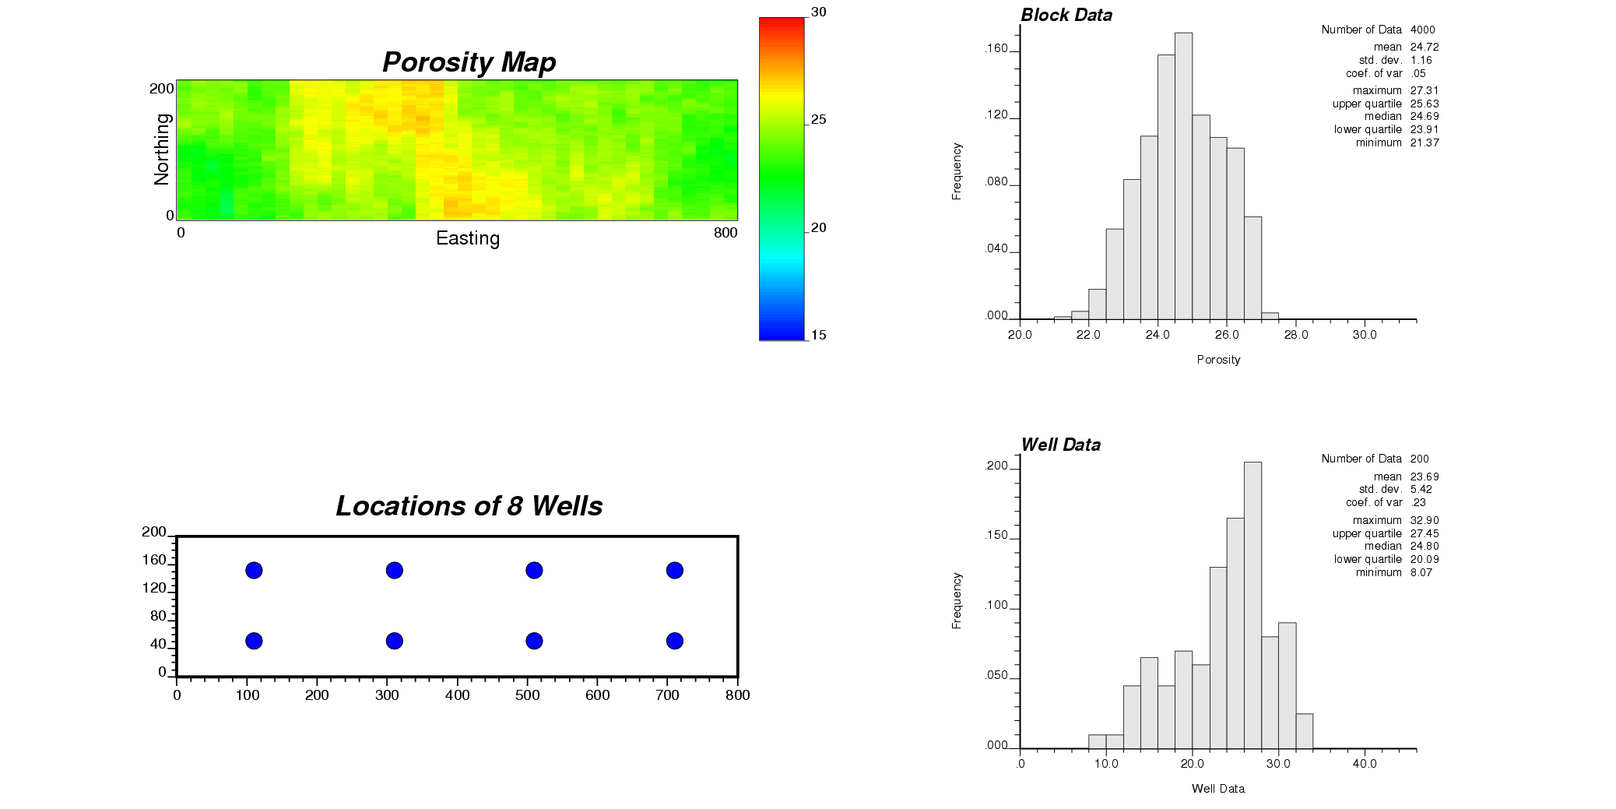
Figure 1: The block data and well data used for the case study

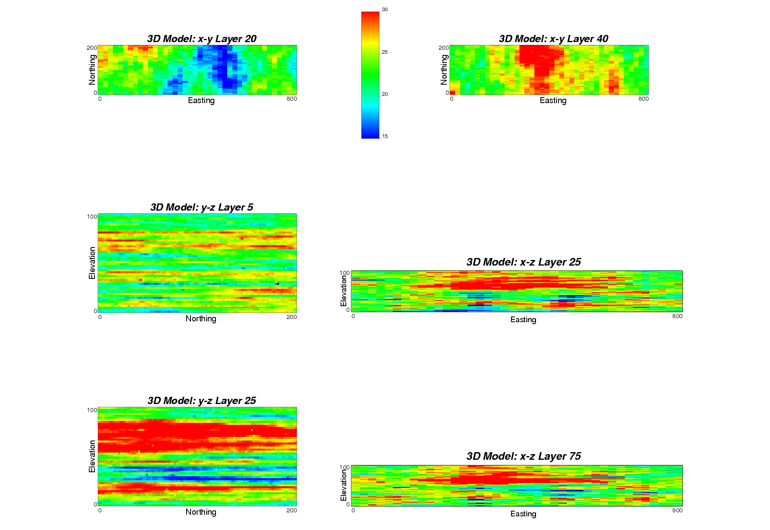
Figure 2: The exact downscaling results in plane view (first row), y-z (left) and x-z (right) cross sections.

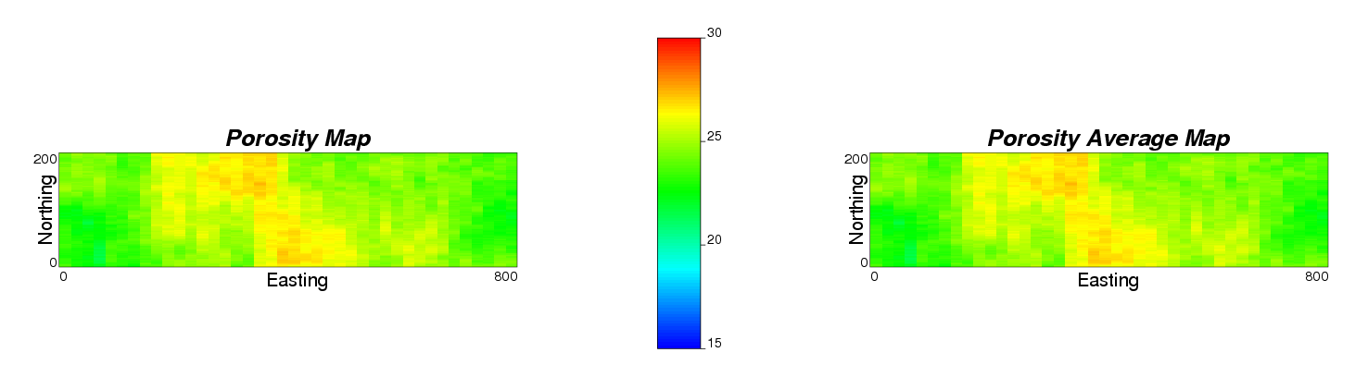
Figure 3: The map of original porosity block data (left) and the map of porosity averages from the 3D model (right).

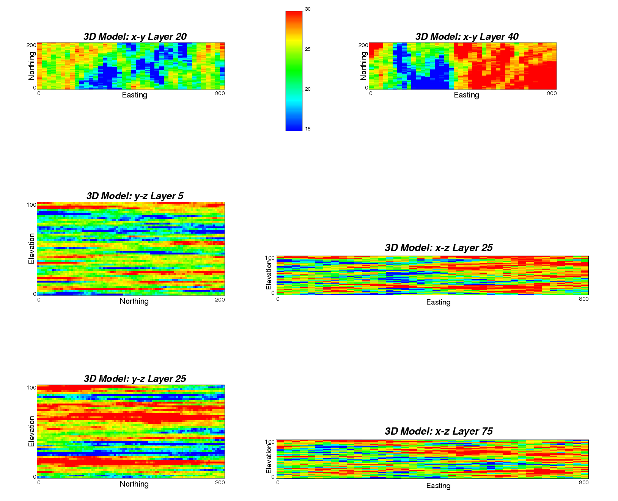

Figure 4: The approximate downscaling results in plane view (first row), y-z (left) and x-z (right) cross sections.

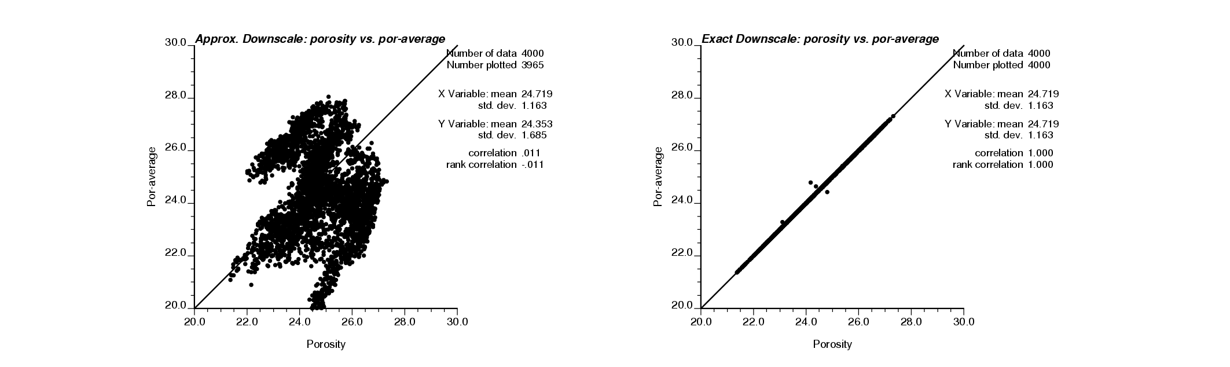
Figure 5: The cross plots of porosity block data vs. block average of fine scale model for the approximate downscaling method (left) and the exact downscaling method (right).
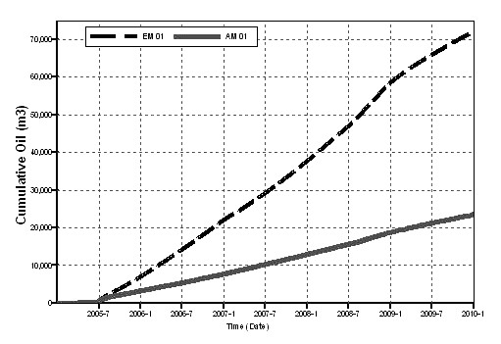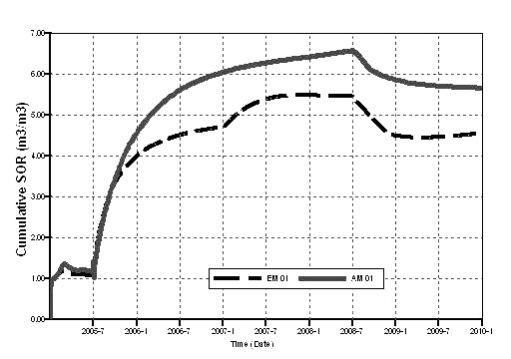
Figure 6: The results of flow simulation using the models generated by the two methods: the left plot is the cumulative oil production curves, and the right plot is the steam oil ratio (SOR) curves. The gray solid line is for the approximate downscaling method, and the black dash line is for the exact downscaling method.

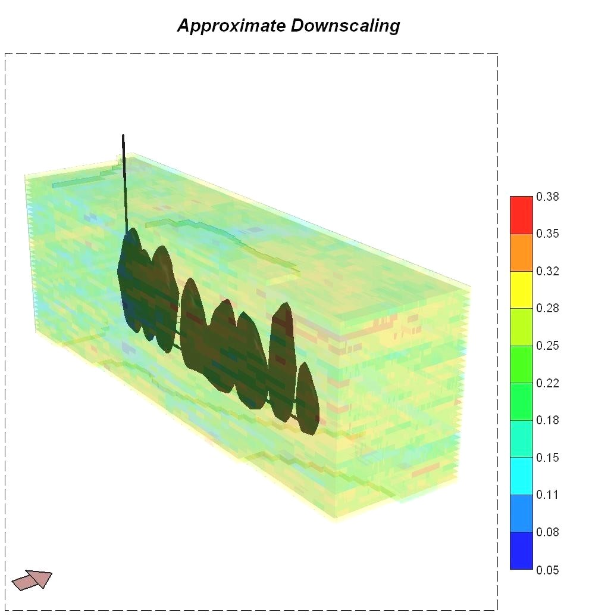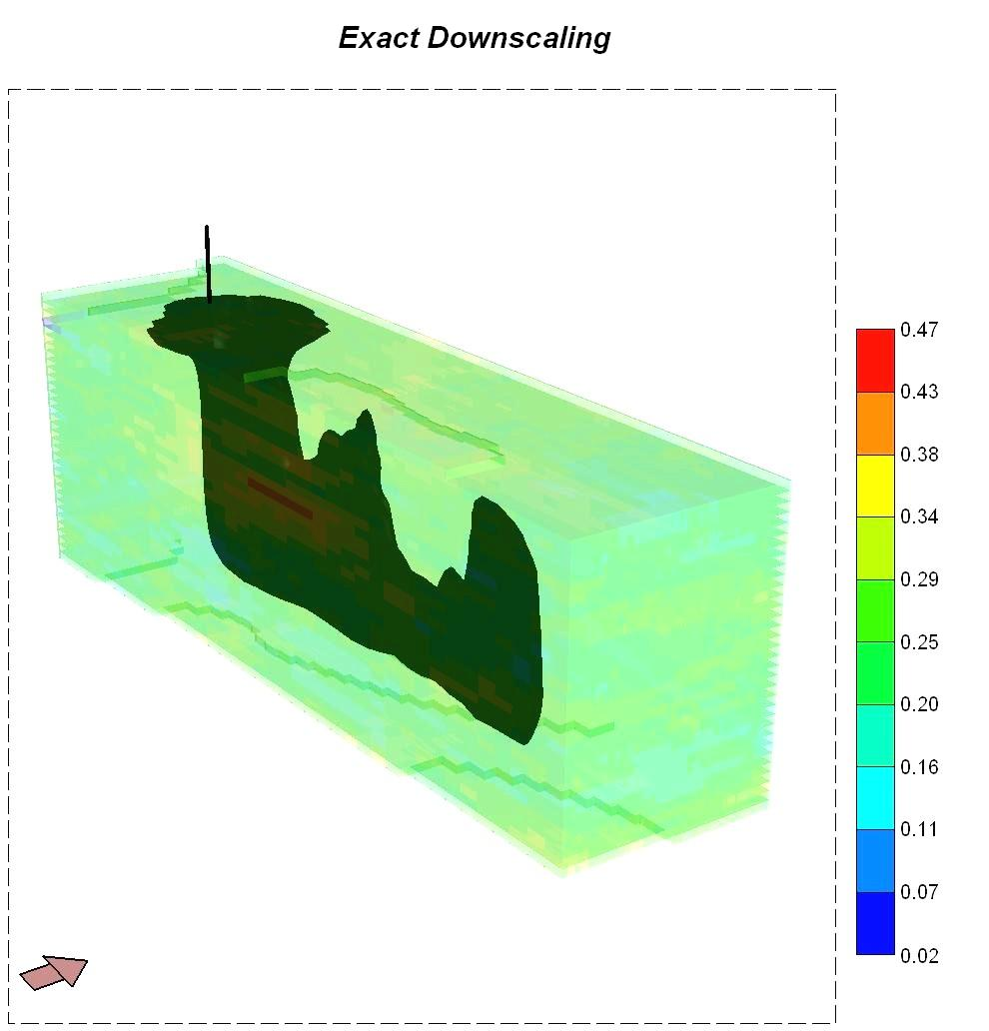
Figure 7: The steam chambles after 5 years of steam injection. The model by exact downscaling gives a better developed steam chamber.

