PAPER 2006-190
PETROLEUM SOCIETY
CANADIAN INSTITUTE OF MINING, METALLURGY & PETROLEUM

Investigation of a Stochastic Optimization Method for
Automatic History Matching of SAGD Processes
x., jia
University of Alberta
C. V., DEUTSCH
University of Alberta
L. B., CUNHA
University of Alberta

This paper is to be presented at the Petroleum Society’s 7th Canadian International Petroleum Conference (57th Annual Technical Meeting), Calgary, Alberta, Canada, June 13 – 15, 2006. Discussion of this paper is invited and may be presented at the meeting if filed in writing with the technical program chairman prior to the conclusion of the meeting. This paper and any discussion filed will be considered for publication in Petroleum Society journals. Publication rights are reserved. This is a pre-print and subject to correction.

Abstract
Western Canada has large reserves of heavy crude oil and bitumen. The Steam Assisted Gravity Drainage (SAGD) process, which couples a steam-based in-situ recovery method to horizontal well technology, has emerged as an economic and efficient way to produce the shallow heavy oil reservoirs in Western Canada. Numerical reservoir simulation allows the ideal way of predicting reservoir performance under a SAGD process. However, prior to the prediction phase, integration of production data into the reservoir model by means of history matching is the key stage in the numerical simulation workflow. Therefore, research and developments on efficient history matching techniques is encouraged.

In this paper an automated technique to assist in the history-matching phase of a numerical flow simulation study for a SAGD process is implemented. The developed technique is based on a global optimization method known as Simultaneous Perturbation Stochastic Approximation (SPSA). This technique is easy to implement, robust with respect to non-optimal solutions, can be easily parallel zed and has shown an excellent performance for the solution of complex optimization problems in different fields of science and engineering. The reservoir parameters are estimated at reservoir scale by solving an inverse problem. At each iteration, selected reservoir parameters are adjusted. Then, a commercial thermal reservoir simulator is used to evaluate the impact of these new parameters on the field production data. Finally, after comparing the simulated production curves to the field data, a decision is made to keep or reject the altered parameters tested.

A Matlab code coupled with a reservoir simulator is implemented to use the SPSA technique to study the optimization of a SAGD process. A synthetic case that considers average reservoir and fluid properties present in Alberta heavy oil reservoirs is presented to highlight the advantages and disadvantages of the technique.

Introduction
The Simultaneous Perturbation Stochastic Approximation (SPSA) methodology^{[1]} has been implemented in optimization problems in a variety of fields with excellent performance. This paper mainly features production data integration into reservoir modeling for Steam Assisted Gravity Drainage (SAGD) processes by automatic history matching with SPSA.

Essentially, automatic history matching problems turn out to be an optimization process, which can be translated into finding the minimum of an objective function. As one of the most important aspects related to the overall efficiency of an optimization methodology, the efficient determination of the gradient of the objective function cannot be omitted. For some cases, it is easy to obtain the gradient of the objective function and the application of ‘gradient-based’ methods for the solution of the optimization problem is usually the natural choice in these circumstances. However, for majority of practical problems, it is time-consuming and expensive to estimate the gradient of the objective function. The notion of ‘gradient-free’ methods is introduced to overcome this problem. As a method in this category SPSA provides a powerful technique for automatic history matching.

In this work, the objective function related to a synthetic SAGD case is defined for automatic history matching. The SPSA algorithm is implemented to improve the efficiency of the iterative procedure during the minimization phase. At each iteration a proposed set of reservoir parameters is analyzed by a commercial thermal reservoir simulator^{[2]} and a decision is made to keep or reject the altered parameters. The computer code developed was used to model main reservoir parameters in a synthetic reservoir model associated with a SAGD process. After optimization a good match was obtained for all the dynamic field data.

Simultaneous Perturbation Stochastic Approximation (SPSA)

The SPSA method has performed well in complex practical problems and has attracted considerable attention worldwide.

As a common difficulty in majority of the optimization algorithms the determination of the gradient of the objective function is not available or costly to obtain, so that gradient-based algorithms are not suitable. To overcome this problem, the concept of a ‘gradient-free’ method was introduced by James C. Spall ^{[1]}. The gradient approximation used in the SPSA method that requires only two objective function measurements per iteration regardless of the dimension of the optimization problem ^{[3]}. Because of the efficient gradient approximation, the algorithm is appropriate for high-dimensional problems where several terms are being determined in the optimization process.

Basic algorithm
The basic SPSA algorithm consists in the general recursive stochastic approximation form:
$θ_{k+1}=θ_{k}−a_{k}g_{k}(θ_{k})$ (1)
$a_{k}=\frac{a}{(k+A)^{α}}$ (2)
$c_{k}=\frac{c}{k^{γ}}$ (3)
$θ^{+}=θ_{k}+c_{k}Δ_{k}$ (4)
$θ^{−}=θ_{k}−c_{k}Δ_{k}$ (5)
$g_{k}(θ_{k})=\frac{y(θ^{+})−y(θ^{−})}{2c_{k}}[Δ_{k1}^{−1},Δ_{k2}^{−1},Δ_{k3}^{−1}\text{.}\text{.}\text{.},Δ_{\text{kp}}^{−1}]^{T}$ (6)
Where θ are the parameters being investigated, p is the dimension of the parameters being investigated, L is the objective function, g(θ) is the gradient of the objective function with respect to the parameters, k is the iteration index, Δk is a random perturbation vector, y(θ+) and y(θ-) are objective function values. Equation (6) is the simultaneous perturbation estimate of the gradient g(θ)=∂L/∂θ at the iterate θ_{k} based on the measurements of the objective function. a_{k}, c_{k}, a, c, A, α and γ are non-negative scalar gain coefficients.

The Matlab code developed in this work is based on the following basic algorithm and steps:

Step 1: Initialization and coefficient selection
The gain sequences should be initialized, as seen in Equations (2) and (3), where the counter index k is 1. The values of a, c, A, α and γ are case dependent and need to be fine tuned when implementing the technique for a particular optimization problem. Generically speaking, α and γ range from 0 and 1.

Step 2: Generation of the simultaneous perturbation vector
A p dimensional random perturbation vector Δk can be generated by Monte Carlo method where each of the p components of Δk is independently generated from a probability distribution. An effective choice for each component of Δk is to use a Bernoulli distribution (+1 and -1) with probability of 0.5 for each outcome, although other choices are valid and may be desirable in some applications.

Step 3: Objective function evaluations
Two measurements of the objective function can be obtained based on the simultaneous perturbation around the current θ_{k}. The objective functions y(θ+) and y(θ-) is firstly calculated with the c_{k} and Δk from step 1 and step 2, where, θ+ and θ- can be obtained from Equations (4) and (5).

Step 4: Gradient approximation
Generate the simultaneous perturbation approximation to the unknown gradient g(θ_{k}) according to Equation 6. It is useful to average several gradient approximations at θ_{k}.

Step 5: Update θ estimate
Use the standard stochastic approximation form in function Equation (1) to update θ_{k} to a new value θ_{k+1}. Check for constraint violation (if relevant) and modify the updated θ.

Step 6: Iteration or termination
The iteration continues by returning to step 1 with k+1 replacing k. If there is no change in several successive iterations or if the maximum iterations number has been reached, the algorithm should stop.

In this paper, the investigated elements for SAGD process are very sensitive parameters. Since this research uses the third part software, i.e. the simulator to do automatic history matching, the simulator itself is subject to the elements. If the elements are not in the range that fits the simulator, errors will come from the simulator. SPSA provides gain coefficients to keep all the elements in a valid range. The choice of the gain sequences is critical to the performance. The values of a and A can be chosen together to ensure effective practical performance of the algorithm. In this paper, A value should be at a magnitude similar to the largest one in the elements. On the other hand, value a should be balanced to avoid overflow or too tiny timesteps.

Global optimization
A desired expected behavior when applying optimization techniques is that the algorithm reaches the global optimum rather than geting stuck at a local optimum value ^{[4]}. Maryak and Chin^{[4]} described two variations, injecting and without injecting noise, for the SPSA to achieve global convergence.

Injecting noise
One method to assure global convergence is to inject extra noise terms into the recursion, which may allow the algorithm to escape local optimum points. The amplitude of the injected noise is decreased over time (a process called “annealing”), so that the algorithm can finally converge when it reaches the global optimum point.

As described in Equation (1) the gradient approximation is a direct gradient measurement. By injecting noise on the basic algorithm can help to achieve global convergence in probability. The basic algorithm is modified as following:
$θ_{k+1}=θ_{k}−a_{k}g_{k}(θ_{k})+b_{k}w_{k}$ (7)
Where, w_{k} is an injected random input term, which is an independent identically distributed standard Gaussian sequence. b_{k} can be calculated as Equation (8):
$b_{k}=\frac{b}{\sqrt{k^{α}\text{log}[k^{1−α}+B]}}$ (8)

Without injecting noise
The injection of noise into an algorithm can make the global optimization possible. But at the same time, it brings some difficulties, such as retarded convergence due to the continued addition of noise. Another variation is the use of the basic SPSA without injected noise to achieve global optimization. This variation has benefits in the set-up (tuning) and performance of algorithm. The SPSA recursion can be expressed as:
$θ_{k+1}=θ_{k}−a_{k}g(θ_{k})+a_{k}{\text{error}}_{\text{noise}}+a_{k}{\text{error}}_{\text{perturbation}}$ (9)
Where, the error-noise is the difference from the true gradient g(▪) due to the noise in the loss measurements. Error-perturbation is the difference due to the simultaneous perturbation aspect ^{[1]} which exists even if there are noise-free loss measurements.

Maryak and Chin ^{[4]} pointed out that the term error-perturbation on the right hand side of Equation (9) acts in the same statistical way as the Monte Carlo injected noise b_{k}w_{k} on the right hand side of Equation (7).

SAGD Case Study
This work considers a synthetic SAGD case. Figure 1 shows the schematic illustration of the reservoir. Reservoir and operational parameters used for the generation of the production data (red dots in Figures 2, 3 and 4) for the “true reservoir” are listed in Table 1.

Horizontal permeability and porosity were the parameters being estimated in this case. For this purpose the SPSA algorithm without injected noise was used. Figures 2, 3 and 4 illustrate the comparison between the “true reservoir” response, the initial reservoir model response and the reservoir response after conditioning the permeability and porosity data to production data. The final result depicted in Figures 2 to 4 was obtained after 16 iterations.

Conclusion
A stochastic optimization method (SPSA) for automatic history matching of SAGD processes is studied. A program is developed to couple SPSA with third party simulation software.

SPSA is an efficient method to achieve the global optimization for automatic history matching. Optimization process for automatic history matching problems concerns the gradient of the objective function. SPSA is robust to work with gradient-based and gradient-free, which makes practical problems possible to be solved.

Gain sequences are important to keep all the elements in valid region, especially when SPSA couples with a commercial simulator, which is subject to the input elements.

Normalization is used in many fields to achieve global optimization. But it is not suitable to call a simulator, which is subject to the input parameters. They are supposed to keep in valid region.

Acknowledgement
Partial financial support (grant G121210820) from the Natural Sciences and Engineering Research Council of Canada is gratefully acknowledged. The authors thank the Computer Modeling Group (CMG) for providing the reservoir simulator and Mr. Dan Khan for interesting discussions on SPSA.

Nomenclature

a_{k}, c_{k}, a, c, A, α , γ = non-negative scalar gain coefficients
g(θ) = elements gradient
L = objective function
y(θ+) = objective function values
y(θ-) = objective function values
θ = investigated elements
p = dimension of investigated elements
k = iteration index
Δk = random perturbation vector
w_{k} = injected random input term
b_{k}w_{k} = injected noise

References
- Spall, J. C., Introduction to Stochastic Search and Optimization: Estimation, Simulation and Control; Wiley, April 2003.
- Computer Modelling Group Ltd., STARS manual; Calgary, Alberta, October 2004.
- Spall, J. C., An Overview Of The Simultaneous Perturbation Method For Efficient Optimization. Johns Hopkins APL Technical Digest, Vo. 19, No.4, 199.
- Maryak, J. L., Chin, D. C., Efficient Global Optimization Using SPSA; Proceedings of the 1999 American Control Conference.
- Maryak, J. L., Chin, D. C., Global Random Optimization by Simultaneous Perturbation Stochastic Approximation; Proceedings of the 2001 Winter Simulation Conference.

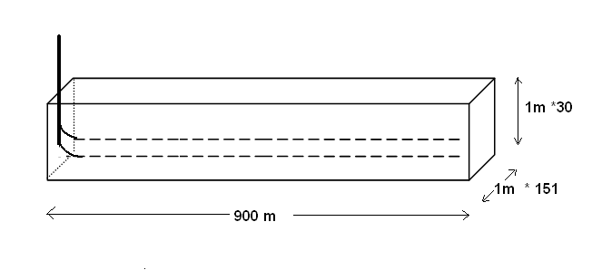
Figure 1: The schematic illustration of the synthetic SAGD process

Grid: i, j, k | 151, 1, 30
Porosity, φ | 0.35
Permeability, kh (Darcy) | 5
Permeability, kv (Darcy) | 2.5
Injector location | 76,1,6
Producer location | 76,1,1
Injector Maximum BHP (kpa) | 1510
Injection temperature (˚C) | 200
Injector Maximum Water rate (m³/day) | 800
Steam quality | 0.95
Producer Minimum BHP (kpa) | 1500
Stream trap (˚C) | 5
Table 1: Reservoir and simulation input data
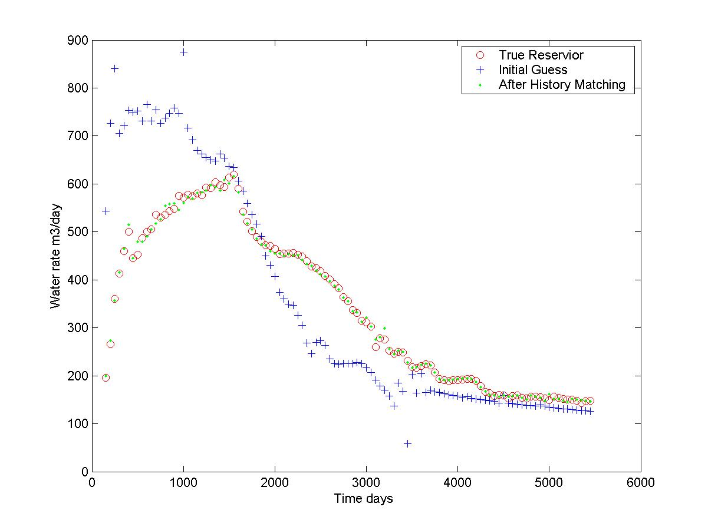
Figure 2: Water flow rate match: true, initial and final simulated values

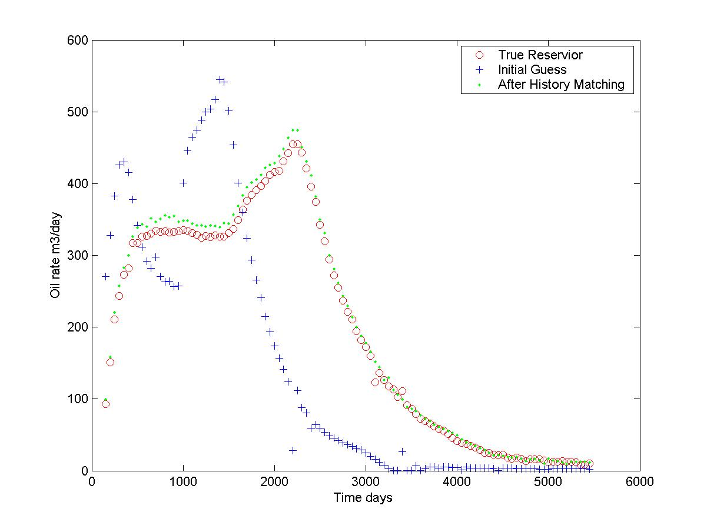
Figure 3: Oil flow rate match: true, initial and final simulated values

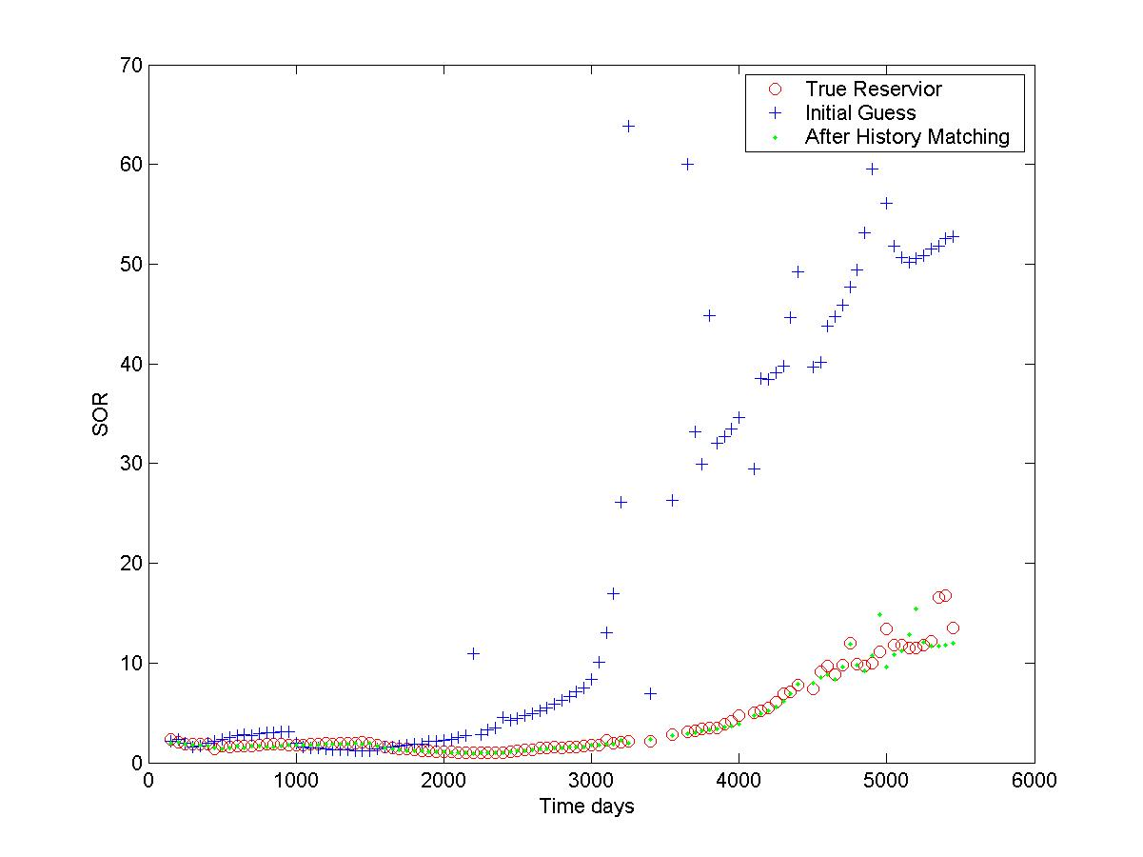
Figure 4: SOR (Steam Oil Ratio) match: true, initial and final simulated values

