PAPER 2006-096
PETROLEUM SOCIETY
CANADIAN INSTITUTE OF MINING, METALLURGY & PETROLEUM

Best Practice Reservoir Characterization for the Alberta Oilsands
J. A. McLennan
University of Alberta, Edmonton, Alberta, Canada
c. v. Deutsch
University of Alberta, Edmonton, Alberta, Canada
This paper is to be presented at the Petroleum Society’s 7th Canadian International Petroleum Conference (57th Annual Technical Meeting), Calgary, Alberta, Canada, June 13 – 15, 2006. Discussion of this paper is invited and may be presented at the meeting if filed in writing with the technical program chairman prior to the conclusion of the meeting. This paper and any discussion filed will be considered for publication in Petroleum Society journals. Publication rights are reserved. This is a pre-print and subject to correction.

EXTENDED ABSTRACT

Abstract
Numerical modeling of Alberta’s oil sands deposits is important for optimum resource management in mining and in-situ extraction projects. The heterogeneous distribution of structural, lithological, and petrophysical properties coupled with limited samples leads to unavoidable geological and production uncertainty. Geostatistics is used to reduce these uncertainties fairly. Nevertheless, uncertainty always remains and operators are faced with making decisions in the presence of uncertainty. This presentation summarizes a workflow of current best practice geostatistical modeling techniques. A framework for making decisions in the face of uncertainty is also presented.

Introduction
Investment in the Alberta heavy oilsands is increasing while conventional oil production declines and offshore development remains costly. There are predictions that 75% of Canadian oil production will come from the Alberta oilsands by 2015. The Athabasca oilsands represent 144 billion barrels of crude reserves. Of this, however, only 15% is economically recoverable using surface mining extraction techniques. The remaining 85% is accessible by in-situ techniques such as steam-assisted-gravity-drainage (SAGD).

Figure 1 illustrates the major considerations involved in a typical geostatistical workflow: (1) geological background, (2) data collection and cleaning, (3) representative statistics, (4) 2D mapping, (5) structural modeling, (6) gridding, (7) lithofacies modeling, and (8) petrophysical property modeling. A transfer function is used to convert geological uncertainty to production uncertainty. For mining, this function is often a calculation of recoverable reserves; for in-situ the function is often SAGD flow simulation.

The main objective of using geostatistics is to provide realistic models of variability and a fair assessment of uncertainty in production performance due to geological uncertainty. Best practice geostatistical techniques appropriate for the Alberta oilsands are assembled from the diverse library of available methods. However, even these recommended techniques cannot remove uncertainty. One is always faced with decision making in the face of uncertainty.

Characterization of Alberta’s oilsands is unquestionably important. The author’s have undertaken a number of projects and have been assembling a handbook on how to model the McMurray formation. The first edition [1] published a number of years ago was quite popular. The second edition will be available by the end of 2006; contact the authors for more information.

Geological Uncertainty
Geological uncertainty is quantified with geostatistical techniques. The main steps and recommended techniques for a standard geostatistical workflow within a typical Alberta oilsands deposit are as follows.

Geological Background
The models of geological heterogeneity must be consistent with the most basic geological interpretations. A sequence stratigraphic approach can be considered [2]. A satisfactory understanding of the overall geological setting is necessary for subsequent geostatistical modeling steps such as making decisions of stationarity (how to pool data), modeling spatial correlation, and estimating petrophysical properties with trend models.

Data Collection and Cleaning
There are numerous types of geological data including hard core interpretations and soft well log profiles, seismic, and analogue outcrops. These are collected at the beginning of the study. The different data types represent different volume supports, have different quality, and may contain errors or be inconsistent in measuring the same geological property. Identifying and resolving these issues is a necessary and often time consuming preliminary step – the application of geostatistics does not correct for poor data.

Representative Statistics
Representative statistics are needed prior to estimation and simulation; however, sample data are often preferentially representative of only high valued areas. Equal weighted statistics are usually optimistic summaries of the domain – a weighting scheme is needed. Cell and polygonal declustering techniques are used when there are enough data in high and low values; a calibration technique with a representative distribution is used [3].

2D Mapping
Some project goals require an assessment of geological and production uncertainty over vast lease-wide areas. High resolution 3D models may be impractical and unnecessary in such cases. A 2D Bayesian updating and mapping approach can be used to combine the correlations between multiple geological variables from various sources into estimates of local and global production uncertainty [4].

Structure Modeling
The surface boundaries defining the reservoir layers need to be identified and modeled. There are a number of reliable gridding algorithms coded in commercial mapping and geostatistical algorithms. Uncertainty is quantified using geostatistical simulation of residual deviations from a base case surface. The geostatistical simulation is normally Gaussian-based with zero residuals at the delineation well locations.

Gridding
An appropriate grid system within each of the layers defined by the structure model is needed for the population of petrophysical properties. Cartesian cell-centered aerial grids are straightforward and suitable in most cases. A stratigraphic vertical coordinate system is modeled in order to restore the existing structure of the layer to its natural correlation style prior to geological deformation [3]. The number of cells or resolution is a balance between required detail and CPU resources.

Lithofacies Modeling
The spatial distribution of petrophysical properties often exhibit significant differences in first and second order summary statistics due to different lithology or facies types. The variety of facies modeling techniques can be broadly grouped into cell-based and object-based modeling. Sequential indicator simulation (SIS) is the recommended cell-based technique when it is not possible to infer reliable shapes for object-based modeling [3].

Petrophysical Property Modeling
Porosity, permeability, and possibly fluid saturation models are most often built using sequential Gaussian simulation (SGS) techniques within each facies type and layer if applicable [3]. There are special modeling options and considerations for all variables such as trend modeling, secondary variables, cloud transforms, and indicator techniques.

Production Uncertainty
Geological uncertainty is the variation between multiple equally probable sets of spatially distributed structure, lithofacies, and petrophysical properties. Each set of parameters is input into a transfer function to calculate a particular production measure. Production uncertainty is the fluctuation between the calculated production measures. Different transfer functions are used for mining and in-situ extraction.

Mining
The transfer function for mining is the calculation of recoverable reserves. Reserves are calculated according to some accuracy and precision thresholds applied to the conditional distribution of possible values within process-scale volumes of interest. The application of this transfer function with multiple geological realizations and relationship to previous modeling choices is straightforward.

SAGD
The transfer function for in-situ is usually SAGD flow simulation for cumulative steam-oil-ratio (CSOR) and cumulative oil production (COP) [5]. This transfer function is complex involving a number of post-processing details such as downscaling geology to high resolution flow simulation grids, ranking to reduce input to flow modeling without misrepresenting uncertainty, and specification of fluid flow equations for simulation.

Decision Making with Uncertainty
Even the best possible geostatistical practices cannot completely remove uncertainty. The goal is to reduce uncertainty while still being fair. One is always faced with making key decisions based on uncertain production performance measures. Modern optimization techniques are well suited to decision making in presence of uncertainty, that is, production well locations and orientations can be optimized while considering multiple realizations [6].

Emerging Techniques
There are a number of new techniques that warrant attention including (1) integration of seismic data [3], (2) geologic process modeling of fluvial and estuarine processes [3], (3) ranking algorithms [7] that facilitate uncertainty characterization with few realizations, and (4) new measurement technology that could further reduce uncertainty.

Conclusion
Geostatistics is used to build equally probable geological scenarios that can be transferred to production uncertainty. Current best practice techniques are used in order to fairly reduce this uncertainty. Table 1 lists the recommended techniques.

References
- McLennan, J.A. and Deutsch, C.V., Guide to SAGD Reservoir Characterization Using Geostatistics. Centre for Computational Geostatistics, 2003.
- Catuneanu, O., Principles of Sequence Stratigraphy. Elsevier, 2006.
- Deutsch, C. V., Geostatistical Reservoir Modeling. Oxford University Press, 2002.
- Ren, W., Leuangthong, O., and Deutsch, C. V., Global Resource Uncertainty Using a Spatial/Multivariate Decomposition. Presented at the 56th Annual Canadian International Petroleum Conference, Calgary, Alberta, 2005.
- McLennan, J.A. and Deutsch, C.V., SAGD Reservoir Characterization Using Geostatistics: Application to the Athabasca Oil Sands, Alberta, Canada. Canadian Heavy Oil Association Handbook (in press).
- McLennan, J.A., Ren, W., Leuangthong, O., and Deutsch, C.V., SAGD Well Optimization. Natural Resources Research (in press).
- McLennan, J.A. and Deutsch, C. V., Ranking Geostatistical Realizations by Measures of Connectivity. Presented at the International Thermal Operations and Heavy Oil Symposium, Calgary, Alberta, 2005 (Paper 98168).

Geostatistical Modeling Step | Recommended Techniques
Geological Background | Sequence Stratigraphic Analysis
Data Collection and Screening | Basic Statistics and Checks
Representative Statistics | Declustering and Debiasing
2D Mapping | Bayesian Updating
Structure Modeling | Residual Elevation Simulation
Gridding | Cartesian / Stratigraphic Transformation
Lithofacies Modeling | Cell-Based (SIS) and Object-Based
Petrophysical Property Modeling | Gaussian Simulation (SGS)
Recoverable Reserves Calculation (Mining) | Accuracy and Precision of Joint Uncertainty
SAGD Flow Simulation (In-Situ) | Downscaling, Ranking, Flow Simulation
Table 1: The recommended workflow and techniques for geological and production uncertainty characterization.

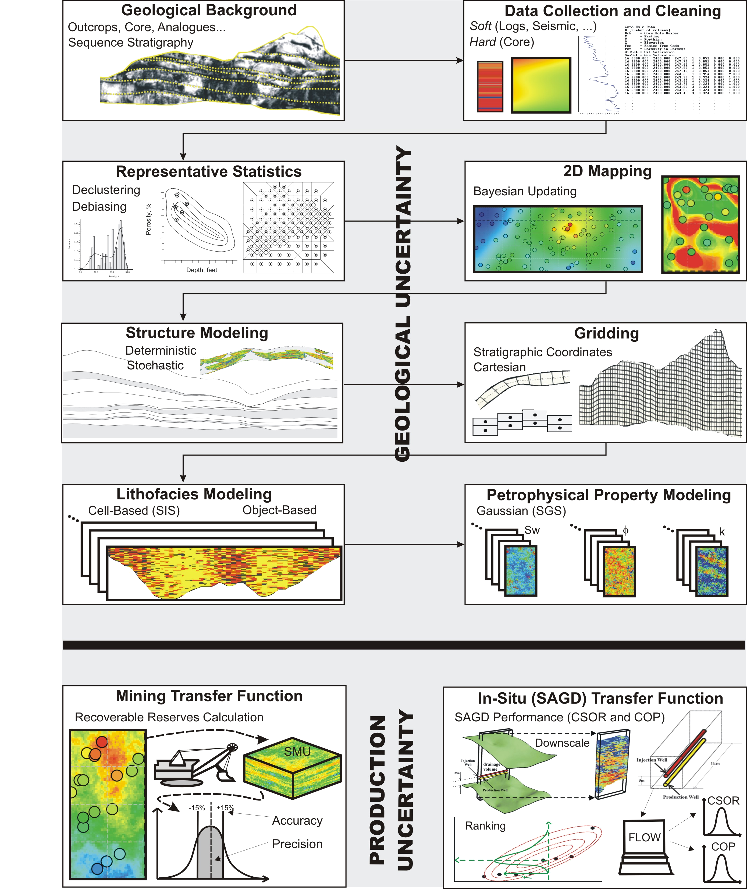

Figure 1: An illustration of the major considerations involved in a typical geostatistical and post-processing workflow.

